Swing pivots – Trend identification methodology
Revision: 1

Speculator: I will show some trend identification techniques using Nifty

Speculator: Let's keep it very simple. One timeframe, one EMA and one momentum indicator, let's use 15-min, 34 ema and RSI(5)

There are two ways swing reversal can happen:

- Taking out the prior swing pivot

- Trade above the 34 ema, come down and test the 34 ema and rejection with a green candle above 34 ema, for upside reversals. For downside reversals, we need to trade below the 34 ema, go back up and test the 34 ema and rejection with a red candle below the 34 ema.
NOTE: Whenever the price moves above 34 and comes back to 34 for rejection the green candle must close above the previous candle's high. Reverse for shorts.

Speculator: Let's begin with the recent swing which started on Dec 22, 2010. Wait for the price to cross the 34 ema and rsi (5) to get overbought i.e move above 70. That's a preliminary indication that a trend change may have started. But, no guarantees at this stage.

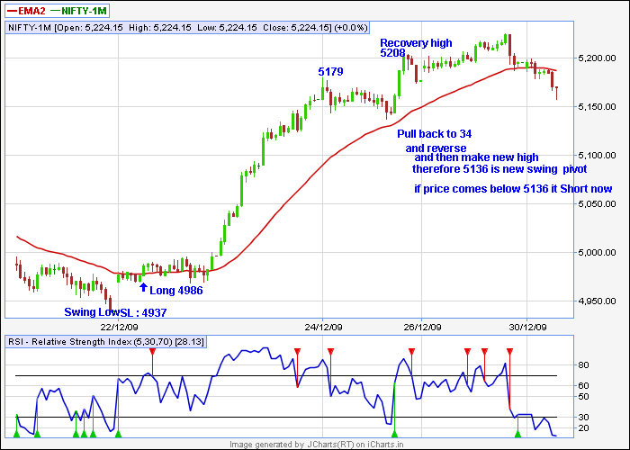

Now wait for the price to test the 34 ema and reverse back. You need to see at least one green candle above the 34 ema. That's around 4986. Now put a stop below the prior swing low 4937 and pray - mean it seriously. At this point we have no confirmation that a trend change has occurred. We are just speculating by taking a position. After some sideways move the price takes off. Until price moves above the prior swing pivot the trend change is not confirmed. In this case the prior swing pivot is at 5048. There are various ways to establish swing pivots. Some use pure price to do that. Some use momentum indicators. Some use moving avg. Momentum benchmarking of pivots is complex and I won't go there.

Now, i will show how to use ema to establish swing pivots. After reaching 5179 high on Dec 24, we pullback to the 34 ema and reverse from there. This reversal make a new recovery high at 5208 on Dec 24.

A rejection from an ema and a new recovery high constitutes a swing pivot.

In this case the low was 5136 from where the rejection occurred from the 34 ema. So 5136 becomes your swing pivot. Note we don't have to touch the 34 ema, going close eto it is good enough. Also remember after the rejection from the 34 ema, you need to make a new recovery high in order to call it a swing pivot.

Ok now for the uptrend to remain intact we have to keep trading above the swing pivot of 5136. On Dec 29, we pullback again towards the 34 ema. In fact, we break below that, go back up and retest the 34 ema and fail again.

Now if this setup had broken 5136, that would be a setup for swing short and the uptrend is considered broken but as you see we didn't break our swing pivot, rather went ahead and made another recovery high. Now the low at 5157 becomes our new swing pivot. On Dec 31 we get another pullback to 5192 and a new high, so 5192 becomes our new swing pivot. On Jan 4 another pullback to 5218 and rejection and new high, so 5218 becomes our new swing pivot. So on a 15-min chart a swing trader has got no exits so far from his long position. On Jan 5, another pullback to 5263 and a new high. So 5263 is our new swing pivot.

Speculator: A break of 5263 will be an indication for him to close his longs
Rvgandhi: any particular reason for 15 min tf ?

Speculator you can use any TF you want, 30-min 60-min daily but you need to tune the indicators to that TF for instance 34 ema is not suitable for 60-min to identify swing pivots.

Speculator: Ok now to the RSI or CCI or Stoch or whatever is your favourite indicator. Let's take RSI which is simple.

Amateur mistake with momentum indicators is that they think overbougt is a sell and oversold is a buy. If it was that simple, the big hedge fund guys would have automated that and asked their computers to make infinite amount of money. Momentum indicators are a great clue as to whether we are in a trending market or a sideways. Firstly don't trade the momentum crossovers, you will go bankrupt. I will guarantee you that ☺

Use momentum indicators to assess trend, let's look at the 15-min chart with RSI(5). I am using RSI(5,30,70) I am using RSI(5) because it is more sensitive than RSI(14) i.e faster

Let's continue with an example - On Dec 22 rsi crossed above 70, then we pulled back below 70 and the price went sideways then the market took off and the RSI got OB again.

When the RSI moves from a neutral(50) or Oversold(below 30) to a overbought position and the price makes a new recovery high, it means a trending move. In case of sideways market, the RSI gets overbought, while the price fails to make a new high.

I will show you some examples. First let's look at the trending moves. On Dec 24, the RSI(5) moved from overbought to oversold. Coincidentally when the RSI was oversold, the price was near the 34. Now the RSI moves back to overbought and the price makes a new high. What does that tell you?

Smsmss: trending market

Phukad: uptrend

Speculator: Yes it means we are trending higher and the 34 ema where rejection happened is the swing pivot. On Dec 29, we again pullback and move from RSI OB to OS. On Dec 31, RSI gets OB again, but we fail to make a new high (high =5221) and RSI breaks below 70. That says we are in sideway move possibly. Then the RSI gets OB again on the same day and the price makes new high at 5229. So, trending behavior again.

After 5229 again we move back to OS. But the price remains above the prior swing pivot. On Dec 4, RSI OB again and new highs at 5234 - trending behavior again. On and on and on......so that's a strong trending market there.

Speculator: We didn’t discuss downtrends. Go back to 11 Dec 15-min NF. Dec 12 market moves down and breaks the prior swing pivot at 5082. What does that say?

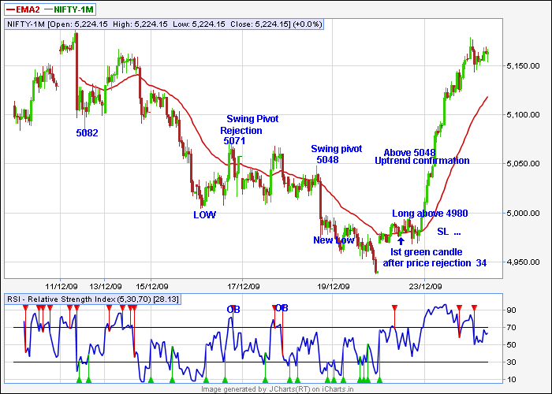

Speculator: establish swing short positons

Phukad: down swing

Speculator: We wait for a price rejection from 34 ema and go short we keep moving down into Dec 16. On Dec 17, we move to 34 ema and have a rejection at 5071. So 5071 become your swing pivot

Rahulsud: but spec this time many candles closed above 34 ema

Rahulsud: it could have been change of trend, when do we take entry??

Speculatr: Rahul, yes, but you don't take the first move above the 34 ema. You wait for the price to come back to the 34 ema, have a rejection there and move up with a green candle above 34 ema to consider long.

Rahulsud: ok got it. In this case price moved below 34. Am i right?

Speculator: In this case we have a rejection and we move below 34 again.

Rahulsud: so can we go short now?

Speculator: Then you move back above 34. But look at your RSI(5)

Rahulsud: It is over bought again

Speculator: The candle close at 5040 above 34 ema. But your RSI is already overbought, so it says a potential sideway move. But if you are aggressive, you can try a long. The next day we gap down i.e rejection from 34 again, now 5071 is our swing pivot, we move back up to 5068 and the RSI gets OB and we get a rejection again, so the downtrend is still intact 5068 is the new pivot. Next day we have another attempt at 34 and rejection

Speculator: That's it guys. I just showed a trend identification technique. You can create your own and fine tune it to your timeframes. Good luck!

JO_JO_1961: how do we add positions to a winning trade?

Speculator: JO_JO, you may enter a partial position and keep adding at higher swing pivots. I do that often. That's money management, which is an entirely different discussion.

Stop loss management

The size of stop loss is always dictated by the volatility in the market. In a high volatile market, increase the stop loss size and reduce the position size. In low volatile markets, decrease the stop loss size and increase the position size.

There are two ways swing reversal can happen and each method requires different ways of handling stop losses.

Taking out the prior swing pivot – In these cases, putting a stop loss below the prior swing low is impractical, as it would be very huge. Instead try to put the stop loss below the most significant candle that caused the breakout above the prior swing pivot.

Trade above the 34 ema, come down and test the 34 ema and rejection with a green candle above 34 ema, for upside reversals. For downside reversals, we need to trade below the 34 ema, go back up and test the 34 ema and rejection with a red candle below the 34 ema – In this case, put a stop loss below the prior swing low or above the swing high, for upside and downside reversals respectively.

Exceptions for this methodology:

This methodology does not work for “V” shaped reversals.“V” reversals typically happens after panic selloffs or at Climactic bottoms. Well, no technique perfectly works in those scenarios. A recent example was on Nov 27, during the Dubai panic.

Recent ADDITIONS by Speculator:

Entry, Exit and Stop rules/guidelines (For Type I reversals)
In my system swing reversal is simply defined as taking out the prior swing pivot. So where does one enter and exit ?. For upside reversal, one should enter as soon as the prior downswing pivot (shown in down arrow in the chart) is crossed and exit when the upswing pivot (shown in up arrow on the chart) is taken out. For downside reversal, enter on break below the upswing pivot and exit on crossing of downswing pivot. While this is the theory, in practice this would require very wide stops. So to make it practical, i have defined a few entry and exit rules. You may develop your own rules based on what suits your risk tolerance. A picture is worth thousand words. So i have attached four charts, two showing upside reversal entry technique (NF1.gif and NF2.gif) and two showing downside reversal entry technique (NF3.gif and NF4.gif).
Entry and Stop loss
Technique #1: (Recommended technique)
(i) For upside reversal wait for a green candle which closes above the prior downswing pivot and the candle should also close above the prior candle high. Candle close above the prior candle high ensures that the momentum is in your favor. Stop loss should be below the reversal candle. If the candle is too big and requires a very big stop loss which does not suit your risk tolerance, don't take the trade. It's not the end of the world. In such cases, wait for a pullback to 34 ema and rejection to enter.
In NF1.gif, there's a candle in the red circle which takes out the downswing pivot, but fails to close in a green candle above the prior candle high. The price action after that is one of a pullback rather than acceleration. So that's not a good entry point. That highlights the necessity of a candle closing above prior candle high, which ensure price acceleration, since the momentum will be in your favor.
(ii) For downside reversal the rules are same. We need a red candle which closes below the prior upswing pivot and close below the prior candle low. Stop loss rules are different here. One should place the stop loss above the immediate swing high on the charts. The reason being, tops have different characteristics than bottoms. Bottoms tend to be "V" affairs. Tops are "M" affairs. Tops gets tested many times before we go down in earnest. So putting a stop above the red reversal candle will almost always result in a stop-out.
Technique #2:
One can start a daytrade from lower levels and convert it into a swing trade, if the swing pivot is taken out. If we fail to take out the swing pivot, close it out as a daytrade. This is assumes that one has good daytrading techniques to enter from lower levels. Although i use this approach often, it's not a recommended technique.
Exit rules
Technique #1: One can exit the entire position at the swing reversal. Although this is the right technique in strongly trending markets, it may wipe out all the profits in range bound markets upon reversal.
Technique #2: This is the technique i use. I exit about 30% of my positions on a 1:2 risk/reward. So if my stop size (risk) is 50 points, i close 30% of my positions on a reward of 2*50 = 100 points. The rest, i close on swing reversal.
UP SIDE REVERSAL:

NF - 1

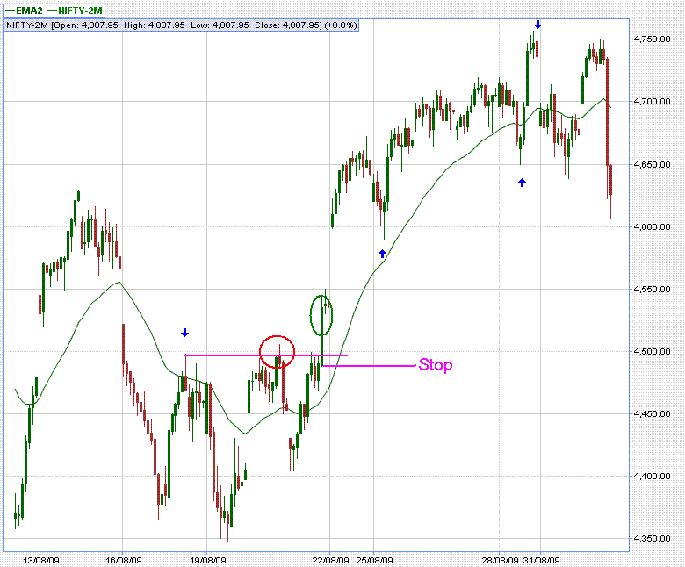

UP SIDE REVERSAL

NF – 2

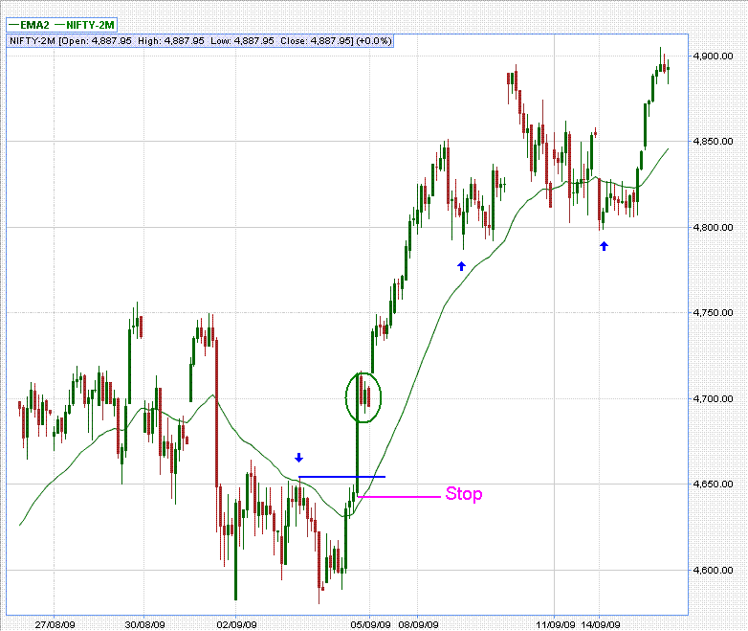

DOWN SIDE REVERSAL

NF – 3

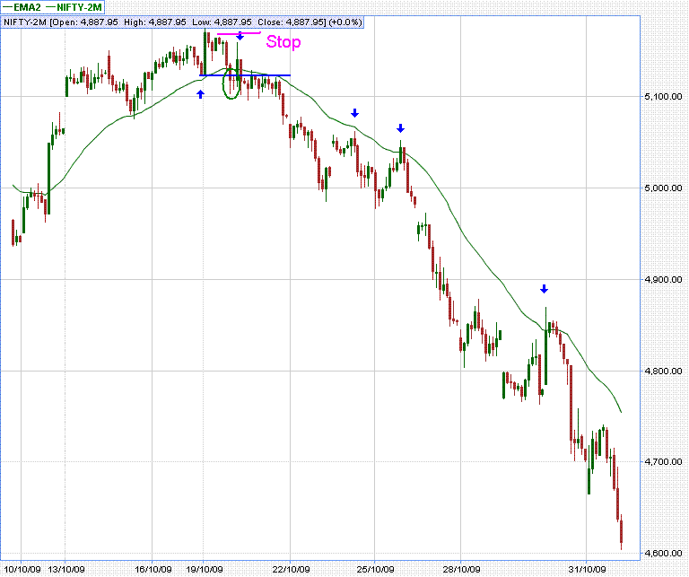

DOWN SIDE REVERSAL

NF – 4

