How to trade in trending market & Range bound market by using ema 10, 30, 89 & BB 30, stochastic ( 13,8,5) for Nifty 3 min TF.

One of the toughest to thing to identify is: whether market is trending or trading i.e. range bound.

I think I can share this with fellow I charters so that guys can benefit on this. People make money in trending market & loose most of the gains during trading market. This is because trending market will be hardly for 30% of the market hours. 70% of the time, market will be in range bound.

After upmove/downmove, most of the guys take positions in the direction of market as this is human nature, this follows our conventional wisdom. But market is unconventional in nature (I am talking about high liquidity stocks & indices).

Your comments on this are welcome ( viswanath MK email id : kv_maligi@yahoo.com)
And also share your trading strategies. I am thankful to Mr.Piyush for sharing his strategy views in the forum. ( Is anybody following Ichimoku charts ? I have very good understanding on this. But I do not have software for charting ichimoku )

The same strategy can be applied for options

Case a ) Trending market :

All above EMA lines will separate each other.

In this case, follow EMA cross for exit.

But entry is made based on stochastic. Exit is based on EMA 10 & 30 cross.

Case b) Trading/range bound market

All above EMA will be close to each other & they will be with in the BB.

In this case, entry & exit is based on stochastic ((13, 8, and 5).

For support & resistance levels, you can follow BB 30.

Chart is attached is herewith.

Chart for case a)

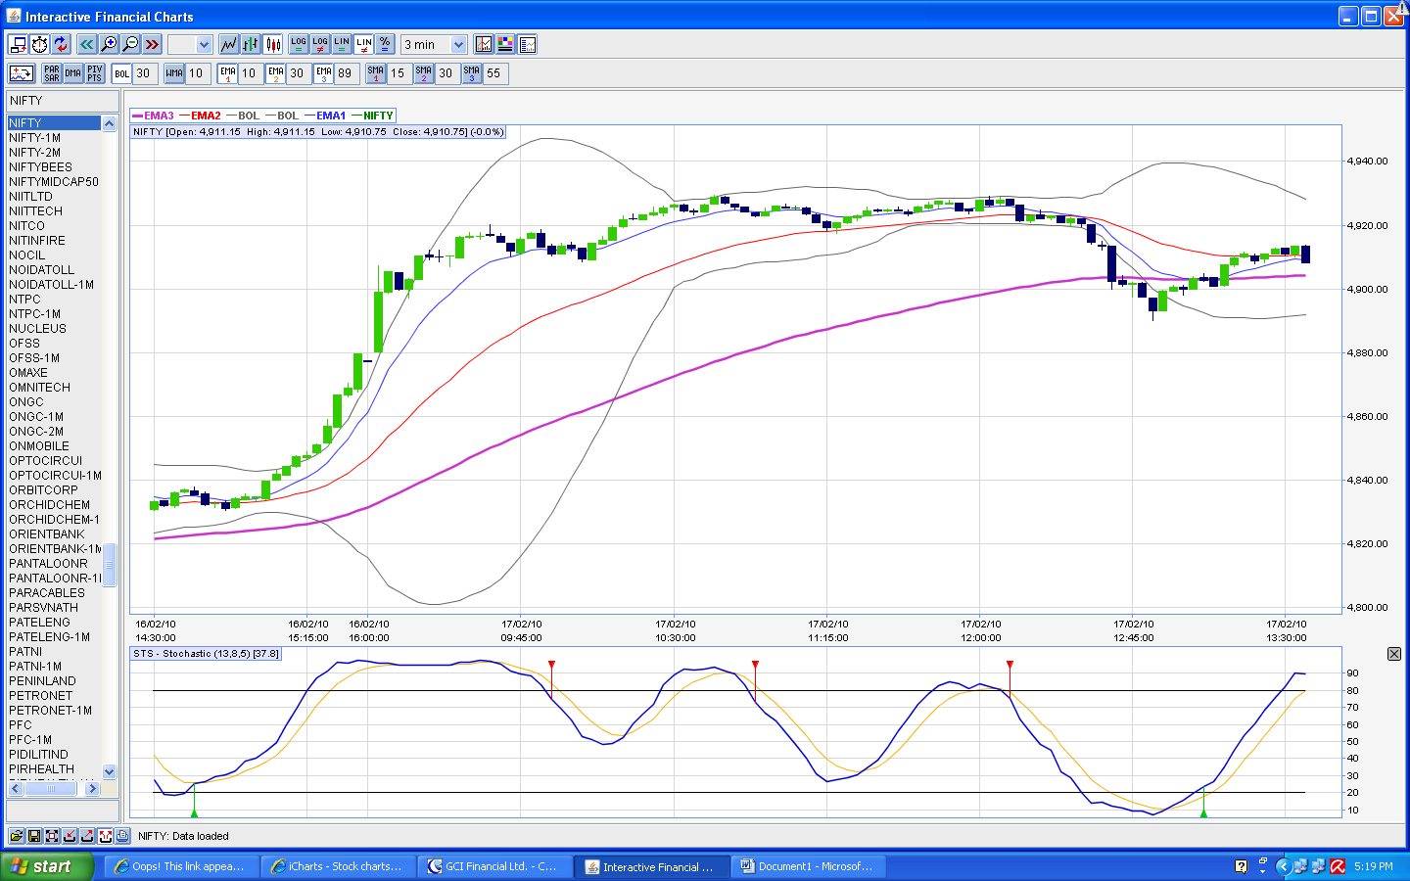
Chart for case b)

