Hi…:)

To : All my trader-friends in iCharts-ShoutBox.

As desired by you guys, here I present the basics of my Fractal Trading System.

The system uses moving averages and price patterns on a bar chart to signal trade entry and exit. The system uses only one standard price-pattern and it is called a ‘Fractal’. So, let us call this as a Fractal Trading System (FTS).

FTS is a trend following system that can help one to identify and trade a new trend in its nascent phase, to stick with an established trend, to pyramid positions, to take part profits and to exit completely before a new trending move starts.

This document does not delve into the funda behind the concept of ‘fractals’, rather we focus on the ‘method’ of using fractals in conjunction with moving average lines.

Fractal Trading System (FTS)

Fractal is a price pattern comprising of a minimum of five bars on any bar chart.
A fractal pattern can have ‘n’ number of bars in it.

Up-Fractal is formed when a price bar has at least two adjacent bars on each side with lower highs.
Down-Fractal is formed when a price bar has at least two adjacent bars on each side with higher lows.
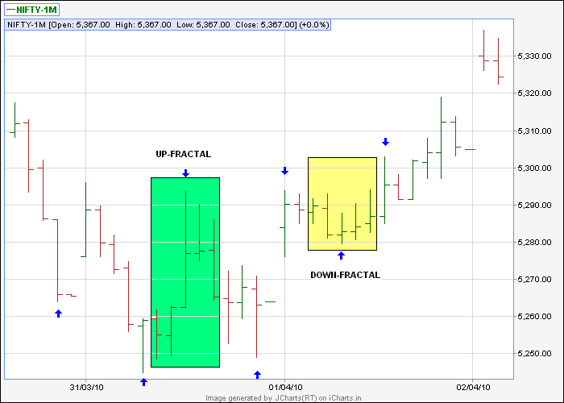

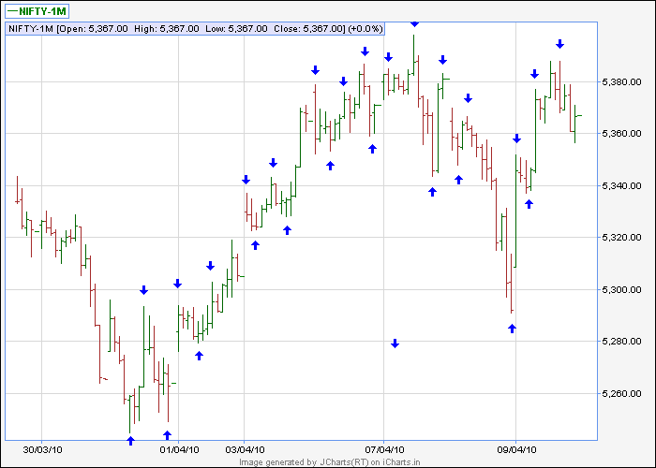

Above 30mts chart shows all Fractals formed in NF-1M from 01-Apr-10 to 09-Apr-10

Market price action generates fractal formations on a continuous basis.
New and lasting price-trends are observed to take-off after moving average confluences. Fractal Trading System endeavors to combine these two insights.

FTS primarily relies on 34EMA for trend identification.
Price extremities of fractals are used for timing trade entries/exits.
The basic trading method is explained below using charts with following settings.

Nifty Futures – 1M Contract
Time Frame – 30 minutes chart
EMAs used – 5 (green), 13(blue) and 34 (Red).

How to open a new trade

A cardinal rule of FTS is that 34EMA is the trend-defining line.
Hence no buy trades shall be initiated below the EMA.
Similarly, no sell trades shall be initiated above the EMA.
In other words, if we see an up-fractal below the 34EMA line, or if we see a down-fractal above the 34EMA line, we do not use it for trade initiation.

Let us take the upmove from 01 Apr 10 as an example.
From the charts, we observe the price making new fractals on both sides of 34EMA.
We are in our trading zone now, because its here that we look for a new trade.

We start by marking the top of the latest up-fractal formed above the 34EMA (green line) and the bottom of the latest down-fractal formed below the 34EMA (red line) as two potential trade entry points. All earlier fractals have no relevance in the FTS.

Importance of these two lines is that :
If the prices were to rally, it has to breach the latest up-fractal top (green line).
If the prices were to fall, it has to breach the latest down-fractal bottom (red line).

We wait for the prices to take-out either of these fractals and as soon as it does, we take positions in the direction of the breach. In this example, we buy (go long) as soon as prices move up and breach the green line.

When a trend kicks in, prices race away, always giving new fractals as time goes.
As long as the price trades above the 34EMA, we ignore all down-fractals.
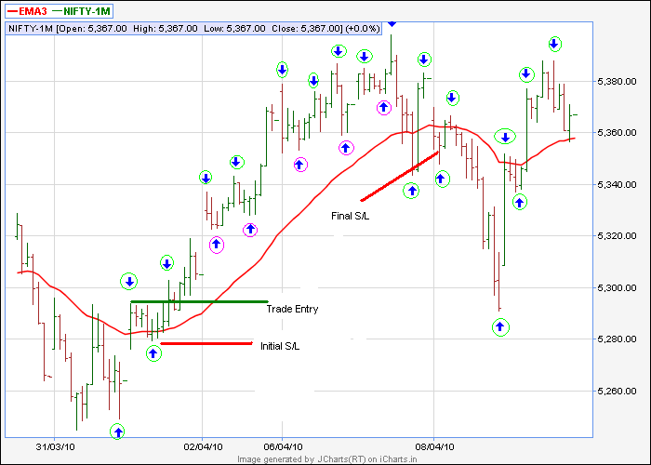

All fractals highlighted in pink are down-fractals formed above the EMA, hence ignored. All fractals highlighted in green are either (a) up-fractals formed above the EMA or (b) down-fractals formed below the EMA. FTS respects only the fractals highlighted in green circles. They are tradable using the system.

Every up-fractal formed above the 34EMA, after the initial fractal breakout, is a valid point for pyramiding positions. One should try pyramiding or late-entry into a trade, only if the overall risk of the trade is within acceptable levels. Entering a trade afresh, after the market moves away from 34EMA is not recommended.

At times up-fractals are formed just below 34EMA. Price and the EMA slide down further, before the market rallies to breach the EMA and the up-fractal. Such fractal break-outs are tradable if at the point of breaking the fractal, price is above 34EMA line.

How to exit a trade

Initial S/L: When a trade is taken close to the 34EMA, price extreme of the latest fractal on the opposite side of 34EMA is the initial Stop/Loss point.

Trailing S/L: Once the price moves comfortably away from the 34EMA, trailing stop-loss is to be used. As the trend unfolds, prices generally pull back to below 13EMA and rally again to give a new high. Move initial stop/loss to the new fractal bottom formed below/near 13EMA, after a new high is seen. See chart for examples.

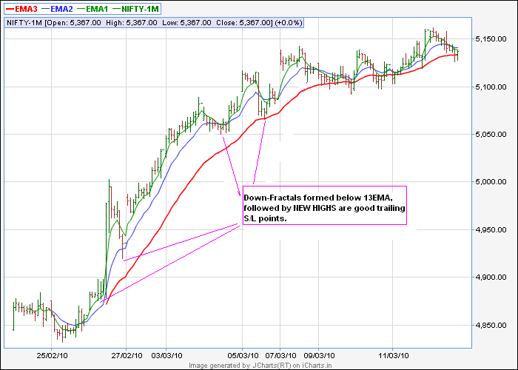

Absolute Stop-Loss :

FTS demands closure of a trade, if prices give an hourly close below 34EMA.
When price goes below 34EMA, new fractals are formed on both sides of the EMA.
In other words, the game starts all over again.

Profit Taking Rules

Though it is not difficult to have hard and fast rules for trade entry and stop loss, defining rules for profit taking is a tricky affair. FTS is a trend-following system and hence it does not put price targets for any move. Nevertheless the system suggests following methods for profit taking.

- Close 50% positions as soon as you observe a 5EMA / 13EMA crossover.
- Trail the balance 50% until finally stopped out by an hourly close below 34EMA.

While there is no ambiguity on the exit rule for the last 50% position, it will be worthwhile to have a flexible approach for the first 50% position, as suggested below.

In a secular trending market, a 5EMA/13EMA cross-over, only warns of a possible trend change. It is not sufficient proof of a trend change. Prices may just stall/consolidate for a while and then the trend may resume with vengeance. Exiting 50% position blindly, on a 5/13 EMA crossover may not be the best idea. It may be worthwhile to put a tight stop-loss for the first 50% position and try to ride out the storm. Anyway it is for the individual to choose. FTS rule is : close first 50% positions on a 5/13EMA crossover.

Following chart shows the entry/exit levels for the trade under discussion.

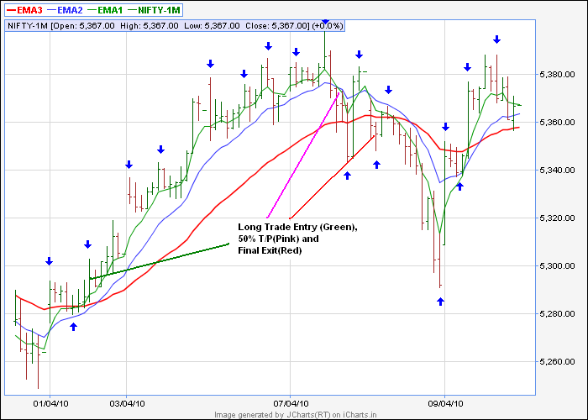

Above example was of a long trade. For short trades identical rules apply.

I’ve tried to explain a simple method for trend-trading. FTS works better in trending markets than in range-bound markets. The method is not recommended for day-trading.

Good Luck to All
jo.jo

