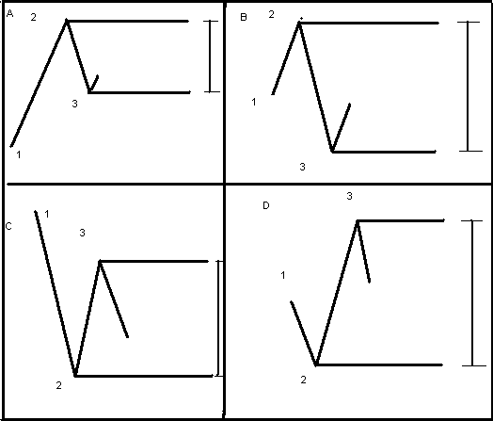

123 Trading System
There are four possibilities that can happen with any stock or index at any stage of trading movement.

- When a scrip moves from point 1 (Point 1 can be taken at any stage of the movement either we make point 1 at the start of the chart or in the middle of the chart or at any level where we find comfortable.) it goes upto point 2. After reaching at Point 2 only two possibility would happen either it will go up or it would go down. If it further goes up then wait till it changes its course…Once the Point 2 is established. Then again the 2 possibilities would occur…either it will go up or go down…if it goes down means Point 2 is still not established but if it goes up means it has again changed its direction again and at that point it has established a Point 3.
Now as per the Diagram 1. Two parallel lines has been drawn one at Point 2 and other at Point 3.
Now this has become our trading zone. After point 3 is established again 2 possibilities either up or down. Now if it goes up wait till the Point 2 is breached then that is the level where long trade can be initiated. And if it goes down short trade can be initiated.

Same applies with other possibilities of B,C,D
Same follows with other diagram condition also.
Trade can be initiated only on the either side breakout
Target:- The difference between from the point 2 and point 3 either side. However profit should be booked at 90% of the target.
Stoploss:- Cost to Cost. Or can Filter(Not more than 5-7 Points Including Brokerage).
Time Frame 5 mins Opening 2-3 can be avoided. And no trade reversal after the stop loss gets hits only re entry.
Volume at the breakout level on either side assures the confirmation for the target.
Below is my actual saved trading I explained this to some other people also. So it was saved for that purpose. If any query I would be glad to discuss it with you all…
