http://www.tonihansen.com/blog/2007_06_01_archive.html

Sunday, June 17, 2007

1-2-3 Continuation Pattern
1-2-3 Continuation Buy Pattern
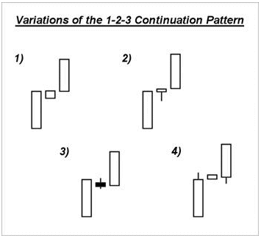
Description: This pattern refers to a three bar pattern where a narrow range bar following an initial momentum bar creates a build-up in momentum, leading to a continuation pattern in the direction of the first bar when the second one breaks higher on the third bar.
Criteria:
1. Wide range bar breaking out of support.
2. Narrow range bar near/at the highs of the previous wide range bar. Often this narrow range bar is also an inside range bar.
Entry: Switch to a smaller time frame and take a breakout from the base on Bar #2, using the entry criteria for a breakout, or use above the highs of the narrow range bar of Bar #2.
Stop: Under the lows of the base or last major pivot low on the smaller time frame, under the lows of the narrow range bar, or under the lows of the third bar at the time of the setup.
Target: Bar #1 = Lows of Bar #2 to highs of Bar #3. Watch for resistance levels overhead such as previous congestion zones or whole number resistance.
Ideal 5 Tech Tools Traits:
Pace: Above average momentum on the first bar, but not wider than an average wide range bar. In other words, if the largest bars tend to be $2, then one that is significantly larger than that will be less likely to form as strong of a follow-through on a 1-2-3 continuation pattern as compared to normal. The pace within the second bar should end up being more gradual overall on the counter-trend moves, such as the pullbacks from highs after an upside move on the first bar.
Volume: Lighter than average volume on Bar #2, followed by increasing volume as the highs of Bar #2 are broken.
Correction Periods: Higher probability of success if the setup triggers on Bar #3 as it is coming out of a correction period.
Support/Resistance:
* This pattern tends to be the strongest when it is coming off a larger time frame support level. A base on Bar #2 that pulls into a moving average support level as it sets up, particularly the 20 period sma, will increase the odds of success.
* Often the highs of Bar #1 and Bar #2 will be at a resistance level such as whole number price resistance. If a significant resistance level is just above the highs of those bars, then it will add risk, since the security will more often stall at that point.
* Watch for prior highs such as the highs of the third wave of selling on ATVI shown below in Figure 2, for resistance to assist with targets.
Trend Placement/Trend Development: Look for a setup near the beginning of a new trend, such as after three waves of selling, as was the case in the daily setup on ATVI shown in the example which follows. This pattern is also strong when it takes place on a larger time frame breakout.
© 2007 Chart provided by Townsend Analytics Ltd.
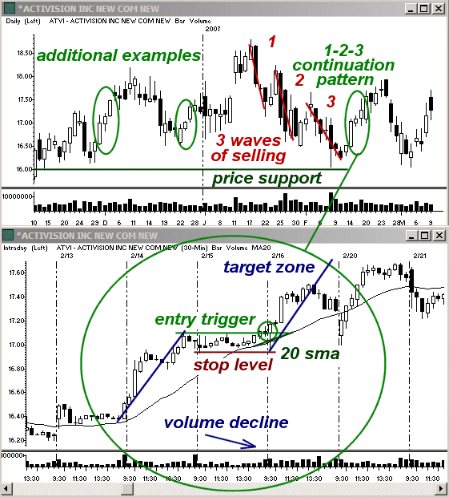
Pros on Daily 1-2-3 Continuation in ATVI:
1. The momentum heading into the base on the 15th was stronger than average to the upside.
3. The base on the 15th had two pullbacks within the range before it broke higher. This is typical of a correction.
3. The volume on the 15th was much lighter than the previous session and then increased as the range broke.
4. ATVI broke higher into the very end of the day on the 15th and morning of the 16th. This is a typical correction zone intraday and is a great time for bases on the 30-60 minute charts to break.
5. The base on the 15th lasted right into the 30 minute 20 sma support, which was followed immediately by the breakout.
6. ATVI had three waves of selling on the daily charts ahead of the continuation pattern. This trend development is typically followed by a larger correction.
7. ATVI had hit strong daily support at previous lows, making a bounce highly probable.
8. There was a lot of room from the time of the breakout until the next major resistance from the highs of the third wave of selling on the daily time frame would hit. This left quite a bit of potential for the setup.
Cons on Daily 1-2-3 Continuation in ATVI:
1. ATVI did not form a base along the highs of the range on the 15th before breaking, but rather moved from the lows of the range over noon and through the highs in the afternoon.
2. The volume did not increase much on the breakout on 2/16 as compared to the prior day’s base.
3. After the initial wave of buying on the 16th, it pulled back more sharply before its second wave of buying as compared to the mid-day correction on the 14th, which slowed the overall momentum and kept it from hitting an exact equal move as easily when coming into the target zone.
1-2-3 Continuation Short Pattern
Description: The criteria for a 1-2-3 Cont. Buy Setup can also be reversed for a short. Simply change “support” to “resistance” and “buy” to “sell” and vice versa to give the short criteria.
1-2-3 Continuation Short Example: Shaw Group Inc. (SGR)
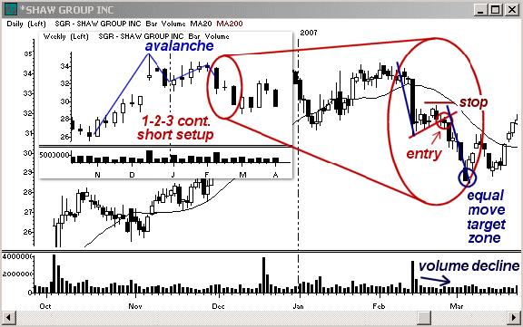
© 2007 Chart provided by Townsend Analytics Ltd.
Pros on Weekly 1-2-3 Continuation in SGR
1. SGR triggered a daily Avalanche breakdown with the first bar of the 1-2-3 Cont. Short Setup. This created room for larger downside follow-through by virtue of its placement in the larger trend.
2. The second bar formed in the lower half of the first with no increase in upside momentum as it came off the support from January’s lows.
3. Within the second bar on the weekly time frame, SGR formed a strong consolidation and broke lower on the third test of lows within that consolidation and heading into bar 3 on the weekly time frame.
4. Volume declined as SGR consolidated in the second bar of the continuation pattern.
5. No immediate support to stall the continuation move.
6. The momentum at the beginning of bar 3 was as strong as heading into bar 2, allowing for SGR to hit an equal move target on the weekly time frame.
Cons on Weekly 1-2-3 Continuation in SGR:
1. No easily discernable base along the lower end of the daily base to allow for a tighter stop.
2. The base on the daily time frame did not quite hit the 20 day sma resistance and might have attempted to test that resistance better before breaking lower.
3. The volume did not show much increase once bar 2 broke to provide volume confirmation of a stronger selloff developing
posted by Toni Hansen @ 7:46 PM 1 Comments

Wednesday, June 13, 2007

Wednesday's Market Action
Trading Slows Ahead of the Fed's Beige Book
Good morning! Market participants were looking for just about anything to grasp onto in Wednesday's session to produce some movement intraday. Unfortunately, until 14:00 ET they lacked anything to sway them one way or the other as we sit and await an increase in news from the next upcoming warnings and earnings season. We've seen a lot of smaller names and thinner stocks topping the market gainers and losers lists lately and its led to a reduction in intraday opportunities in stocks and has led to my favoring EMini trading in recent sessions. This is a nice benefit of having access to both marketplaces and not getting tied down to just one or the other. You can go where the most money is. When news is romped, the momentum players in the equities market can offer the best risk versus reward, but when things are slow on the news front, it's the indices themselves that I find most attractive.
A key difference in trading equities versus futures is that in the equities market I tend to scan for specific criteria, focusing on certain combinations to give me setups, but in the futures market you have to have a larger arsenal and even greater patience since there is no scanning to do in between trades. Instead you just have to wait out the current move and then have the patience to await the next trigger, even though it may take a bit of time to get one that lines up on multiple time frames since those have the highest odds for success. In a way though, you can be a bit more lazy since you don't have to worry about scanning and flipping through charts to find the next big mover. Instead you can just sit and keep half an eye on things as they develop as long as you don't get wrapped up in the minute by minute action and loose track of the bigger picture.
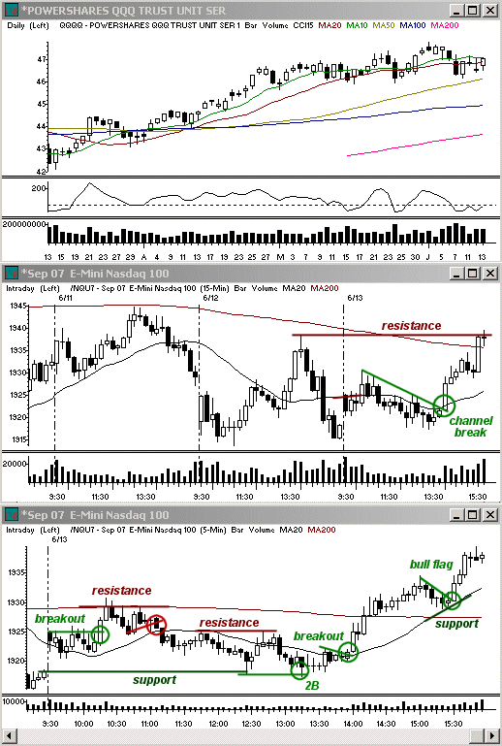
This being said though, I did had a more difficult time on Wednesday locating setups in the indices as well as the stocks. The market had gapped higher out of the open, which, given the overall market range, was on the bullish side. The market had opened directly under resistance, however, with the 15 minute 20 simple moving average directly overhead. This forced the indices into a trading range for the first 45 minutes of the day. As they did so the volume declined before breaking higher out of the range with the 10:15 ET reversal period. A rapid, albeit brief, rally followed which took the indices into price resistance from the previous session, but it lasted for less than 15 minutes before slowly turning over and giving way to an excessive amount of choppy trading throughout the remainder of the morning and into the first half of the afternoon.
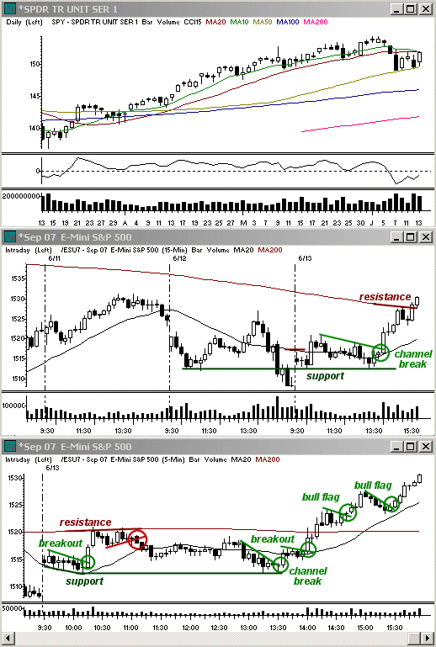
After reversing off highs, the indices slowly worked their way lower until finally finding support when the Nasdaq gap closed at about 13:00 ET. At this point the 1 minute setups that had ruled the day finally lined up with the 15 minute charts to favor an upside move into the afternoon, however, the 14:00 Beige Book loomed on the horizon and continued to hold down most stocks. The indices themselves began to give an indication for their preference just before the release. The Nasdaq formed a 5 minute 2B pattern while the YM had perhaps the strongest pattern with a Phoenix between 13:17 and a trigger at 13:33 ET. This provided a great scalp with the clearest pattern of the afternoon up to that point. A second strong setup formed with a base from 13:39-13:57 ET. The setup then took off when the Fed release hit, moving quickly higher to break free from the congestion in play in the market up until that point on the day.
It was about this time that a number of individual stocks finally found a foothold, although most of the setups were rather sloppy and I still had a difficult time locating what I felt would end up being decent positions ahead of time. Even when I found stocks I liked, they didn't have clear-cut setups for the most part and required a good deal of faith and willingness to place some larger stops than usual to avoid a higher risk of getting flushed out due to the choppier trading.
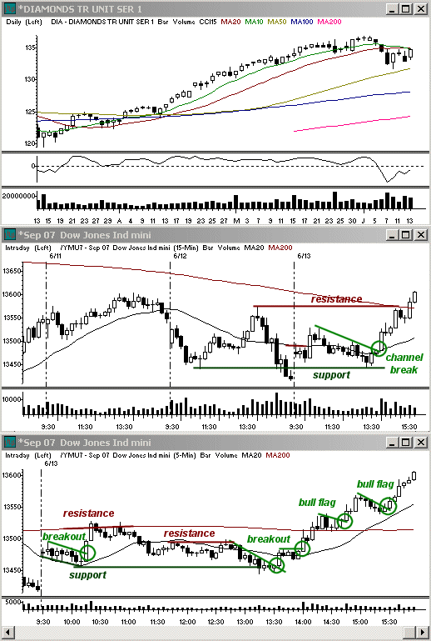
Despite the risks from the type of trend move in play in the afternoon, the market still trended higher into the close. The Dow Jones Industrial Average ($DJI) had nearly a 200 point gain, adding 187.34 at the closing bell. Out of the Dow 30, 29 closed with solid gains, many rallying more than 2%, such as AA, BA, C, CAT, DD, GM, and INTC. The S&P 500 ($SPX) gained 22.67 points, while the Nasdaq Composite ($COMPX) rose 32.54 points on the day. The strongest sectors included real-estate investment trusts ($DJR), utilities ($UTY), and oil stocks ($XOI). Even though the momentum increased on the upside on Wednesday, the market can still go either way on Thursday since we're stuck in a daily trading range and we still likely to see more of the thinner stocks in the top momentum lists again.
© 2007 Toni Hansen
© 2007 All charts brought to you by Real Tick III by Townsend Analytics, Ltd.
posted by Toni Hansen @ 9:07 PM 0 Comments

Tuesday, June 12, 2007

Tuesday's Market Action
Market Displays Uncertainty Despite Heavy Trading
Good morning! Volume was strong in Tuesday's session, but the market was all over the place. When I begin my day the first thing I do in the morning is scan through the premarket gainers and losers. These will tell me what type of momentum potential we have for the session as a whole. Then, shortly after the open, I will scan through all of the top intraday gainers and losers that have the strongest trading out of the open. On the best days these lists will tend to have a plethora of well-known and well-followed names and there will be a number of popular stocks on both sides. On Tuesday this was not the case. Many of the stocks that habitually make these lists were missing and a lot of the names which did show up were more thinly traded stocks, particularly in the Nasdaq.
Due to this lack of momentum in individual stocks, I had a very difficult time finding things to trade. I like to see stocks which have setups on multiple time frames. In other words, I likely won't short a stock which has strength on a larger time frame unless the trend is severely exhausted and vice versa. Most of the stocks I came across at the open that did catch my eye on the daily charts for potential intraday continuation never gave decent setups intraday on Tuesday. Since I prefer not to scalp in stocks unless it at least is going to give me a 50 cent move, I found myself rather bored before long.
Even when I went back after the close and poured through the day's action I found very few things that I wished I had seen during the day and had missed since most of the gainers at that point had either been because of initial upside which ten fell flat for the remainder of the day or else they just climbed steadily throughout the session like ETN. Most of these that did move, however, did so without a great daily chart and without strong intraday continuation setups that would not get you killed if you tried them on every stock you came across. By the end of the day I was so bored I literally fell asleep and completely missed the last two hours of trading which is kind of funny because I am NOT a nap person. At least it's good thing I don't have a boss to answer to! On the plus side though, there was some decent action in the indices as a whole and this allowed me to still manage to finish ahead despite my lack of stock trades.
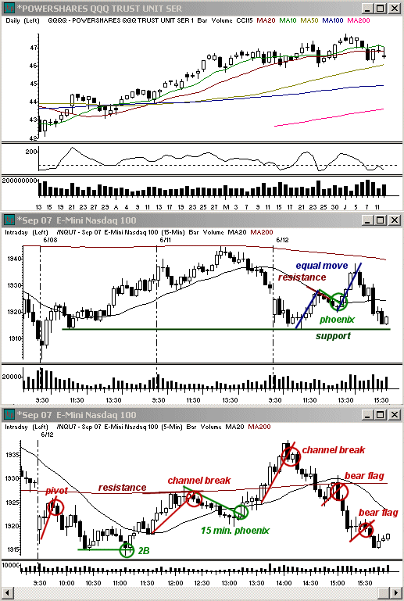
When the market opened on Tuesday the indices experienced a marked decline since the previous day's close. The opening prices were at support from the previous day's lows in the S&P 500 and the Dow Jones Industrial Average and Friday's morning congestion in the Nasdaq Composite, however, and this forestalled further selling initially. Instead the market bounced for a bit out ofthe open, closing a good chunk of the gap before hitting resistance around 9:45 to 9:50 ET. The rally had taken place on declining volume ever since the open and this made it easier for the indices to turn back around as the morning progressed. By 10:15 the three major indices were coming into new intraday lows and were now having to deal with support levels from Friday on all three, having strongly cleared Monday's lows.
The increase in momentum on the mid-morning sellinggave the indices very little chance to gain strength when they tried tobounce into 10:30 ET. I had caught the YM on this initial attempt tomove off support, but was forced to scalp it for only small gains before the indices moved lower again into 11:00 ET. This was too early for a solid bear flag, which should have at least hit the 5 minute 20sma, and ideally the 15 minute 20 sma given the extent of the selloffinto the earlier lows. The result was a 2B reversal pattern where the indices established a very slightly lower low on this form of a double bottom and it created a change in momentum that then allowed for a stronger reversal into mid-day.
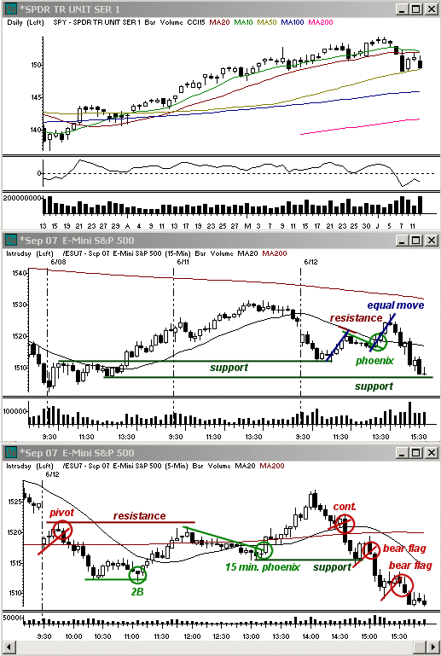
The market climbed steadily throughout the remainder of the morning. It eventually ran into resistance at the 12:00 ET reversal period when the indices hit their 15 minute 20 simple moving averages intraday and the 15 minute 200 simple moving averages on the all-sessions charts (which include the afterhours data). The strong combo of resistance levels and the reversal period led to a correction off the highs going into the early afternoon. Due to the larger intraday resistance, it seemed likely to me that the 5 minute 20 sma support would break on the pullback, but I never saw any conviction coming into the selloff so I just sat it out and waited. Following the 13:00 ET reversal period the market did find a foothold again when the gradual pullback along the 15 minute 20 sma broke through the resistance for a second wave of intraday buying on the 15 minute charts.
As in the morning rally, the momentum in the afternoon on the upside was steady and it led to a nice equal move on the 15 minute charts before also hitting price resistance from the previous session at the 14:00 ET reversal period. Even though the morning reversals trailed the reversal periods by about 5 minutes, the market held the afternoon ones perfectly and the market again began to correct out of 14:00 ET. This is about when I called it a day since I had not expected as strong of a reversal off the highs as we ended up getting. I found nothing in my scanning that caught my attention and figured that the momentum on the buying in the indices would hold off any strong reversal and the market would instead get stuck between the highs and the 15 minute 20 sma support for most of the remainder of the day.
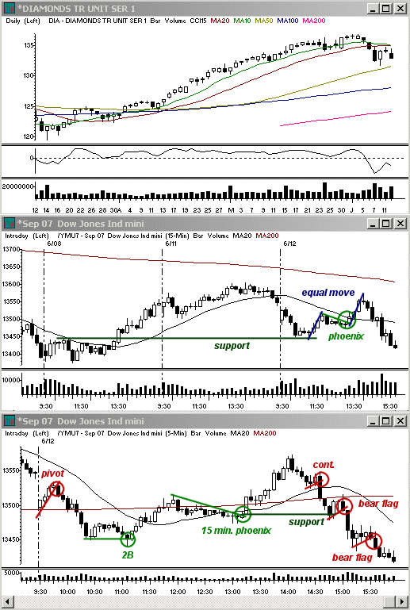
Had I waited just a few minutes to monitor the reaction to the market resistance it would have been obvious that was not going to be the case. The turnaround gained momentum on the downside immediately andreacted little to the 5 minute 20 sma which was the initial support. A series of small bear flags ended up taking the market lower into the close. By the end of the day all three indices had given back all the gains they had recouped since the open and the Dow ($DJI) closed lower by 129.95 points, the S&P 500 ($SPX) fell 16.1 points, and theNasdaq ($COMPX) lost 22.4 points. Since the market was unable to bust through the 10 and 20 day simple moving averages we were keeping an eye on yesterday, it diminishes the odds for a triangle on the daily charts at this time and instead favors a break in the 50 day sma with the next main support at the 100 day sma and early April trading levels if last week's lows can give way within the next couple of sessions.
© 2007 Toni Hansen
© 2007 All charts brought to you by Real Tick III by Townsend Analytics, Ltd.
posted by Toni Hansen @ 10:33 PM 0 Comments

