Divergence Cheat Sheet:-

Type | Bias | Price | Oscillator | Description | Example
 | Bullish  Divergence  By  Wilder | Lower Low | Higher Low | Indicates underlying strength. Bears are exhausted.  Warning of possible trend direction change from down to up. | 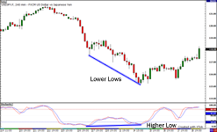
 | Bearish  Divergence  By  Wilder | Higher High | Lower High | Indicates underlying weakness. Bulls are exhausted.  Warning of possible trend direction change from up to down. | 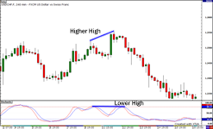
 | Bullish  POSITIVE  REVERSAL  BY  ANDREW  CARDWELL | Higher Low | Lower Low | Indicates underlying strength. Good entry or re-entry. Occurs during retracements in an uptrend. Nice to see during price retest of previous lows. “Buy the dips” | 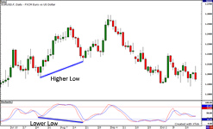
 | Bearish  NEGATIVE  REVERSAL  BY  ANDREW  CARDWELL | Lower High | Higher High | Indicates underlying weakness. Found during retracements in a downtrend. Nice to see during price retests of previous highs. “Sell the rallies” | 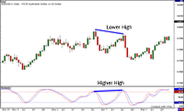
Failure  Swing |  | Bullish |  | RSI moves below 30 (oversold), bounces above 30, pulls back, holds above 30 and then breaks its prior high.
 |  | Bearish |  | RSI moves above 70, pulls back, bounces, fails to exceed 70 and then breaks its prior low.
