Lets call spade a spade

Things were right on the track, I was simply happy when slowly we were approaching to 16th November, the paper trades I have taken on that day showed me that what could be the result of our set up when we face some strong fundamental driven move.

The huge sell off which started on 16th is due to credit crisis and a few other international issues such as china asset bubble and though we expected a correction and there were clear sign in index charts that a correction is coming, but I believe that those bad news has changed the market fundamentals for the time being. It happens rarely, once or twice in a year or so. and according to me it’s a fundamental case, not technical.

However, lets cut it short, this set up can not generate proper signal during a panic stricken sell off. Let us go through some examples and find out what were the results.
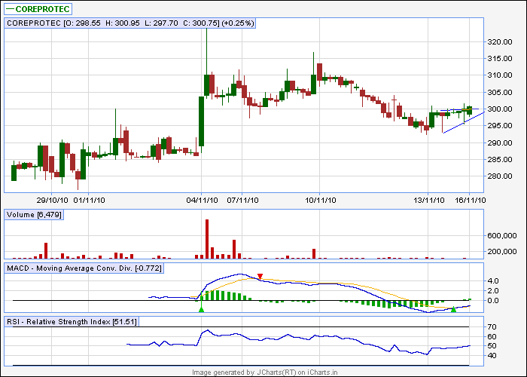
macd buy, rsi rising pattern bullish.
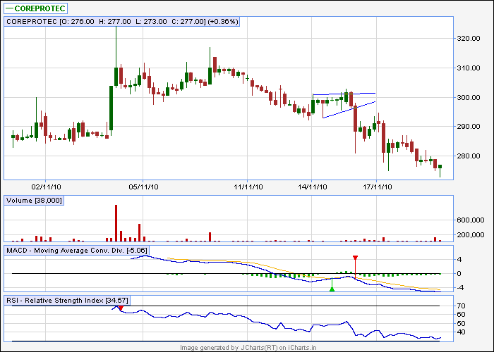
went down!!!!
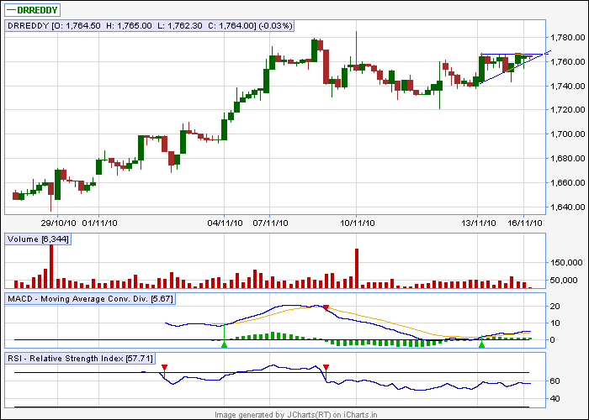
same set up
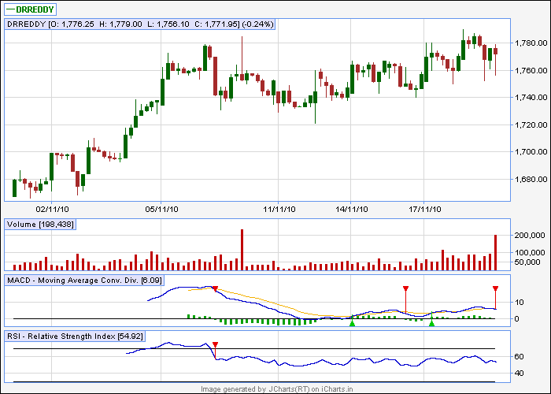
some how touched 1780, but not quite satisfactory

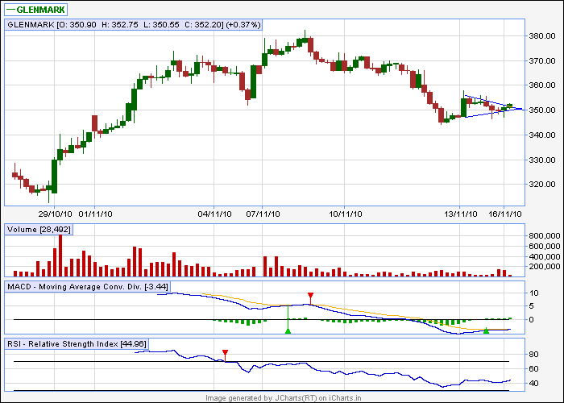
pennant. Macd and rsi bullish
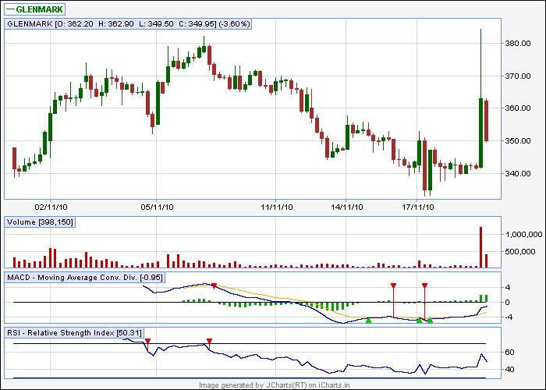
touched 380, but before that, touched 330 level, sl breached I guess
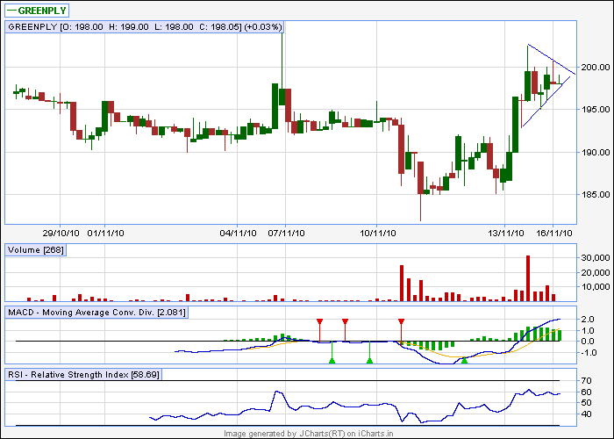
pennant. Macd and rsi bullish
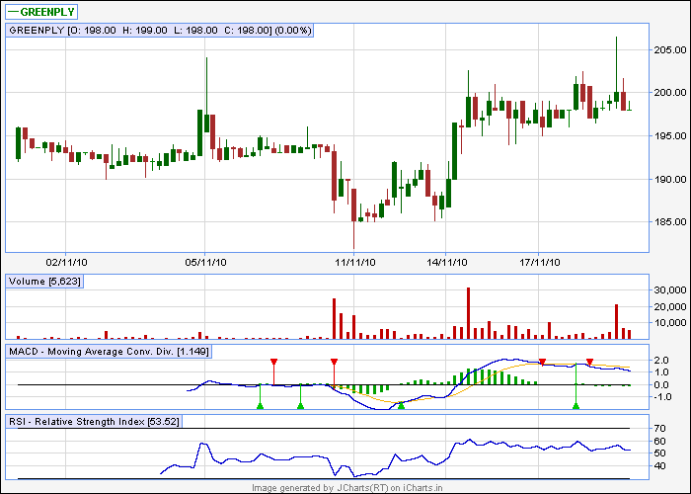
choppy move
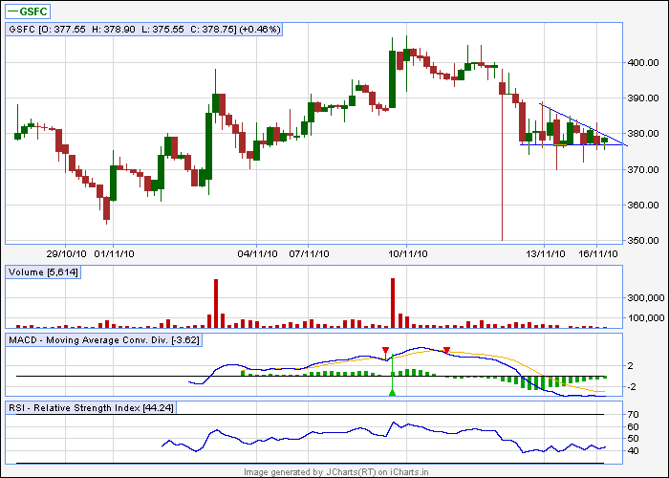
altogether bearish

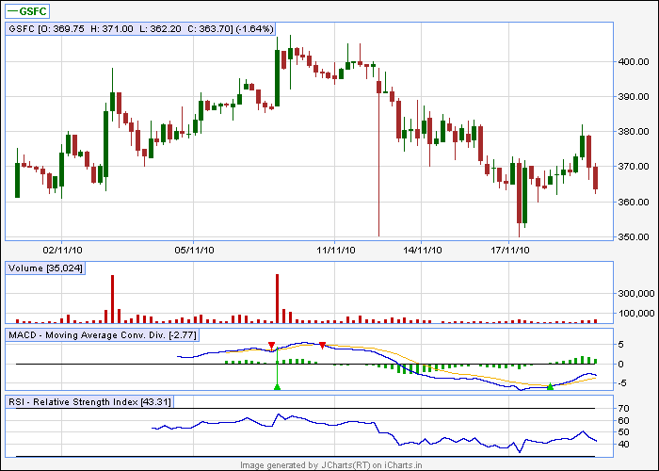
being bearish. It rocked
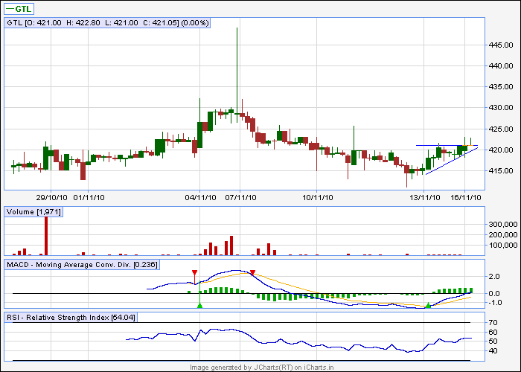
altogether bullish
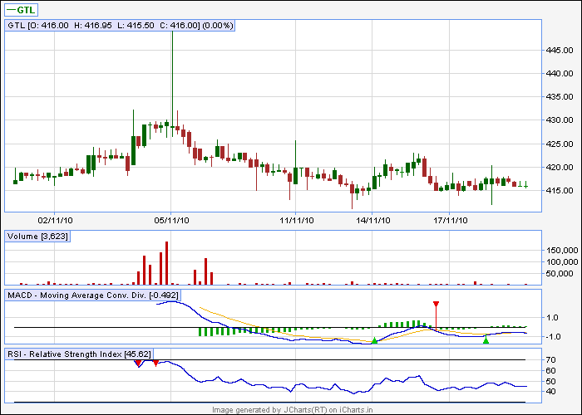
choppy!!!
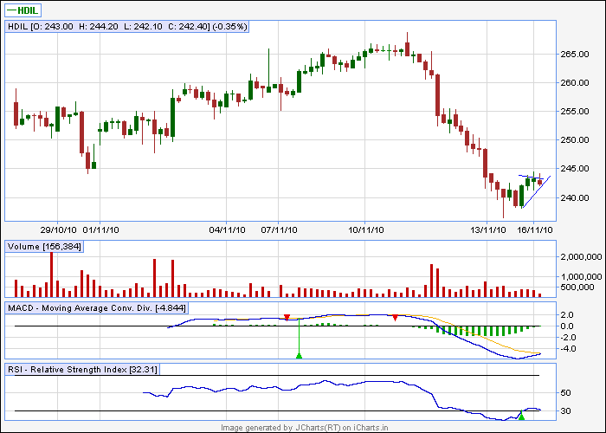
as per classical rule, we need to wait as macd is not bullish yet but going to be bullish

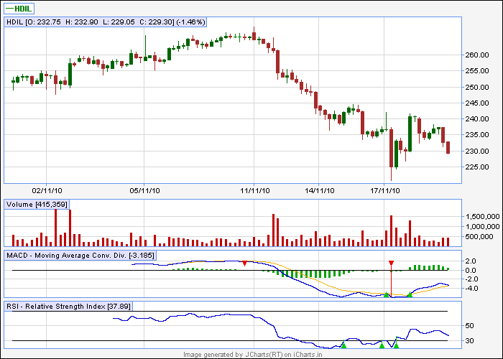
result of impatience!!!!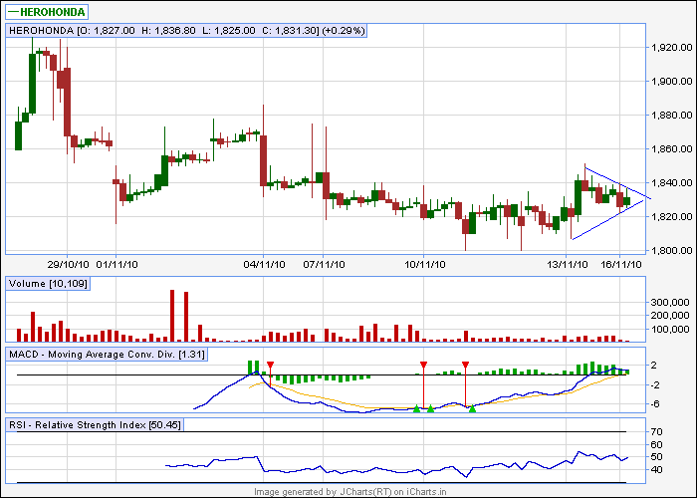

pennant. Indicators are bullish

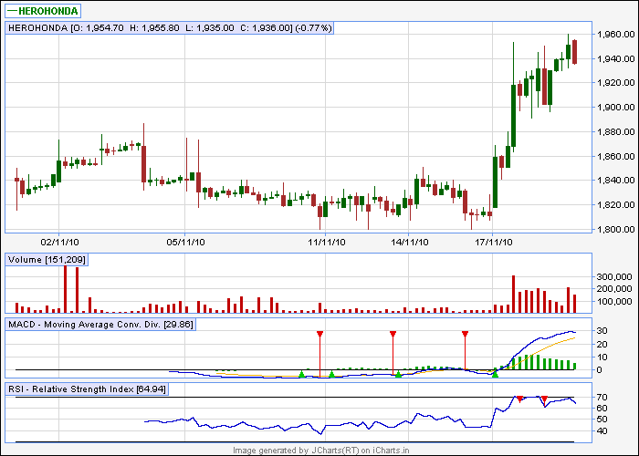
given a strong bo, but not from the designated bo level, went down from that level and then given bo
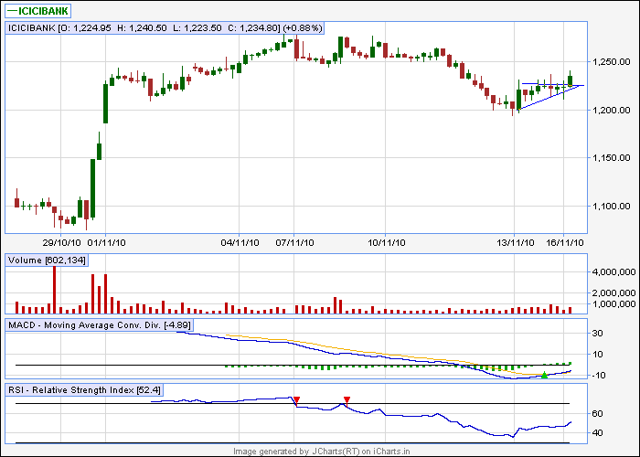
Altogether bullish pattern
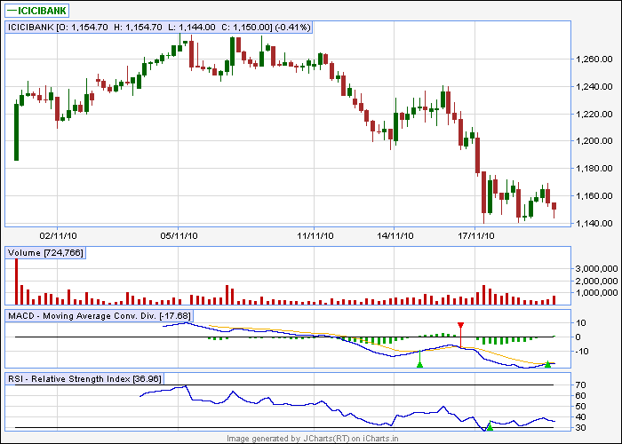
disaster is a small word to describe

inshort, we can conclude that during fundamentally driven or particularly during panic driven market this set up is a big zero

