ADX - Average Directional Index
The Average Directional Index (ADX), is generally used as a secondary indicator during technical analysis. It measures the strength of a prevailing trend but is not a directional indicator. The Average Directional Index (ADX) indicator is a combination of the positive directional indicator (+DI) and the negative directional indicator (-DI). The +DI tracks the upward trend of the stock, while the -DI tracks the downward trend. The Average Directional Index (ADX) indicator combines the two and produces a unified trend strength indicator. It is a fairly slow indicator and one must be careful in applying it because it takes time to adjust to market moves.
Average Directional Index Technical Analysis
ADX < 20 - indicate a non-trending (sideways/rangebound) market with low volumes.
cross of ADX above 20 - indicate the start of a trend (either up or down).
ADX > 40 and begins to fall - indicate the slowdown of a current trend, possibly even a reversal.
Though the indicator's fluctuations are in a range from 0 and up to 100, it seldom goes over a point of 60. A value lower than 20 demonstrates a weak trend; if the value is over 40 it shows a strong trend, whether it is an upward or downward trend.
Like most indicators used for technical analysis, there are some general ways in which the Average Directional Index (ADX) indicator is used to generate signals - crossovers, ranging, reversals, and DI crosses. In the case of the ADX, the indicator uses crossovers of its +DI and -DI, as well as levels associated with the calculation.

Technical Analysis with ADX Ranging
One way traders will use the Average Directional Index (ADX) in their technical analysis is as a confirmation of whether or not a security is trending, and to avoid choppy periods in the market where many find it harder to make money. In addition to a period where the ADX is below 20, we recommend not trading a trend based strategy when the ADX line is below both the +DI Line and the -DI Line.

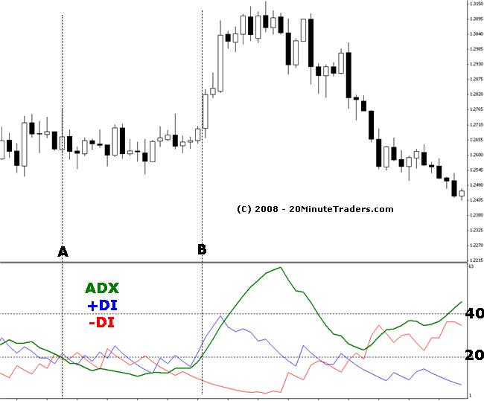
Technical analysis of the above graph shows us the Average Directional Index (ADX) between points A and B is below the +DI and -DI as well as being below 20. The market is definitely ranging, where profit becomes more difficult. This is definitely not a time for a trend based trading method.

ADX Crossovers Technical Analysis
Another way that traders use the ADX is to identify the potential start of a new trend in the market. When the Average Directional Index (ADX) crosses above the 20 line, this indicates a possible new trend. The longer the market has been ranging, the greater the chance this is a true crossover.
To catch a trend in its early stages, you might look for securities with an ADX that advances above 20. Also, an ADX decline from above 40 might signal that the current trend is weakening and a trading range may develop.
As the Average Directional Index (ADX) indicator is non-directional, it does not show whether the market is in an uptrend or a downtrend but simply how strong or weak the trend. When the ADX line is above 40 and rising this is indicative of a strong trend, and when the ADX line is below 20 and falling this is indicative of a ranging market.

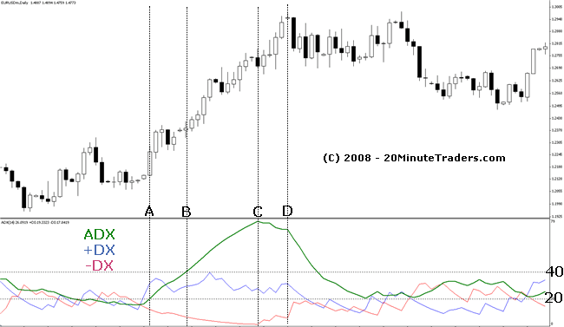
Technical Analysis of the above graph shows us many things:
The ADX approaching point A is below 40 and falling, and eventually even dips below 20. Notice the price during that period is very choppy. Basically it is a sideways market. Even short term trading would be difficult during this period.
At point A, the Average Directional Index (ADX) has crossed above 20. While above the -DI line, it is still below the +DI line, so we may want to wait for confirmation or check another indicator. However, notice the trend is definitely in an upward trend between points A and B, with a small retracement exception. Technical analysis shows us that we could have made some short term gains during this period, but the ADX still is below 40.
Once the ADX crosses 40 at point B, we can see that the trend continues to move upward strongly. Remember, the Average Directional Index (ADX) is an indication of trend strength. As the trend continues, the ADX keeps increasing to about 76 at point B. The Average Directional Index (ADX) rarely reaches over 60, and when it does, we recommend caution as it could be approaching exhaustion.

Technical Analysis with ADX Reversals
Another way traders use the Average Directional Index (ADX) is as an indication of trend reversals. When the ADX is trading above both the +DI line and the -DI line and then turns lower this is often a signal that the current trend in the market is reversing and traders will position themselves accordingly. Especially if the ADX at the time of the reversal is over 60.
Using the same graph as the previous discussion above, between points C and D we see the ADX turn and start moving down. The trend is still fairly strong, as we see the price continue to increase, but the movement is slowing, as indicated by the ADX value.
Finally we see the ADX drop sharply, and move back down below the 40 range, almost to the 20 level. Technical analysis of this period shows us how it indicates a choppy or sideways market. However, for the traders that got into a long position between points A and B, there was substantial profit to be made. Thus, technical analysis of the Average Directional Index (ADX) can be quite useful.

ADX +DI and -DI Cross Technical Analysis
Some traders use the ADX and DI indicators to signal trades. While we don't recommend this as the only technical analysis you use due to the ease of false signals, it can be quite informative. The basic signals are to trade long when the +DI crosses above the -DI (as this is a sign that the Bulls are winning out over the Bears) and to trade short when the +DI line crosses below the -DI (as this is a sign that the Bears are winning over the Bulls).
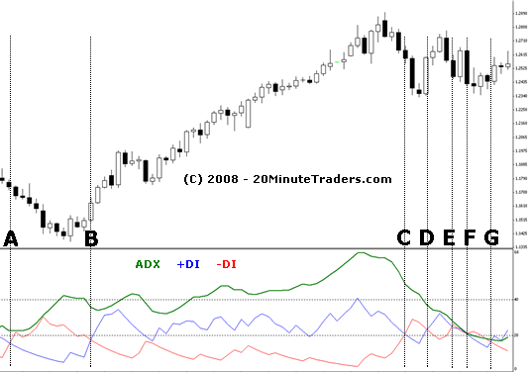

Lets use the graph above for more technical analysis. At point A, we see the -DI has crossed above the +DI. This indicates a short signal, and indeed, prices are dropping. As the -DI goes up and the +DI goes down, widening the gap, we see the Average Directional Index (ADX) increasing in value showing strength of trend. Then the ADX levels off and starts to drop slightly, as the divergence of the -DI and +DI signals reduces. At point B, the +DI crosses above the -DI indicating a long position. We close our short position (for a profit) and open a long position. The trend increases in strength, as shown by the ADX, and prices climb steadily, again making us profitable.
However, at point C, we see the +DI and -DI cross again, indicating a short position. We close our long position (for a profit). If we were to open a short position, we'd see another cross at point D, which we'd then close our short and go long, then another cross at point E, F, and G. Each time, based on the DI Cross alone, we would be losing money on each of those trades, since the price hasn't moved enough for profitability. So how has our technical analysis failed? Well, it hasn't. It is doing exactly what it is supposed to do. Our technical analysis interpretation is flawed. Taking such a basic indicator as our sole source of transaction signals is usually a bad idea. However, what if we were to also take into account the ADX? Maybe we only enter the trade if the ADX is increasing? Or above 20, or above 40? Maybe we look at a completely different indicator for confirmation? The point we are trying to make is that you must have a good trading method. The Average Directional Index (ADX) can be one indicator used in that trading method, but like all indicators, it should not be used as the sole indication. Try it, test it, find what works best for your trading method.

Average Directional Index Calculation
The Average Directional Index (ADX) is derived from two other indicators, also developed by Wilder, called the Positive Directional Indicator (+DI) and the Negative Directional Indicator (-DI).
ADX(t) = ( (ADX(t-1) * (n-1)) + DX(t) ) / n
n = smoothing period
DX(t) = ( 100 * (+DI(t) - -DI(t)) / (+DI(t) + -DI(t))
+DI = Positive Directional Movement = MAX (H(t) - H(t-1), 0)
-DI = Negative Directional Movement = MAX (L(t) - L(t-1), 0)
The Average Directional Index (ADX) is a derivative of the Directional Movement Index (DMI). First, the largest part of the current period's high or low that is outside of the previous period's high or low range is calculated. Then, the largest part of the current range above the previous range is taken as +DI. Conversely, the largest part of the current range below the previous range results in the value for -DI. The range increment is the current period's True Range. The Directional Movement is then divided by the True Range to make the Directional Movement relative to the True Range.
The standard calculation uses 14 trading periods as the basis for the calculation. This should be modified to fit your trading method. Using a shorter period will cause the ADX indicator to be more volitile, and therefore should be used for shorter term trades. Using a longer period will cause the ADX indicator to be less volitile, and therefore should be used for longer term trades.
Fortunately, most charting software have a built in ADX indicator, so its just a matter of selecting your desired parameters and watching the display giving you fairly accurate results so you can concentrate on technical analysis.

Average Directional Index Summary
Readings for the Average Directional Index (ADX) usually range between 20 and 40. Readings above 20 and rising indicate a trending market while readings below it indicate a consolidating market. Moreover, readings above 40 and falling tend to suggest that the market's prevailing trend is losing strength.
Also, signals can be indicated by looking at where the +DI and -DI lines cross each other. When the +DI crosses above the -DI from below, it is a bullish signal. When the -DI crosses above the +DI from below, it is a bearish signal.
The ADX is a standard component on any basic technical chart used for technical analysis. The Average Directional Index focuses on the strength of trend of the security and is a great indicator used for technical analysis. It is important to note that the Average Directional Index (ADX) is often not used as the sole generation of buy and sell signals but used in conjunction with other indicators and chart patterns. This relatively simple indicator can quickly be incorporated into any trading strategy. As with any indicator, always experiment with it to find the best match for your trading method and technical analysis.

