Please note that this is the notes prepared from various articles: this is not my own presentation/interpretation of things. I request you to treat this as my trading diary. I request suggestions from one and all. My self being a swing trader, most of the topics relate to this.

My view of trading.

The math in successful trading:

Let me present like this. If you are throwing a coin 100 times, math says that, it is likely (probable) that you get 50% of times heads and 50% of times tails. Further, also it says that the probability of the above statement increases with the increase of the number of times you throw the coin. That means if you throw 1000 times it is even more likely (even more probable) that you get 50% of times heads and 50% of times tails.

Seems irrelevant?

(1) Now you have this case. If you take up a trade, there are two probabilities. You win 50% of times and you loose 50% of times. How can we be benefited form this scenario? Now if each time you win you get 2% and each time you loose you loose 1%. You are finally at benefit. This is to say that the money management/risk management are more important that your technical analysis. So take up the trades that have 1:3 risk reward ratio (or at lease 1:2 risk reward ratio) to turn the math (statistics) in your favor. Know your stop loss before you trade.
(2) Now you can even enhance your profits by adopting a strategy that wins more than that looses. As far as I know, there is no trading strategy that wins all the times. Best of the strategies have 60-75% of the probability of winning trades.
(3) There are good times and bad times for any strategy. Know when not to trade your strategy to further your profits, by cutting your losses. A trend following strategy fails during a ranged/sideways market. Similarly capturing tops/bottoms (against trend strategies) fail during strong trends and result in big losses.
(4) Market is trending only 20-30% of the times. This is when a trader gets extremely good profits. Remaining times the market remains sideways. So one need to have the skill to understand, if market is trending or going sideways, as such one must be having at least two strategies to handle these two different kinds of markets.
(5) Understand that 80% of profits of a successful trader come from 20% of trades. This is possible only if one follows the basic rule of trading “run the winning trades (by trailing stops) and cut the loosing trades”.

I am not a successful trader, am I a trainer now? Funny,

I shall add points to this as and when necessary and keep updating this file.

Coming to the part of technical analysis I would like to discuss the following topics (topic by topic, gradually, when ever I find time, keep editing this, on the advice of experts and ultimately we have great book for beginners)

Getting the big picture.
Timeframes (Goals, objectives and strategy for each timeframe)
Trends
Trend lines
Support/Resistance (trend lines, swing high/swing low, moving averages, Fibonacci, pivot points)
Moving averages.
Momentum indicators (DMI, MACD only)
Trend identification
Oscillators (RSI, CCI)
Fine tuning entry/exit.
And finally, some strategies to handle trending/trading markets.

Advanced:
The three parameters of trading: price, volume and time

CATCH THE BIG PICTURE: WHERE ARE WE?

The simplest method of understanding the general market behavior is to know about the hypothetical chart I present here, called the master chart. The idea here is that markets will at one of these several stages at any point of time. That is, at any point of time, the markets are in (a) trending (up or down) condition or (b) Trading (sideways/range-bound) condition or (c) changing (trending to trading/trading to trending) condition.

Master Chart: this is a hypothetical figure only to explain different conditions of market.

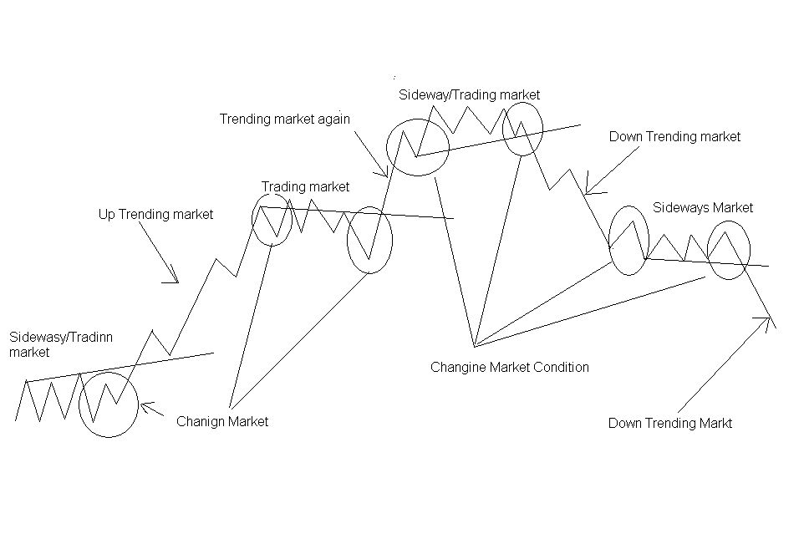

Master chart: Where are we?
It is crucial to know “where are we?” in the master chart. Please note that markets become “sideways/range-bound” at least for a brief period before resuming a trend or at the end of each trend. Also note that at the end of each sideways/range-bound market condition there is a possibility of trending market either in up or down direction. Approximately, 70% of the time markets are range bound (trading) condition or changing condition and only about 30% of the time markets are trending. The first step towards swing trading is to identify the present condition on the master chart. Here it is notable that a seasoned trader gets 70% of the profits in trending markets and 30% of his profits from the sideways market, of course, after some loosing trades during changing market.

Therefore, one needs to develop different strategies to trade different market conditions. This is where the technical analysis comes to our rescue to understand the trend and adopt suitable strategy in each condition.

Now here is chart of nifty over past few years and compare this:

(Nifty weekly line chart over few years)
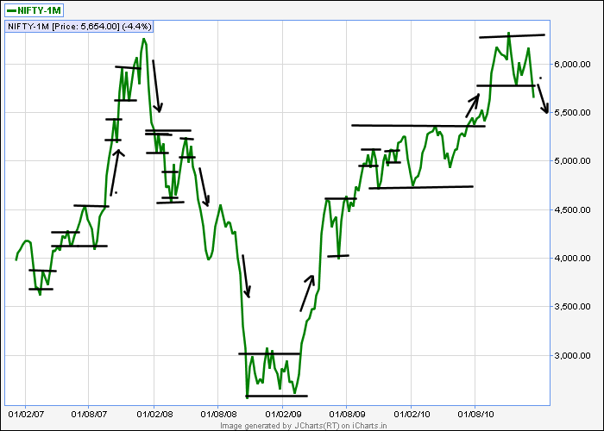

Nifty chart daily over 1 year:
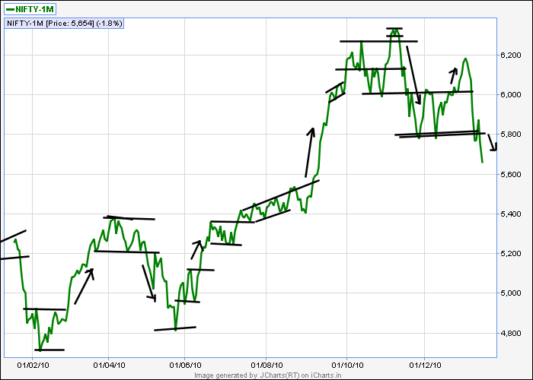

Nifty Hourly Chart over one month
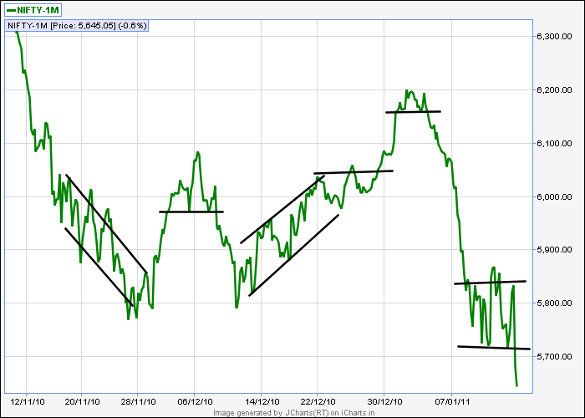

So the process is same. A sideways market in weekly chart may appear as trending market in daily chart and a sideways market in daily chart may appear as trending in hourly chart. And so on. The point here is to understand what are our objectives? What we expect from trading? Depending on these questions one has to choose the timeframe for trend identification and stick to it. If you have chosen one timeframe and start looking “trend” in another “irrelevant” time frame the entire picture changes. So choose one timeframe for getting the trend, according to you objectives and go to the (one step) higher timeframes only to get the big picture and filter the trades and (one step) lower timeframes only to fine tune you entry/exit.

Look at ABAN chart, in hourly chart you get a trend and daily chart shows sideways movement. If you go long, viewing up trend in hourly chart, mean while it is at the resistance in daily chart you get caught up.

Trend Lines and Trend Identification

What is a trend? A trend is simply, the persistence of a security's price to move in a particular direction. Also, a trend is in effect till it is reversed or broken. A trend can be bullish, bearish or flat (sideways). However markets never go up or down in a straight line. There are always corrections (in bullish markets) and pullbacks or relief rallies (in bearish markets). By identifying trends and reversals, you can enter and exit trends at the correct time and earn excellent profits with minimum risks.
Follow the trend for profitable trading: The easiest and safest way to earn excellent profits consistently is to simply follow the trend and trade.
Advantages: By following the trend, you will always be on the "right" side of the market. Trend analysis helps distinguish emotional decisions ("I think it's time to sell...") from analytical decisions ("I will hold until the current rising trend is broken"). Trend analysis will also discourage you from going short in a bullish market or going long in a bearish market.
Could it be bull market while bear market?
When ever we talk of trend, we must bear in mind, what time frame we are following and what amount of data we are considering. For a long term player it could be an up trend while for a short term player it could be a down trend. So there are always different views about the market as follows.
Very long/long term view (for investors), intermediate view, short term view (for positional traders), very short term view (for swing traders) and intraday view (for day traders/scalpers, of course scalpers do not care for the trend). So we must speak of trend in conjunction with the above different views of the market. So without the term view/period there is not meaning for trend.
Short, Intermediate and Long Term Trends; simply put, short, intermediate and long-term trends are the three kinds of trends that we see each day in our study of technical analysis. "A trend is your friend", is just one of the sayings that have come out of the study of primary as well as secular trends. Given the understanding that the psychology of the markets actually moves the markets, we can acknowledge that psychology develops and ends the trends we are going to look at today.
Learning how to identify the trend should be the first order of business for any student of technical analysis. Most investors, once invested in an uptrend, will stay there looking for any weakness in the ride up, which is the indicator needed to jump off and take the profit. The bull and bear markets are also known as primary markets, and history has shown us that the length of these markets generally last from one to three years in duration. If we consider recent history, the current markets are showing the early signs of making the turn from a three-year bear market to the makings of an early bull market.
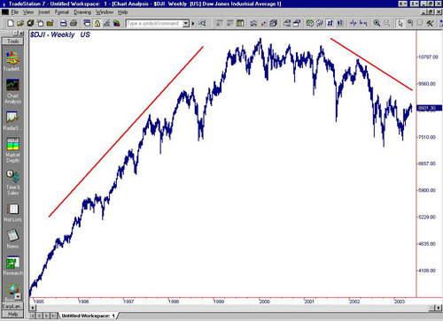

You can see in the chart that the bull market preceding the most recent three-year slide lasted much longer than the average trend duration of which I spoke above, and if certain economic factors don't soon resolve themselves, the bear market may be somewhat longer than most would like to see.
A secular trend, one that can last for one to three decades holds within its parameters many primary trends, and, for the most part, is easy to recognize because of the time frame. The price-action chart, for a period of 25 years or so would appear to be nothing more than a number of straight lines moving gradually up or down. Have a look for a moment at the chart of the S&P 500 below. I have taken the chart back to early the 1980s to show you the rise of the market leading up to the turn of the century.

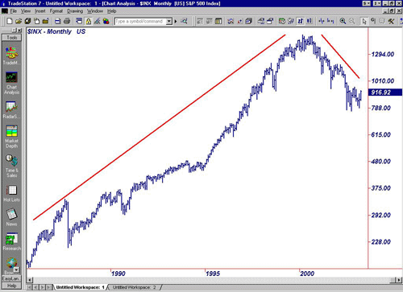
Within all primary trends are intermediate trends, which keep the business journalists and market analysts constantly, searching for the answers for why an issue or a market suddenly turns and heads in the direction opposite to that of yesterday or last week. Sudden rallies and directional turnarounds make up the intermediate trends and, for the most part, are the results of some kind of economic or political action and its subsequent reaction. History tells us that the rallies in bull markets are strong and that the reactions are somewhat weak. The flip side of the coin shows us that bear-market reactions are strong and that the rallies are short. Twenty/twenty hindsight also shows us that each bull and bear market will have at least three intermediate cycles. Each intermediate cycle could last as little as two weeks or as long as six to eight weeks.

Trend lines-
Technical analysis is built on the assumption that prices trend. Trend Lines are an important tool in technical analysis for both trend identification and confirmation. A trend line is a straight line that connects two or more (Preferably three) price points and then extends into the future to act as a line of support or resistance.

The significance of a trend line: Trend lines are a part of many techniques and strategies designed to show how price has trended in the past to predict movements in the future. Commonly, trend lines are used as support and resistance, indicating where investors favor buying or selling. Trend lines can also be used as a part of a comprehensive trading plan to show the general direction of the market, without any interest paid to support and resistance.
The many different kinds of trend lines: Trend lines can be horizontal or vertical and anywhere in between. Generally, a trend line is drawn with a slope to mark even the most modest up-trends or down-trends in the market. Horizontal trend lines (called support/resistance line) are also very popular for showing support and resistance lines at a common price point. It is fairly common that a stock will trade wildly around a common price point and do it even over the course of time. “Round” numbers such as $25 or $50 are more likely to be a place for a horizontal support or resistance because traders like to use round numbers as entry and exit points.
A trend line is worth its weight in gold: Professional traders, specifically day traders and swing traders have success using trend lines because trend lines are a better indicator over the short run than the long run. For long-term investors, trend lines usually fall out of favor because they provide very little trades over the long term and are not as effective over long periods as they are short term. The volume that can be found in short term trading mostly focuses around the small support and resistance points, thus making trend lines very important to day and swing traders.
Argument against a trend line: There has been much debate between academia and traders, regarding the worthiness of trend lines in market data. The academic theoretical position stipulates that a theoretical market is so perfect in nature that trending would not occur. The viewpoint of the trader focuses on the inner workings of the minds of hundreds of thousands of other traders, who all find certain price points more interesting and lucrative than others. The argument against trend lines is that they are self-fulfilling prophecies and do not work out to real world gains. However, the fact is that trend lines are used simply as guidance for future price movement based on how day traders value today’s positions, and many traders use technical analysis profitably.
Remember: A trend is in force till it has reversed. A trend has ended ONLY if there are clear signal that the opposite rend has started. Stronger the trend, stronger the trend reversal signal (and vice versa)
How to draw a trend line? The first consideration when looking at any market is the direction of the long term trend. Trend lines illustrate the direction of the market movement and provide a primary consideration in any analysis. Keeping in mind that the market can move in more than one direction the following applies when drawing a trend line:

Drawing Up Trend-Lines
Up Trends consist of a series of successively higher highs and lows. The trend lines above have been drawn by connecting as many successive lows as possible (along the bottom of the price range). An up trending trend line represents major support for prices as long as it is not violated.
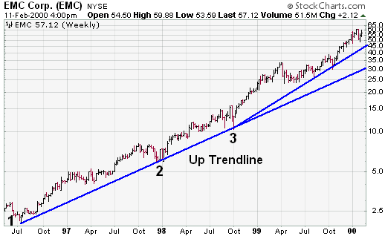
Let’s put it in the form of a formula.
Uptrend = Higher Highs (desirable but not necessary) + Higher Lows (is a must)
This property of up-trends is what separates it from a trading range. Even though a trading range may rally up or down in price, unlike the trend, the trading range only manages to rally prices back to a similar level as seen previously. The “strong trends” however, ignores previous highs ands lows and continues in its direction.
Drawing Down Trend-Lines
Down Trends consist of a series of successively lower highs and lows. Down trending trend lines are drawn by connecting as many successive highs as possible as shown above (along the top of the price range). As long as prices remain below the downtrend line, the downtrend is solid and intact. A break above the downtrend line indicates that net-supply is decreasing and that a change of trend could be imminent. A down trending trend line, represents major resistance for prices, as long as it is not violated.

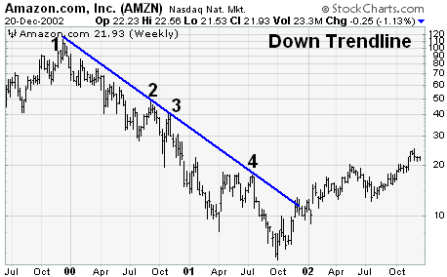

Let’s put it in the form of a formula.
Downtrend = Lower Highs (is a must) + Lower Lows (is desirable but not necessary).
Drawing Trend-lines; important points to remember
What makes the task of identifying a new trend even harder is that technical indicators have a bad habit of contradicting each other. When identifying a new trend it is important to stick to just a handful of indicators. Try not to complicate things by analyzing all that are available to you.
(a) As a rule of thumb a trend-line has to connect three points before it becomes valid, just as with drawing support and resistant lines.
(b) It is best to draw trend lines through areas of congested prices, rather than extreme points. These areas show where the majority of the market have rejected the recent low and pushed prices back above the trend-line.
(c) Sometimes when we draw a trend-line we find that prices break it too quickly, but then the chart reveals that there was indeed a trend, but it was not as we had first drawn it. This can be partly due to a few factors, but let’s look at an example.
When drawing a trend-line on an uptrend we want to join recent lows. The more lows we join, or the more that bounce off our trend-line, the more technically correct it is. When drawing a trend-line on a downtrend we want to join recent highs. The more highs we join, or the more that bounce off our trend-line, the more technically correct it is.
Draw the line above the price action and extend it into the future to help predict future price action.

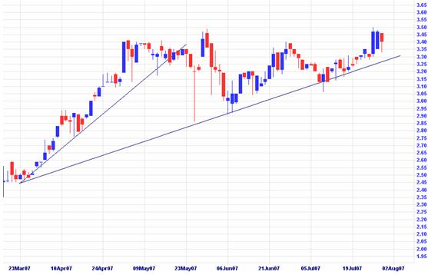
Here we have two trend-lines, but which one is the true indicator of the trend. Well the answer depends on your trading plan. Both start at the same point and each has its benefits depending on that trading plan you have in place. The smaller of the two trend lines suits those with a short term view. Others, who are looking for long term profits can choose to trade with the longer trend line. and at present this may continue to for months ahead if prices break through the resistance point at around $3.50.
(d) Validity: The general rule in technical analysis is that it takes two points to draw a trend line and the third point confirms the validity. As long as prices remain above the trend line, the uptrend is considered solid and intact. A break below the uptrend line indicates that net-demand has weakened and a change in trend could be imminent.
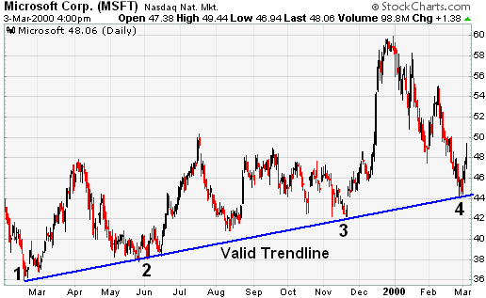

(e) SPACING OF POINTS: The lows used to form an uptrend line and the highs used to form a downtrend line should not be too far apart, or too close together. The most suitable distance apart will depend on the time frame, the degree of price movement, and personal preferences.
If the lows (highs) are too close together, the validity of the reaction low (high) may be in question. If the lows are too far apart, the relationship between the two points could be suspect. An ideal trend line is made up of relatively evenly spaced lows (or highs). The trend line in the above MSFT example represents well-spaced low points.
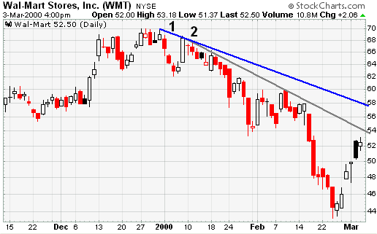

(f) ANGLES: As the steepness of a trend line increases, the validity of the support or resistance level decreases. A steep trend line results from a sharp advance (or decline) over a brief period of time. The angle of a trend line created from such sharp moves is unlikely to offer a meaningful support or resistance level. Even if the trend line is formed with three seemingly valid points, attempting to play a trend line break or to use the support and resistance level established it will often prove difficult. the angle of the trend directly reflects the intensity of emotional commitment from the participating market crowd. A steep movement shows that the crowd is in a panic, and like most panics it is not likely to last long. A steady movement shows that the crowd has much more in control with their trading decisions. The lack of panic means the trend is likely to last longer.
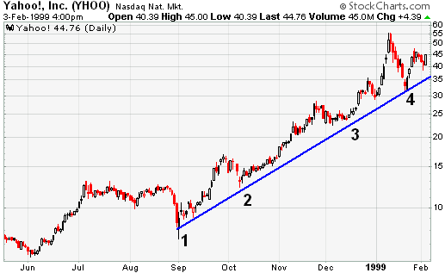

The trend line for Yahoo! (YHOO) was touched four times over a 5-month period. The spacing between the points appears OK, but the steepness of the trend line is unsustainable, and the price is more likely than not to drop below the trend line. However, trying to time this drop or make a play after the trend line is broken is a difficult task. The amount of data displayed and the size of the chart can also affect the angle of a trend line. Short and wide charts are less likely to have steep trend lines than long and narrow charts. Keep that in mind when assessing the validity and sustainability of a trend line.
(g) Repetition of Trend-line Angle; Stocks also have a habit of repeating the angle of the trend-lines. You can use this tactic to draw preliminary trend-lines. Observe.
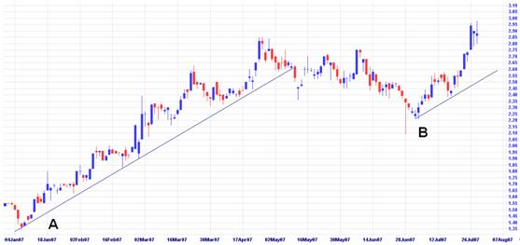
Trend-line A and trend-line B are of the same angle. Preliminary trend-line B although only connected by two lows however provides a valid guide for future price action. One more connection from price to this trend-line would make it valid. Whether we take this trade or not however depends on further analysis.
A possible strategy is to measure the angle of the trend and rate it according to that angle. If it is too steep for your trading strategy then pass up the trade. If the angle is too small and you would have to hold a position for too long, you may want to look for better opportunities.
(h) INTERNAL TREND LINES; Sometimes there appears to be the possibility for drawing a trend line, but the exact points do not match up cleanly. The highs or lows might be out of whack, the angle might be too steep or the points might be too close together. If one or two points could be ignored, then a fitted trend line could be formed. With the volatility present in the market, prices can over-react, and produce spikes that distort the highs and lows. One method for dealing with over-reactions is to draw internal trend lines. Even though an internal trend line ignores price spikes, the ignoring should be within reason.
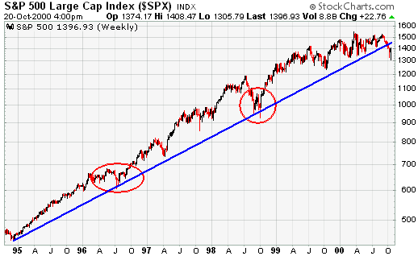
The long-term trend line for the S&P 500 ($SPX) extends up from the end of 1994, and passes through low points in Jul-96, Sept-98 and Oct-98. These lows were formed with selling climaxes, and represented extreme price movements that protrude beneath the trend line. By drawing the trend line through the lows, the line appears to be at a reasonable angle, and the other lows match up extremely well.
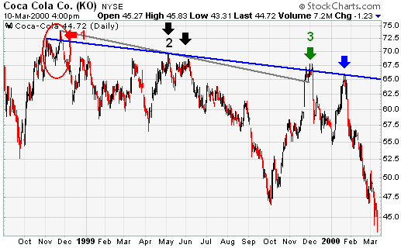
Sometimes, there is a price cluster with a high or low spike sticking out. A price cluster is an area where prices are grouped within a tight range over a period of time. The price cluster can be used to draw the trend line, and the spike can be ignored. The Coca Cola chart shows an internal trend line that is formed by ignoring price spikes and using the price clusters, instead. In October and November 1998, Coke formed a peak, with the November peak just higher than the October peak (1). If the November peak had been used to draw a trend line, then the slope would have been more negative, and there would have appeared to be a breakout in Dec-98 (gray line). However, this would have only been a two-point trend line, because the May-June highs are too close together (black arrows). Once the Dec-99 peak formed (green arrow), it would have been possible to draw an internal trend line based on the price clusters around the Oct/Nov-98 and the Dec-99 peaks (blue line). This trend line is based on three solid touches, and it accurately forecasts resistance in Jan-00 (blue arrow).

CONCLUSIONS; Trend lines can offer great insight, but if used improperly, they can also produce false signals. Other items - such as horizontal support and resistance levels or peak-and-trough analysis - should be employed to validate trend line breaks. While trend lines have become a very popular aspect of technical analysis, they are merely one tool for establishing, analyzing, and confirming a trend. Trend lines should not be the final arbiter, but should serve merely as a warning that a change in trend may be imminent. By using trend line breaks for warnings, investors and traders can pay closer attention to other confirming signals for a potential change in trend.
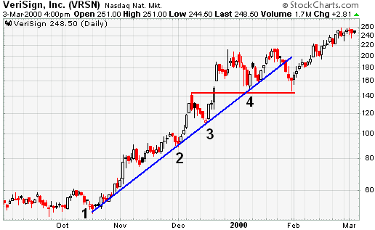
The uptrend line for VeriSign (VRSN) was touched 4 times, and seemed to be a valid support level. Even though the trend line was broken in Jan-00, the previous reaction low held, and did not confirm the trend line break. In addition, the stock recorded a new higher high prior to the trend line break.
Channels, Support & Resistance; Trend-lines also offer areas of support and resistance. The trend-line in an uptrend provides an area of support while the trend-line in a downtrend provides an area of resistance. Drawing channel lines above or below the trend-lines can help to complete the picture on either the downtrend or uptrend. To construct a channel on an uptrend draw a parallel line connecting recent highs. To construct a channel on a downtrend draw a parallel line connecting recent lows. Here is an example using the same graph as above. Channels help traders’ timely entry and exits when trend trading. If used in a system with other indicators, they can provide a powerful tool. While channels can provide areas of support and resistance for a trend, their value as true support and resistance is weak. It is much easier for the market to break a trend or channel line than it is to break through true areas of support or resistance. There is one other important character that should be noted about trend-lines acting as support and resistance. That is that a trend-line, once broken can act as a future support or resistance line.
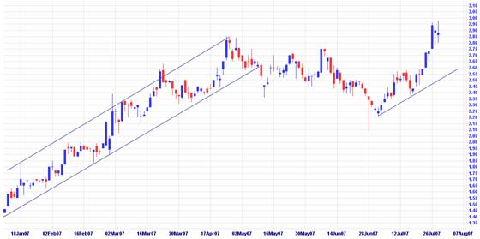

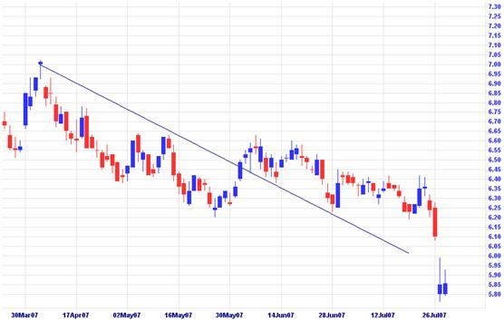
The trend-line shows above acts as an area of resistance, but once prices break the trend-line they start to approach it from above. The trend-line’s role has changed; it now acts as a support line for the new trend, which is then broken in July.
Trend-lines Strength: the strength of a trend-line can be determined by three factors.
Timeframe: The longer the timeframe of a trend, the more valid it is in the market and the stronger it is. A trend on a weekly chart is stronger that the trend on your daily chart.
Length: The longer the length of the trend, the better it reflects mass market behavior over time. The longer the trend-line, the greater its inertia and the more force required to break it.
Contacts: Every time prices bounce off the trend-line it reconfirms its ability to withstand any retaliation from the market that pushes against it. Remember it takes three contacts to confirm a trend-line, any more above that number just adds to its strength.
Volume & Trends: Observe volume levels throughout the trend. During an uptrend, volume should expand as prices are pushed higher, while declines should occur on smaller than average volume levels. Be wary if the decline back to the trend-line occurs on larger than average volume, it could spell the end of the trend. Be ready with your stop loss plan in place.
Trading Guidelines; The rules for trading a trend can be simple and blunt. Trends also offer the amateur some grace. A sloppy entry on a trend can often be forgiven, whereas a sloppy entry in a trading range can spell disaster. Later we will explore how different technical indicators can help us to time our entry into a well established trend. In the mean time, let’s look at some basic rules for trading trends.
1. Always trade with the trend, do not try to second guess a well established trend, unless your analysis give you reason to trade in the opposite direction. Even then you should practice tight money and risk management to ensure errors in judgment do not hurt you. When the trend is up, trade from the long side and back your bucks with the bulls. When the trend is down, trade from the short side and back your bucks with the bears.
2. Pay attention to trends on larger timeframe charts. If the weekly chart shows a dominant downtrend but your daily chart is showing the start of a new uptrend, pay more attention to the trend on the weekly chart.
3. Measure the angle of the trend. The “steeper” the angle, the “lesser time” the trend is likely to last. If you are in for the short term this may present a good opportunity to place a quick trade. Those who prefer the less risky, longer term option should stay away from steep trend-lines and look for something with stability. If the angle of the trend-line is greater than 45 degrees, place a stop directly under your trend-line if you’re trading an uptrend. A fast moving uptrend can decline just as quick.
4. If you are trading an uptrend and prices accelerate above your trend-line, you can draw new trend-line to reflect this change in behavior. This is provided you can connect 3 points of contact to validate its existence. This does not mean you can draw a new trend-line if prices break through your original trend-line. Stick to your exit strategy and if it signals to get out, don’t adjust your trend-line just so you can stay in the trade. Reverse applies for those selling short.
5. When looking to enter into a trend, try and place your buy orders when prices pull back to the trend-line then bounce away. If you buy too far away from the trend-line, your stop loss position will be too wide and you will open yourself up to too much unnecessary risk. As prices bounce off the trend-line, place your buy order, and place your stop just below the trend-line. This ensures that any mistake in entry has the minimal impact on your trading capital.
ADVANCED CONCEPTS
SCALE SETTINGS: High points and low points appear to line up better for trend lines when prices are displayed using a semi-log scale. This is especially true when long-term trend lines are being drawn or when there is a large change in price.
An arithmetic scale displays incremental values (5, 10, 15, 20, 25, and 30) evenly as they move up the y-axis. A $10 movement in price will look the same from $10 to $20 or from $100 to $110.
A semi-log scale displays incremental values in percentage terms as they move up the y-axis. A move from $10 to $20 is a 100% gain, and would appear to be a much larger than a move from $100 to $110, which is only a 10% gain.
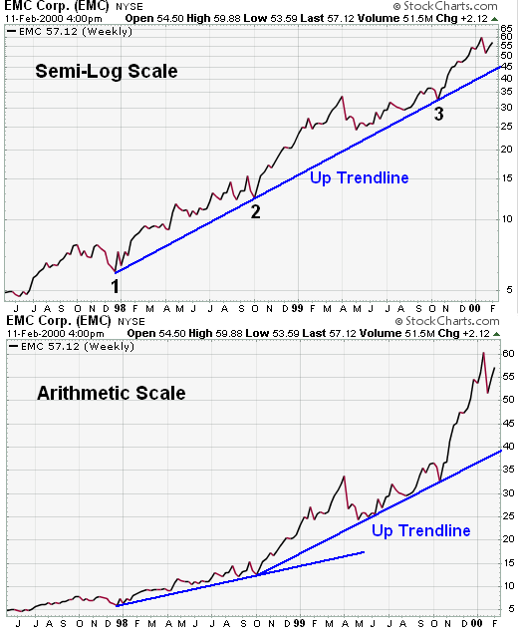
In the case of EMC, there was a large price change over a long period of time. While there were not any false breaks below the uptrend line on the arithmetic scale, the rate of ascent appears smoother on the semi-log scale. EMC doubled three times in less than two years. On the semi-log scale, the trend line fits all the way up. On the arithmetic scale, three different trend lines were required to keep pace with the advance.
