Recognizing Reversal Signals
These are two analogies to help explain the patterns of stocks as they transition between one move and the next move. When a stock is completing a move, it experiences a period of deceleration, which is referred to by chartist as price consolidation. Consolidation is one of the most important signals that a stock is about to begin a new move. The move can be a continuation in the same direction, or it can be a reversal in the opposite direction. The area of consolidation represents a battle zone where the bears are at war with the bulls. The outcome of the battle often defines the direction of the next move. As short-term traders, it is important to identify these areas of consolidation and enter a trade just as the new move is beginning. During the consolidation period or 'battle zone', traders, both long and short are patiently waiting on the sidelines watching to learn the outcome of the battle. As these winners emerge, there is often a scramble of traders jumping in with the winning team. The candlestick patterns gives the trader excellent clues on when this move is about to take place, and helps the trader time his entry so that he can get in at the very beginning.
There are four different consolidation patterns experienced by stocks. They are 1) Bearish Continuation, 2) Bullish Continuation, 3) Bearish Reversal and 4) Bullish Reversal.
The Bearish Continuation Consolidation Pattern: Several strong bearish candlesticks precede the Bearish Continuation pattern where the bears are clearly in control (Figure 12). The bears and bulls then begin to battle by pushing the stock up and down in price in a tightly formed consolidation zone. The narrowing size of the candlesticks toward a line of support indicates that the bears are winning the battle. The bulls finally weaken and allow the bears to penetrate the line of support, at which time the bears quickly conquer new territory by taking the stock to lower prices.
By recognizing the consolidation pattern the trader is able to short the stock just after the stock breaks the line of support, and profit from the sharp move downward. The cause of the sharp sell off is fueled by the emotions of the traders watching for the outcome of the battle. Traders, who bought the stock in the area of consolidation in hope of a rally off of support, are now scrambling to exit their losing positions. Traders who are short from the period before the area of consolidation are realizing that their original entries were correct and are adding to their winning positions.
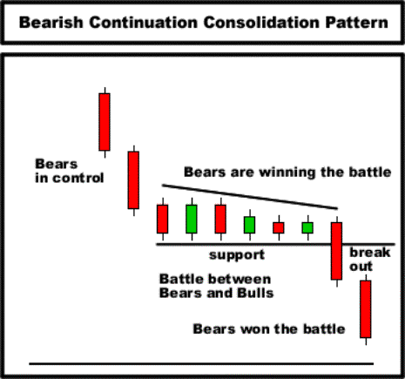
Figure 12
The Bullish Reversal Consolidation Pattern: Several strong bearish candlesticks precede the Bullish Reversal Continuation pattern where the bears are clearly in control (Figure 13). The bears and bulls then begin to battle by pushing the stock up and down in price in a tightly formed consolidation zone. The narrowing size of the candlesticks toward a line against upward resistance indicates that the bulls are winning territory from the bears. The bears finally weaken and allow the bulls to penetrate the line of resistance, at which time the bulls quickly conquer new territory by taking the stock to higher prices.
By recognizing the consolidation pattern the trader is able to buy the stock just after the stock breaks the line of resistance, and profit from the sharp move upward. The cause of the rally is fueled by the emotions of the traders watching for the outcome of the battle. Additional traders who jump in to buy the stock now that its strength has been confirmed fuel the sharp upward move. Traders who are currently short the stock in the area of consolidation waiting in hope of a breakdown, are now scrambling to cover their short positions. This buying action also fuels the fire pushing the stock to higher prices.
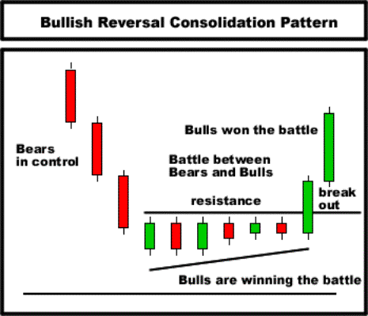
Figure 13
The Bearish Reversal Consolidation Pattern: Several strong bullish candlesticks precede the Bearish Reversal Continuation pattern where the bulls are clearly in control (Figure 14). The bears and bulls then begin to battle by pushing the stock up and down in price in a tightly formed consolidation zone. The narrowing size of the candlesticks toward a line of support indicates that the bears are winning the battle. The bulls finally weaken and allow the bears to penetrate through the line of support, at which time the bears quickly conquer new territory by taking the stock to lower prices.
By recognizing the consolidation pattern the trader is able to sell short the stock just after the stock breaks the line of support, and profit from the sharp spike downward. Additional traders who jump in to short the stock now that its weakness has been confirmed fuel the sharp sell off. Traders, who are currently long the stock in the area of consolidation waiting in hope of a breakdown, are now scrambling to sell their long positions. This selling action also fuels the fire pushing the stock to lower prices.
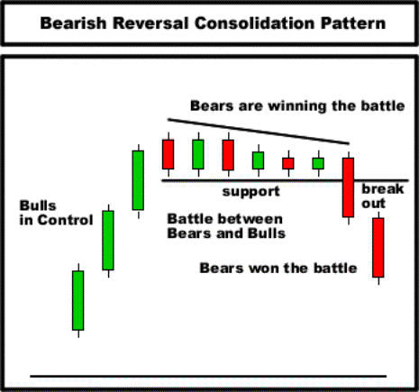
Figure 14
The Bullish Continuation Consolidation Pattern: Several strong bullish candlesticks precede the Bullish Continuation Consolidation Pattern where the bulls are clearly in control (Figure 15). The bears and bulls then begin to battle by pushing the stock up and down in price in a tightly formed consolidation zone. The narrowing size of the candlesticks toward a line of resistance indicates that the bulls are winning the battle. The bears finally weaken and allow the bulls to penetrate the line of resistance, at which time the bulls quickly conquer new territory by taking the stock to higher prices.
By recognizing the consolidation pattern the trader is able to buy the stock just after the stock breaks the line of resistance, and profit from the sharp move upward. The cause of the sharp sell off is fueled by the emotions of the traders watching for the outcome of the battle. Traders, who shorted the stock in the area of consolidation in hope of a sell off in the area of consolidation, are now scrambling to exit their losing positions. Traders who are long from the period before the area of consolidation are realizing that their original entries were correct and are adding to their winning positions.
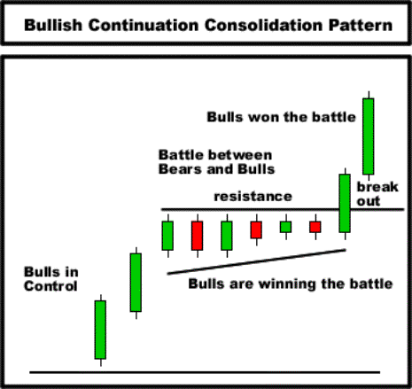
Figure 15

Increasing the Odds
As we learned in the last section, the best trading opportunities present themselves just after a breakthrough in price consolidation. Not every consolidation pattern; however, is tradable. There are additional patterns, which significantly increase the odds of the trade following through in the desired direction.
The tools, which we present, are 1) support/resistance 2) trends, 3) moving averages.
Support and Resistance: Support and resistance are general price areas that have halted the movement of stock in the past. Support and resistance lines are used to help access how much the stock price will remove before it is halted.
There are two main types of support and resistance; 1) Major price support/resistance, and 2) Minor price support/resistance
Major Price Support/Resistance: Major Price Support is an artificial horizontal line representing an area where a stocks downward movement was halted to give way to a new upward movement (Figure 16). Therefore, the price level is supporting the price of the stock. Similarly, Major Price Resistance is an artificial horizontal line representing an area where a stocks u ward movement was halted to give way to a new downward
movement. Therefore, the price level is resisting the price of the stock.
When considering a stock as a trading opportunity it is important to note the location of the nearest support and resistance levels. Stocks near areas of support make for better buy opportunities and stocks near areas of resistance make for better short opportunities. In the same way, the trader should be more cautious about shorting stock above areas of support, and buying stock near areas of resistance.
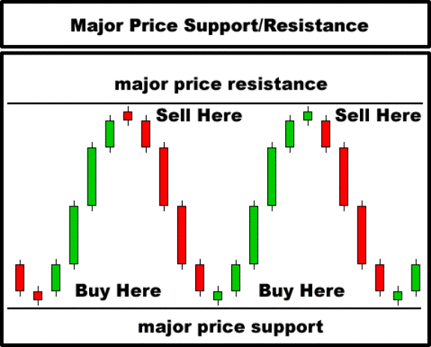
Figure 16
Minor Price Support/Resistance: Minor Price Support is an artificial horizontal line representing an area, which previously served as price resistance, but has now transformed to price support (Figure 17). Likewise, Minor Price Resistance is an artificial horizontal line representing an area, which previously served as price support, and has now transformed to price resistance (Figure 18).
When considering a stock as a trading opportunity it is important to note the location of the nearest support and resistance levels. Stocks near areas of support make for better buy opportunities and stocks near areas of resistance make for better short opportunities. In the same way, the trader should be more cautious about shorting stock above areas of support, and buying stock near areas of resistance.
For an in-depth analysis of how minor support & resistance works, see the free "Educational Section" of our main website at http://www.candlestickshop.com/free
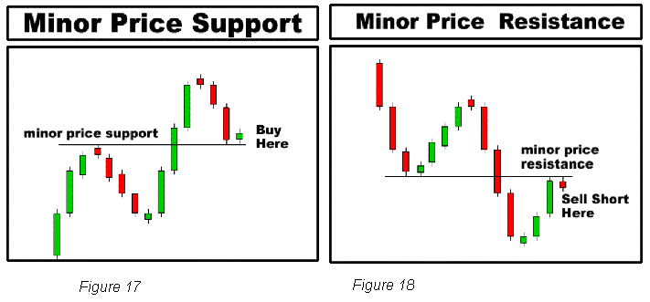
Trends:
Even the strongest stocks will need a period of rest through a pullback in price or a period of marking time with little to no price movement. A strong stock will often pull back in price as short to medium term traders take their profits off the table, and in the process, increase selling pressure, which will temporarily push the stock lower. A strong stock, after rest will often resume its rally after these slight pullbacks. The trader has better odds in his favor by playing the stock in the direction of the trend.
In otherwise, the trader should enter long positions only on up trending stocks that have pulled back for rest ready to resume the rally. Likewise, the trader should enter short positions on down trending stocks that have pulled back for rest ready to resume the decline (Figures 21& 22). A stock in a sideways pattern can be either bought or shorted if the stock is at strong price support or resistance.
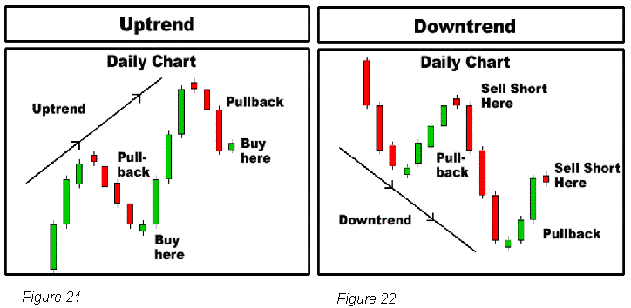
Moving Averages: Moving averages can be used as support and resistance levels. Stocks tend to rebound off of moving averages much in the same way that they rebound off major and minor support and resistance lines. A moving average can be plotted using any period; however, the periods that seem to provide the strongest support and resistance for short term trading are the 10MA, 20MA, 50 MA, 100MA and 200MA.
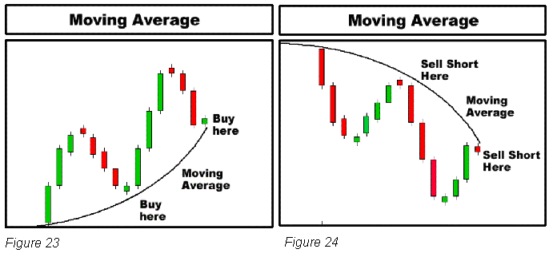

Candlestick Line Time Frames:

Dissecting a Candlestick; changing time frames when viewing candlestick patterns is useful tool when looking for patterns leading up to good trading opportunities.
For example, consider the Bullish Harami Pattern that is manifested on the Daily time frame chart (Figure 26).The same stock plotted on a 15 min time frame chart shows that the stock is actually setting up for a Bullish Reversal Consolidation pattern.
Using the Daily chart and the 15 min chart together make it easier to find possible trade opportunities. For example, the trader can scan for Harami setups on the Daily chart, and then pull up a 15 min chart to confirm the stock is experiencing a consolidation pattern preparing for a break out.
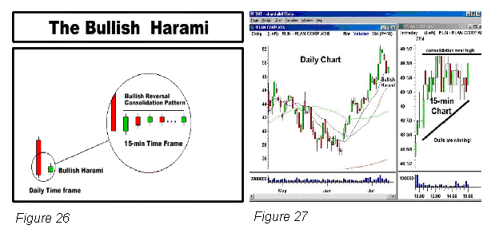

Daily Candlestick Play Instructions

1) Bullish Harami Candlestick Play Instructions:

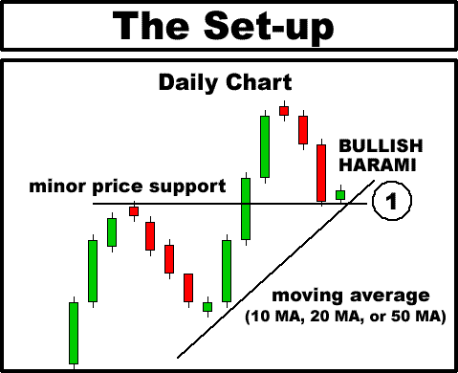
Step 1 - Look for a BULLISH HARAMI resting on MINOR PRICE SUPPORT, and/or a rising Major Moving Average (10 MA, 20 MA, or 50 MA) on the daily chart.
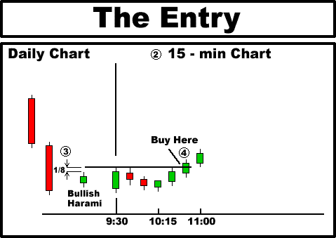
Step 2 - Pull up a 15 min. chart of the stock.
Step 3 - Note the high price of the previous day's daily HARAMI candlestick. Your entry point is 1/8th above this price.
Step 4 - On the following day, allow the stock to trade for 5 minutes before entering. Enter the stock only if it breaks above the entry criteria (1/8th above previous day's high) and only after it has traded for 5 minutes. If the stock does not break above the entry point, do not enter.
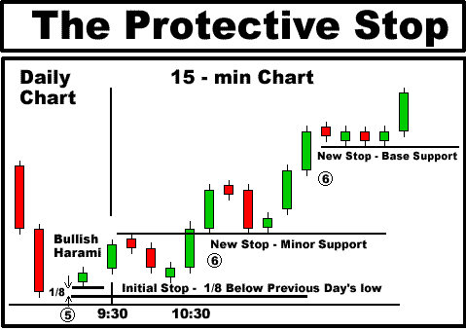
Step 5 - Place the initial protective stop 1/8 below the low of the previous day's HARMAI candlestick. Exit the stock for a small loss immediately if the stock breaks below this price.
Step 6 - Monitor the stock as it continues to rally upward. Look for areas of support (either minor price support or base price support) on the 15 minute chart, and re-adjust your protective stop price upward as the stock continues to rally. This will protect your profits, and/or minimize your losses if the stock should turn against you.
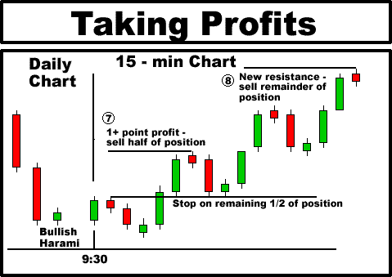
Step 7 - Monitor the stock on a 15 min. charts as it climbs upward, and stay in as long as the protective stop is not violated. Allow the stock to achieve 1 point or greater profit, and then look for signs of weakness. A reversal candlestick pattern on the 15 minute chart will serve as a good indicator for a reversal point. After the price reaches an area of resistance and weakens, sell half of your position. This may occur on the same day as entry, or on the following day, depending on the strength of the stock. Maintain the latest protective stop price for the remaining half of your position.
Step 8 - Allow stock to continue it's rally. After the stock has rallied further, again look for an area of resistance where the stock begins to weaken and reverse. This could be a DOJI candlestick, or any other reversal candlestick pattern on the 15 min. chart. Sell the remainder of the position for profit.

2) Bearish Harami Candlestick Play Instructions
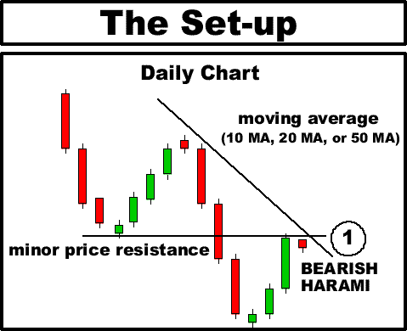
Step 1 - Look for a BEARISH HARAMI against MINOR PRICE RESISTANCE, and/or against a declining Major Moving Average (10 MA, 20 MA, or 50 MA) on the daily chart.
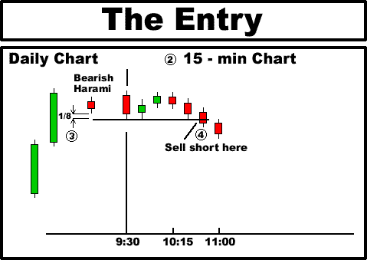
Step 2 - Pull up a 15 min. chart of the stock.
Step 3 - Note the low price of the previous day's daily HARAMI candlestick. Your entry point is 1/8th below this price.
Step 4 - On the following day, allow the stock to trade for 5 minutes before entering. Sell short the stock only if it breaks below the entry criteria (1/8th below the previous day's low) and only after it has traded for 5 minutes. If the stock does not break below the entry point, do not enter.
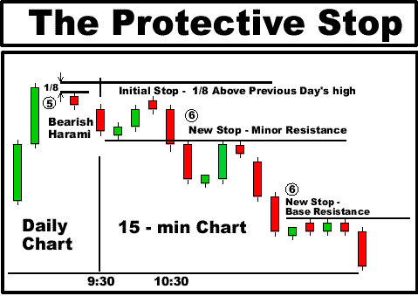
Step 5 - Place the initial protective stop 1/8th above the high of the previous day's HARAMI candlestick. Cover the stock for a small loss immediately if the stock breaks above this price.
Step 6 - Monitor the stock as it continues to decline downward. Look for areas of resistance (either minor price resistance or base price resistance) on the 15 minute chart, and re-adjust your protective stop price downward as the stock continues to decline. This will protect your profits, and/or minimize your losses if the stock should turn against you.
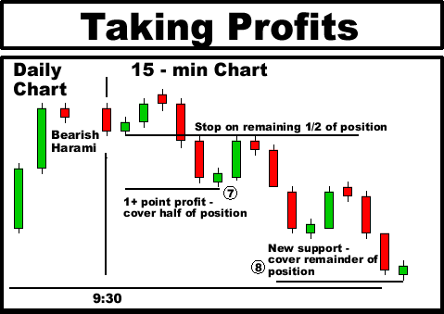
Step 7 - Monitor the stock on a 15 min. chart as it declines downward, and stay in as long as the protective stop is not violated. Allow the stock to achieve 1 point or greater profit, and then look for signs of strength. A reversal candlestick pattern on the 15 minute chart will serve as a good indicator for a reversal point. After the price reaches an area of support and strength, cover half of your position. This may occur on the same day of entry, or on the following day, depending on the weakness of the stock. Maintain the latest protective stop price for the remaining half of your position.
Step 8 - Allow stock to continue it's decline. After the stock has declined further, again look for an area of support where the stock begins to strengthen and reverse. This could be a DOJI candlestick, or any other reversal candlestick pattern on the 15 min. chart. Cover the remainder of the position for profit.

3) Black Crows Candlestick Play Instructions:
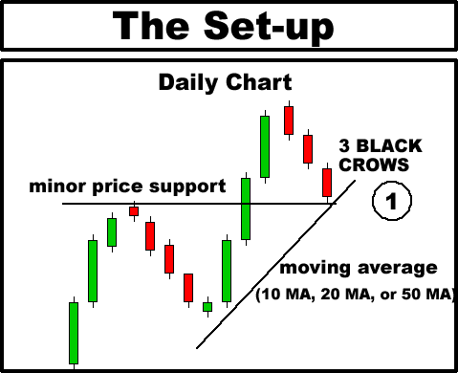
Step 1 - Look for 3 BLACK CROWS resting on Minor Price Support, and/or a rising Major Moving Average (10 MA, 20 MA, or 50 MA). Ideally you want to find a series of 3 red candlesticks; however, 2 red candlesticks can also work well.
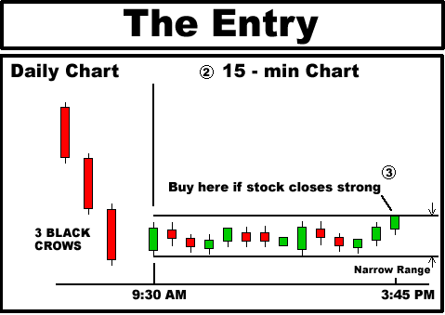
Step 2 - Pull up a 15 min. chart of the stock.
Step 3 - Monitor the stock's trading during the last 30 minutes before the close, and enter only if the stock is closing strong near it's high price of the day. You will reduce your risk by entering only if the range of the day (high price minus low play price) is narrow. This way, when you set your protective stop at the day's low, you will only take a small loss if the stock should reverse.
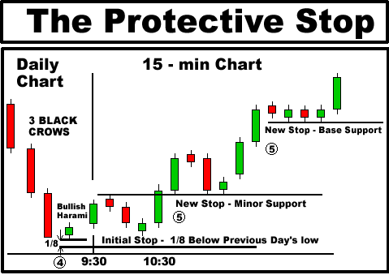
Step 4 - Observe the daily chart after the market has closed. The stock has now formed a BULLISH HARAMI on the daily chart, but you were able to spot the setup on the previous day and enter before the rest of the herd! On the next day, observe where the stock opens. If the stock opens relatively near to the opening price (say within 5/8th), place the initial protective stop 1/8th below the low of the previous day's candlestick. Exit the stock immediately if the stock breaks below this price. If the stock gaps up, proceed to Step 6. If the stock gaps down, proceed to Step 8.
Step 5 - Monitor the stock as it continues to rally upward. Look for areas of support (either minor price support or base price support) on the 15 minute chart, and re-adjust your protective stop price to 1/8th under these levels of support. This will protect your profits, and/or minimize your losses if the stock should turn against you.
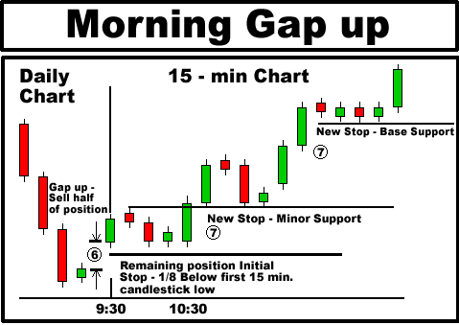
Step 6 - If the stock closes strong on the previous day, there is a good chance that the play will be spotted by other traders (note how a BULLISH HARAMI is formed on the daily chart), and result in a morning price gap upward. If the stock gaps up by over 5/8 point, sell half of the position immediately after the open to lock in your profit. Place a protective stop 1/8th under the first 15 min. candlestick for the remainder of your position.
Step 7 - Monitor the stock as it continues to rally upward. Look for areas of support (either minor price support or base support) on the 15 minute chart, and re-adjust your protective stop price to under these levels of support. This will protect your profits, and/or minimize your losses.
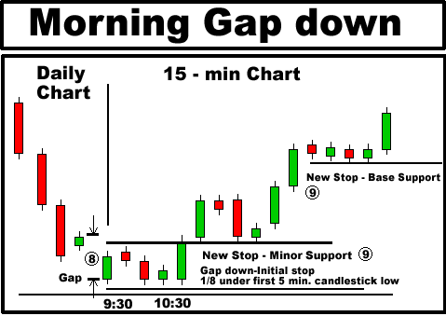
Step 8 - It is also possible for the stock to gap down on the following day due to overall market weakness. If the stock gaps down and opens 5/8th lower than the previous day's close, DO NOT PANIC AND SELL RIGHT AWAY. In most cases, the stock will rally after a gap down, and the low price of the day will occur in the first 5 minutes of trading. Let the stock trade for 5 minutes and place a protective stop 1/8th below the low of the first 5 minute candlestick. Sell the stock immediately if it breaks this protective stop.
Step 9 - Monitor the stock as it continues to rally upward. Look for areas of support (either minor price support or base price support) on the 15 minute chart, and re-adjust your protective stop price to 1/8th under these levels of support. This will protect your profits, and/or minimize your losses.
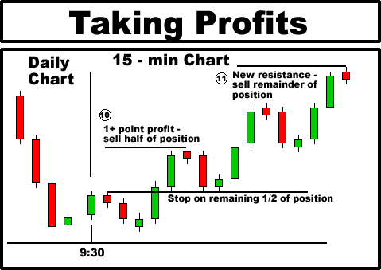
Step 10 - Monitor the stock as it climbs upward, and stay in as long as the protective stop is not violated. After the stock has achieved 1 point profit or greater, look for signs of weakness. A bearish candlestick on the 15 minute chart will serve as a good indicator for a reversal point. After the price reaches an area of resistance and weakens, sell half of your position. This may occur on the same day as entry, or on the following day, depending on the strength of the stock. Maintain the latest protective stop price for the remaining half of your position.
Step 11 - Allow the stock to continue it's rally. After the stock has rallied further, again look for an area of resistance where the stock begins to weaken and reverse. This could be a DOJI candlestick, or any other reversal candlestick pattern on the 15 min. chart. Sell the remainder of the position for profit.

4) Soldiers Candlestick Play Instructions:
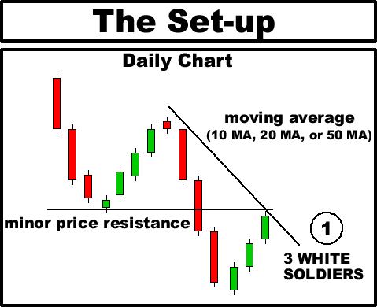
Step 1 - Look for 3 WHITE SOLDIERS against Minor Price Resistance, and/or a declining Major Moving Average (10 MA, 20 MA, or 50 MA). Ideally you want to find a series of 3 green candlesticks; however, 2 green candlesticks can also work well.
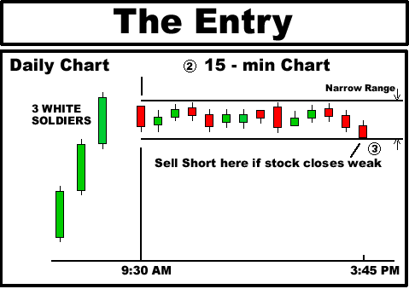
Step 2 - Pull up a 15 min. chart of the stock.
Step 3 - Monitor the stock's trading during the last 30 minutes before the close, and enter only if the stock is closing weak near it's low price of the day. You will reduce the risk of the by entering only if the range of the day (high price minus low play price) is narrow. This way, when you set your protective stop at the day's high, you will only take a small loss if the stock should reverse.
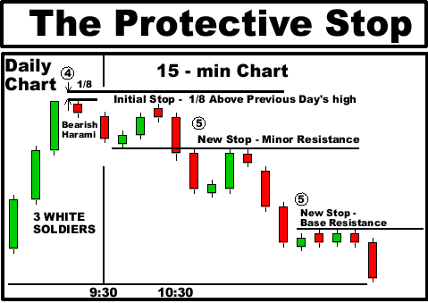
Step 4 - Observe the daily chart after the market has closed. The stock has now formed a BEARISH HARAMI on the daily chart, but you were able to spot the setup on the previous day and enter before the rest of the herd! On the next day, observe where the stock opens. If the stock opens relatively near to the opening price (say within 5/8th), place the initial protective stop 1/8th above the high of the previous day's candlestick. Exit the stock immediately if the stock breaks above this price. If the stock gaps down, proceed to Step 6. If the stock gaps up, proceed to Step 8.
Step 5 - Monitor the stock as it continues to decline downward. Look for areas of resistance (either minor price resistance or base price resistance) on the 15 minute chart, and re-adjust your protective stop price to 1/8th above these levels of resistance. This will protect your profits, and/or minimize your losses if the stock should turn against you.
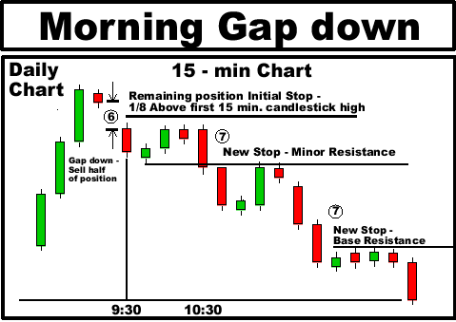
Step 6 - If the stock closes weak on the previous day, there is a good chance that the play will be spotted by other traders (note that it has now formed a BEARISH HARAMI on the daily chart), and result in a morning price gap downward. If the stock gaps down by over 5/8 point, cover half of the position immediately after the open to lock in your profit. Place a protective stop 1/8th above the high of the first 15 min. candlestick for the remainder of your position.
Step 7 - Monitor the stock as it continues to decline downward. Look for areas of resistance (either minor price resistance or base resistance) on the 15 minute chart, and re-adjust your protective stop price to above these levels of resistance. This will protect your profits, and/or minimize your losses.
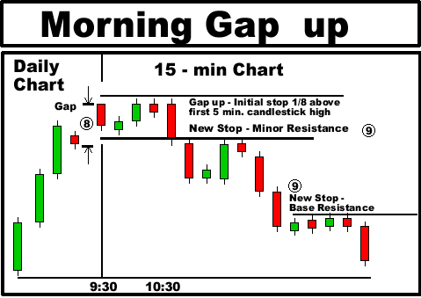
Step 8 - It is also possible for the stock to gap up on the following day due to overall market strength. If the stock gaps up and opens 5/8th higher than the previous day's close, DO NOT PANIC AND COVER RIGHT AWAY. In most cases, the stock will sell off after a gap up, and the high price of the day will occur in the first 5 minutes of trading. Let the stock trade for 5 minutes and place a protective stop 1/8th above the high of the first 5 minute candlestick. Cover the stock immediately if it breaks this protective stop.
Step 9 - Monitor the stock as it continues to decline downward. Look for areas of resistance (either minor price resistance or base price resistance) on the 15 minute chart, and re-adjust your protective stop price to 1/8th above these levels of resistance. This will protect your profits, and/or minimize your losses.
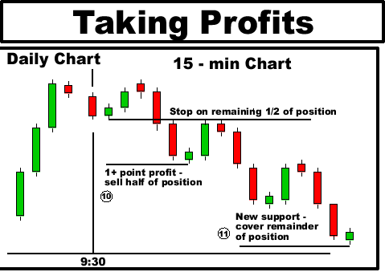
Step 10 - Monitor the stock as it declines downward, and stay in as long as the protective stop is not violated. After the stock has achieved 1 point profit or greater, look for signs of strength. A bullish candlestick on the 15 minute chart will serve as a good indicator for a reversal point. After the price reaches an area of support and strength, cover half of your position. This may occur on the same day as entry, or on the following day, depending on the weakness of the stock. Maintain the latest protective stop price for the remaining half of your position.
Step 11 - Allow the stock to continue it's decline. After the stock has declined further, again look for an area of support where the stock begins to strengthen and reverse. This could be a DOJI candlestick, or any other reversal candlestick pattern on the 15 min. chart. Cover the remainder of the position for profit.

5) Long Red Candlestick Play Instructions
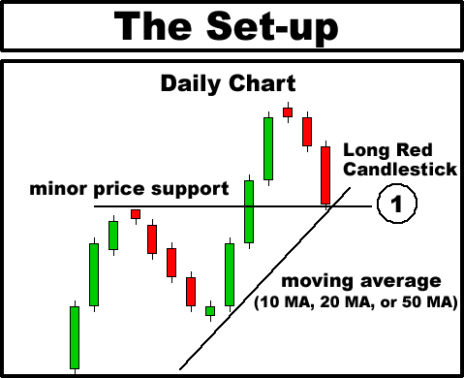
Step 1 - Look for a LONG RED CANDLESTICK resting on MINOR PRICE SUPPORT and also a rising MAJOR MOVING AVERAGE (10 MA, 20 MA or 50 MA).
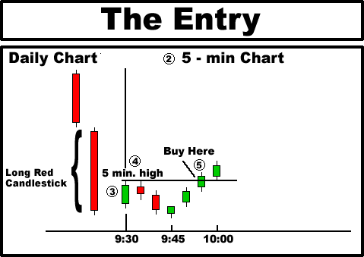
Step 2 - Pull up a 5 minute chart of the stock.
Step 3 - Note the opening price of the stock. If the stock gaps up or down more than 5/8th, DO NOT enter the trade. If the stock opens within 5/8th of the previous day's close, proceed to Step 4.
Step 4 - Wait for the stock to trade for 5 minutes. After 5 minutes, note the high of the first 5 minute candlestick.
Step 5 - Enter the stock if it trades 1/8th above the high of the first 5 minute candlestick. If the stock does not trade 1/8th higher than the high of the first 5 minute candlestick, DO NOT enter the trade.
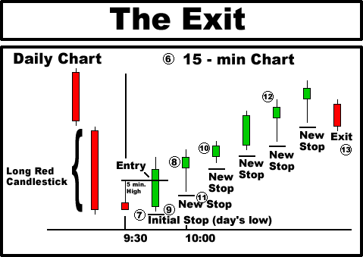
Step 6 - Pull up a 15 minute chart of the stock.
Step 7 - After entering the stock, place an initial protective stop 1/8th below the low price of the day.
Step 8 - Monitor the stock during the next 15 min. candlestick.
Step 9 - Adjust the protective stop to 1/8th below the low price of the previous 15 min. candlestick. Stay in the trade as long as the stock trades above this price.
Step 10 - Monitor the stock during the next 15 min. candlestick.
Step 11 - Adjust the protective stop to 1/8th below the low price of the previous 15 min candlestick. Stay in the trade as long as the stock trades above this price.
Step 12 - Continue to monitor the stock during each new 15 min. candlestick, and adjust your protective stop to 1/8th below each previous 15 min. candlestick's low.
Step 13 - Exit the stock for profit when it finally trades 1/8th below the low price of a previous 15 min. candlestick.

6) Long Green Candlestick Play Instructions
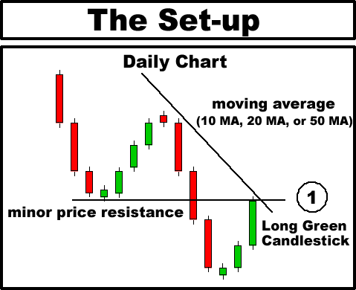
Step 1 - Look for a LONG GREEN CANDLESTICK against MINOR PRICE RESISTANCE and also against a declining MAJOR MOVING AVERAGE (10 MA, 20 MA or 50 MA).
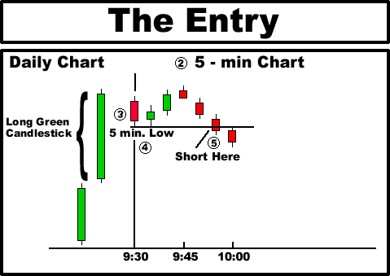
Step 2 - Pull up a 5 minute chart of the stock.
Step 3 - Note the opening price of the stock. If the stock gaps up or down more than 5/8th, DO NOT enter the trade. If the stock opens within 5/8th of the previous day's close, proceed to Step 4.
Step 4 - Wait for the stock to trade for 5 minutes. After 5 minutes, note the low of the first 5 minute candlestick.
Step 5 - Sell short the stock if it trades 1/8th below the low of the first 5 minute candlestick. If the stock does not trade lower than the low of the first 5 minute candlestick, DO NOT enter the trade.
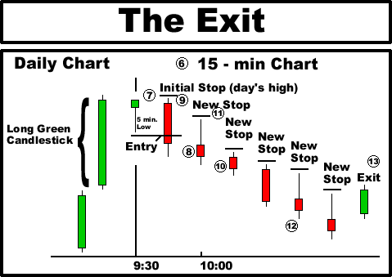
Step 6 - Pull up a 15 minute chart of the stock.
Step 7 - After shorting the stock, place an initial protective stop 1/8th above the high price of the day.
Step 8 - Monitor the stock during the next 15 min. candlestick.
Step 9 - Adjust the protective stop to 1/8th above the high price of the previous 15 min. candlestick. Stay in the trade as long as the stock trades below this price.
Step 10 - Monitor the stock during the next 15 min. candlestick.
Step 11 - Adjust the protective stop to 1/8th above the high price of the previous 15 min candlestick. Stay in the trade as long as the stock trades below this price.
Step 12 - Continue to monitor the stock during each new 15 min. candlestick, and adjust your protective stop to 1/8th above each previous 15 min. candlestick's high.
Step 13 - Cover the stock for profit when it finally trades 1/8 above the high price of a previous 15 min. candlestick.

7) Bullish Thrusting Line Candlestick Play Instructions
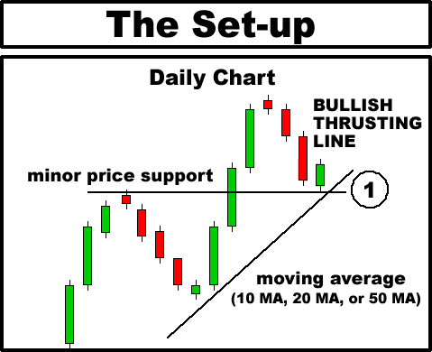
Step 1 - Look for a BULLISH THRUSTING LINE resting on MINOR PRICE SUPPORT, and/or a rising Major Moving Average (10 MA, 20 MA, or 50 MA) on the daily chart.
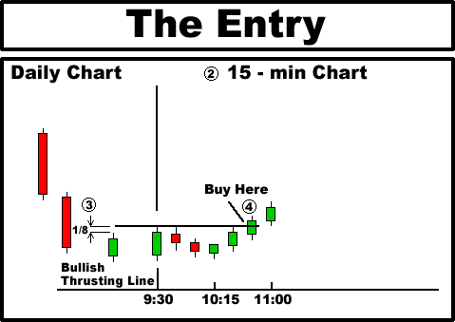
Step 2 - Pull up a 15 min. chart of the stock.
Step 3 - Note the high price of the previous day's daily THRUSTING LINE candlestick. Your entry point is 1/8th above this price.
Step 4 - On the following day, allow the stock to trade for 5 minutes before entering. Enter the stock only if it breaks above the entry criteria (1/8th above previous day's high) and only after it has traded for 5 minutes. If the stock does not break above the entry point, do not enter.
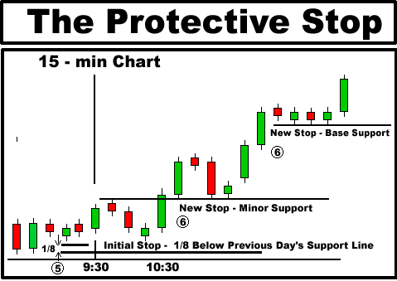
Step 5 - Observe the previous day's candlesticks on a 15 min chart. Find an internal line of support that is formed on the 15 min. chart. This will usually be an intra-day area where the stock moves down to and then rallies multiple times during the day. Place the initial protective stop 1/8 below the area of intraday support. Exit the stock for a small loss immediately if the stock breaks below this price.
Step 6 - Monitor the stock as it continues to rally upward. Look for areas of support (either minor price support or base price support) on the 15 minute chart, and re-adjust your protective stop price upward as the stock continues to rally. This will protect your profits, and/or minimize your losses if the stock should turn against you.
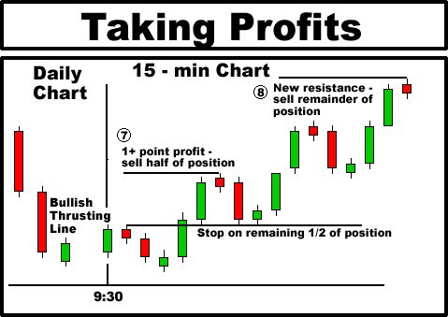
Step 7 - Monitor the stock on a 15 min. charts as it climbs upward, and stay in as long as the protective stop is not violated. Allow the stock to achieve 1 point or greater profit, and then look for signs of weakness. A reversal candlestick pattern on the 15 minute chart will serve as a good indicator for a reversal point. After the price reaches an area of resistance and weakens, sell half of your position. This may occur on the same day as entry, or on the following day, depending on the strength of the stock. Maintain the latest protective stop price for the remaining half of your position.
Step 8 - Allow stock to continue it's rally. After the stock has rallied further, again look for an area of resistance where the stock begins to weaken and reverse. This could be a DOJI candlestick, or any other reversal candlestick pattern on the 15 min. chart. Sell the remainder of the position for profit.

Weekly Candlestick Play Instructions

1) Bullish Harami (Weekly) Candlestick Play Instructions
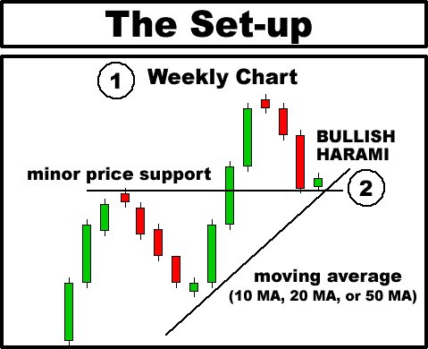
Step. 1 - Pull up a Weekly chart of the stock.
Step 2- Look for a BULLISH HARAMI resting on MINOR PRICE SUPPORT, and/or a rising Major Moving Average (10 MA, 20 MA, or 50 MA) on the Weekly chart.
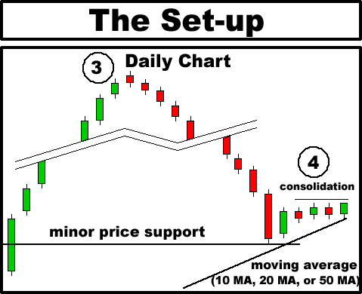
Step 3 - Pull up a Daily chart of the stock. Note that the Harami pattern formed on the Weekly chart is made up of 5 individual daily candlesticks.
Step 4 - Look for consolidation of the last 3 or 4 daily candlesticks at the high price of the week. This consolidation line represents an area where the stock takes a rest before resuming it's uptrend. The objective is to enter the stock just before the next big upward move.
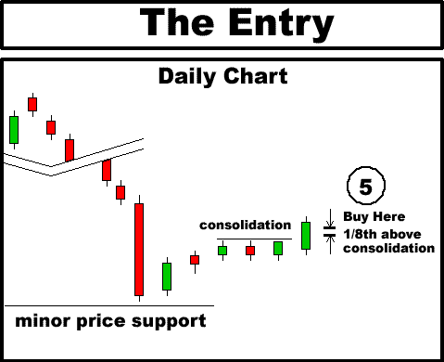
Step 5 - Enter the stock only if it breaks 1/8th above the area of consolidation line. This will often correspond to the high price of the week. If the stock does not break through the area of consolidation, DO NOT ENTER THE TRADE.
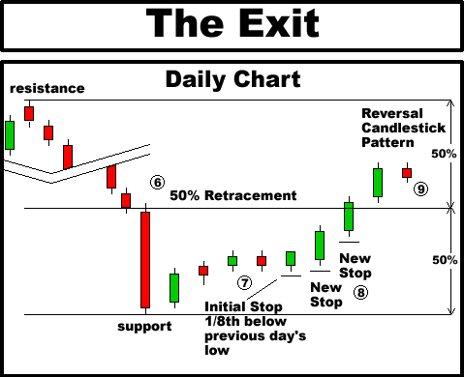
Step 6 - Mark off the 50% retracement line. This will be the halfway point between the line of support where the stock began it's rally, and the line of resistance where the stock made it's last major pull-back.
Step 7 - After entry, place an initial protective stop 1/8th below the low price of the previous day's candlestick. Sell the stock immediately if the stock breaks below this price.
Step 8 - On each new day, adjust the trailing protective stop to 1/8th below the previous day's candlestick's low price. Continue to use a trailing stop as long as the stock remains below the 50% retracement line.
Step 9 - After the stock has broken above the 50% retracement line, look for a reversal candlestick. This will most likely be a bearish candlestick which closes near it's low price of the day. Sell the stock for profit either before the market close, or at the market open the next day.

2) Bearish Harami (Weekly) Candlestick Play Instructions
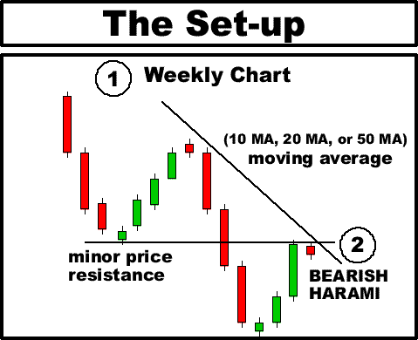
Step 1 - Pull up a Weekly chart of the stock.
Step 2- Look for a BEARISH HARAMI against MINOR PRICE RESISTANCE, and/or a declining Major Moving Average (10 MA, 20 MA, or 50 MA) on the Weekly chart.
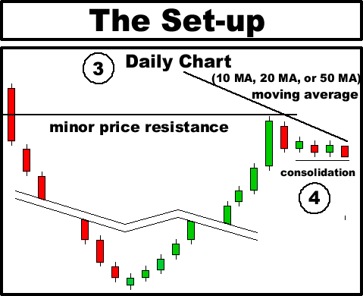
Step 3 - Pull up a Daily chart of the stock. Note that the Harami pattern formed on the Weekly chart is made up of 5 individual daily candlesticks.
Step 4 - Look for consolidation of the last 3 or 4 daily candlesticks at the low price of the week. This consolidation line represents an area where the stock takes a rest before resuming it's downtrend. The objective is to enter the stock just before the next big downward move.
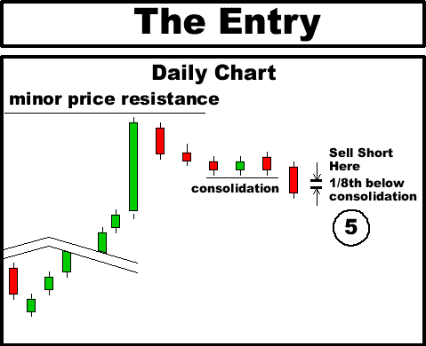
Step 5 - Enter the stock only if it breaks 1/8th below the area of consolidation line. This will often correspond to the low price of the week. If the stock does not break through the area of consolidation, DO NOT ENTER THE TRADE.
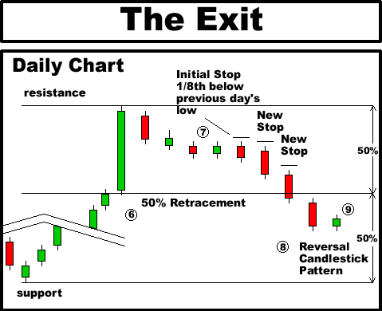
Step 6 - Mark off the 50% retracement line. This will be the halfway point between the line of resistance where the stock began it's decline, and the line of resistance where the stock began it's last major rally.
Step 7 - After entry, place an initial protective stop 1/8th above the high price of the previous day's candlestick. Cover the stock immediately if the stock breaks above this price.
Step 8 - On each new day, adjust the trailing protective stop to 1/8th above the previous day's candlestick's high price. Continue to use a trailing stop as long as the stock remains above the 50% retracement line.
Step 9 - After the stock has broken below the 50% retracement line, look for a reversal candlestick. This will most likely be a bullish candlestick which closes near it's high price of the day. Cover the stock for profit either before the market close, or at the market open the next day.

3 Black Crows (Weekly) Candlestick Play Instructions
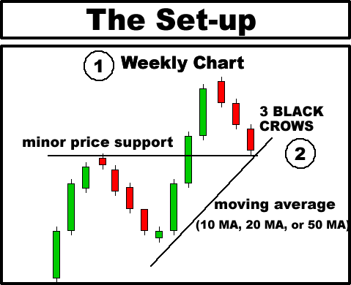
Step 1 - Pull up a Weekly chart of the stock after the market close for the week (Friday after close).
Step 2- Look for a THREE BLACK CROWS resting on MINOR PRICE SUPPORT, and/or a rising Major Moving Average (10 MA, 20 MA, or 50 MA) on the Weekly chart. Place the stock on your watch list for the upcoming week.
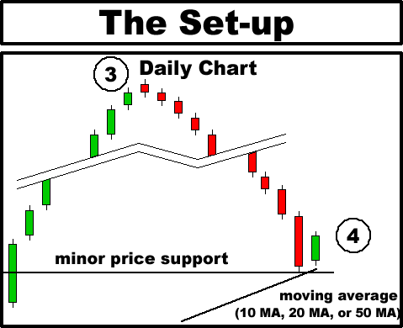
Step 3 - Allow the stock to trade one full day. Pull up a Daily chart of the stock after the stock has formed the first daily candlestick of the week (Monday after close).
Step 4 - Look for a BULLISH HARAMI candlestick resting on MINOR PRICE SUPPORT, and/or a rising Major Moving Average (10 MA, 20 MA, or 50 MA) on the Daily chart.
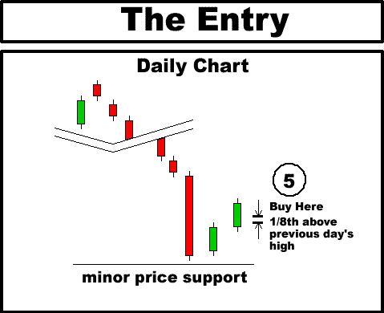
Step 5 - Enter the stock only if it breaks 1/8th above the high of the previous HARAMI candlestick. If the stock does not break the previous day's high, DO NOT ENTER THE TRADE.
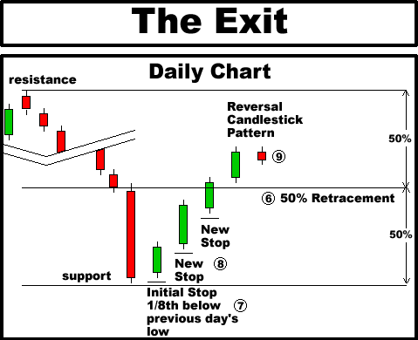
Step 6 - Mark off the 50% retracement line. This will be the halfway point between the line of support where the stock began it's rally, and the line of resistance where the stock made it's last major pull-back.
Step 7 - After entry, place an initial protective stop 1/8th below the low price of the previous day's candlestick. Sell the stock immediately if the stock breaks below this price.
Step 8 - On each new day, adjust the trailing protective stop to 1/8th below the previous day's candlestick's low price. Continue to use a trailing stop as long as the stock remains below the 50% retracement line.
Step 9 - After the stock has broken above the 50% retracement line, look for a reversal candlestick. This will most likely be a bearish candlestick which closes near it's low price of the day. Sell the stock for profit either before the market close, or at the market open the next day.

3 White Soldiers (Weekly) Candlestick Play Instructions
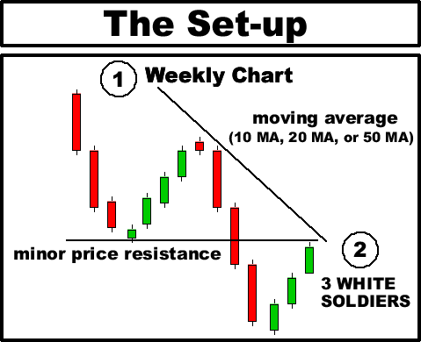
Step 1 - Pull up a Weekly chart of the stock after the market closes for the week (Friday after close).
Step 2- Look for THREE WHITE SOLDIERS against MINOR PRICE RESISTANCE, and/or against the declining Major Moving Average (10 MA, 20 MA, or 50 MA) on the Weekly chart. Place the stock on your watch list for the upcoming week.
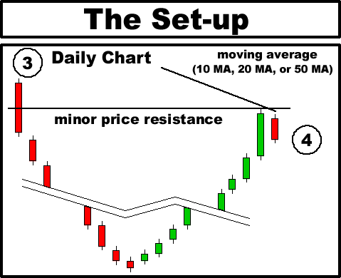
Step 3 - Allow the stock to trade one full day. Pull up a Daily chart of the stock after the stock has formed the first daily candlestick of the week (Monday after close).
Step 4 - Look for a BEARISH HARAMI candlestick against MINOR PRICE RESISTANCE, and/or a declining Major Moving Average (10 MA, 20 MA, or 50 MA) on the Daily chart.
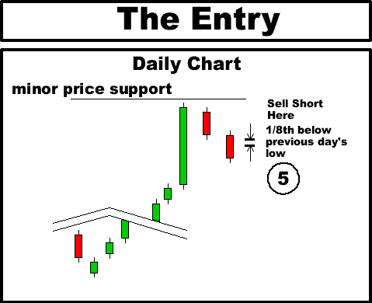
Step 5 - Sell short only if the stock breaks 1/8th below the low of the previous HARAMI candlestick. If the stock does not break the previous day's low, DO NOT ENTER THE TRADE.
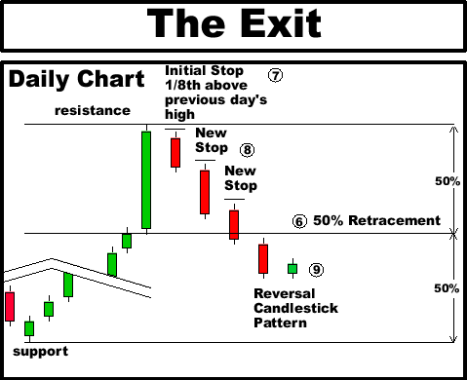
Step 6 - Mark off the 50% retracement line. This will be the halfway point between the line of resistance where the stock began it's decline, and the line of support where the stock begain it last major rally.
Step 7 - After entry, place an initial protective stop 1/8th above the high price of the previous day's candlestick. Cover the stock immediately if the stock breaks above this price.
Step 8 - On each new day, adjust the trailing protective stop to 1/8th above the previous day's candlestick's high price. Continue to use a trailing stop as long as the stock remains above the 50% retracement line.
Step 9 - After the stock has broken below the 50% retracement line, look for a reversal candlestick. This will most likely be a bullish candlestick which closes near it's high price of the day. Cover the stock for profit either before the market close, or at the market open the next day.

