Candlestick patterns
- White vs. Black candles: hollow (White) candlesticks, where the close is greater than the open, indicate buying pressure. Filled (Black) candlesticks, where the close is less than the open, indicate selling pressure.
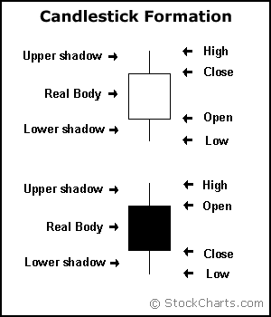
- Long vs. Short Bodies: the longer the body is, the more intense the buying or selling pressure. Conversely, short candlesticks indicate little price movement and represent consolidation or indecision.

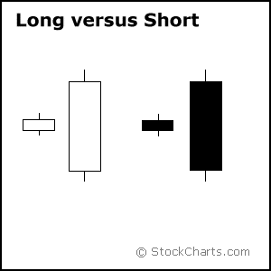
- Support/Resistance basing on long candles: after extended declines, long white candlesticks can mark a potential turning point or Support level. If buying gets too aggressive after a long advance, it can lead to excessive bullishness. Similarly, after a long advance in prices, a long black candlestick can foreshadow a turning point or mark a future Resistance level. After a long decline a long black candlestick can indicate panic or capitulation.

- Marubozu brothers (Long Body): A White Marubozu forms when the open equals the low and the close equals the high. This indicates that buyers controlled the price action from the first trade to the last trade. Similarly, a black Marubozu forms when the open equals the high and the close equals the low. This indicates that sellers controlled the price action from the first trade to the last trade
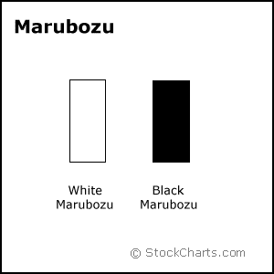
- Long vs. Short Shadows: Candlesticks with short shadows indicate that most of the trading action was confined near the open and close. Candlestick with long shadows show that traded extended well past the open and close. Candlesticks with a long upper shadow and short lower shadow indicate that buyers dominated during the session, and bid prices higher. However, sellers later forced prices down from their highs, and the weak close created a long upper shadow. This becomes more significant when it occurs after a prolonged advance of prices and could be a potential turning point. Conversely, candlesticks with long lower shadows and short upper shadows indicate that sellers dominated during the session and drove prices lower. However, buyers later resurfaced to bid prices higher by the end of the session and the strong close created a long lower shadow. This becomes more significant when it occurs after prolonged decline in prices and could indicate a potential turning point.
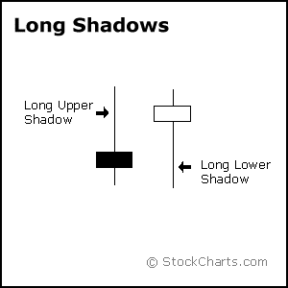

- Spinning Tops: Spinning Tops are Candlestick lines that have small bodies with upper and lower shadows that exceed the length of the body. The long upper shadow shall be almost equal to the long lower shadow. Spinning tops represent indecision. The small real body (whether hollow or filled) shows little movement from open to close and the shadows indicate that both bulls and bears were active during the session. Even though the session opened and closed with little change, prices moved significantly higher and lower in the meantime. Neither buyers nor sellers could gain the upper hand and the result was a standoff. After a long advance or long white candlestick, a spinning top indicates weakness among the bulls and a potential change or interruption in trend. After a long decline or long black candlestick, a spinning top indicates weakness among the bears and a potential change or interruption in trend.

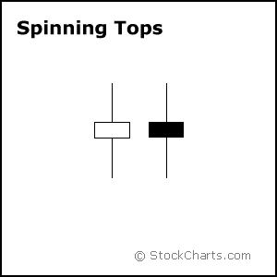
- Doji: Doji are important candlesticks that provide information on their own and as components of in a number of important patterns. Doji form when a security's open and close are virtually equal, but not necessarily equal. The length of the upper and lower shadows can vary and the resulting candlestick looks like a cross, inverted cross or plus sign. Determining the robustness of the doji will depend on the price, recent volatility, and previous candlesticks. Relative to previous candlesticks, the doji should have a very small body that appears as a thin line. Steven Nelson notes that a doji that forms among other candlesticks with small real bodies would not be considered important. However, a doji that forms among candlesticks with long real bodies would be deemed significant. Also, the relevance of a doji depends on the preceding trend or preceding candlesticks.
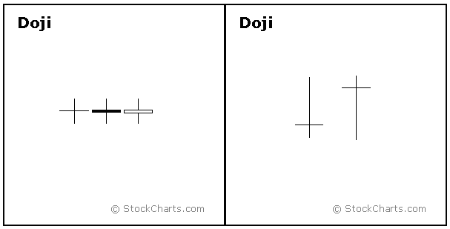
- Alone, doji are neutral patterns. The word "Doji" refers to both the singular and plural form, i.e., neither bullish nor bearish. Doji convey a sense of indecision or tug-of-war between buyers and sellers. Neither bulls nor bears were able to gain control and a turning point could be developing. Any bullish or bearish bias is based on preceding price action and future confirmation.

- Doji after an Up-Trend: after an advance, or long white candlestick, a doji signals that the buying pressure is starting to weaken and up-trend could be nearing an end, but not essentially the end of up-trend or reversal. Even after Doji forms further down side is required to confirm the bearishness. This may come as a gap down, long black candlestick, or decline below the long white candlestick's open. After a long white candlestick and doji, traders should be on the alert for a potential evening doji star.
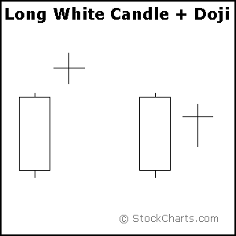

- Doji after Down-Trend: after a decline in prices, or long black candlestick, a doji signals that selling pressure is starting to diminish. Doji indicate that the forces of supply and demand are becoming more evenly matched and a change in trend may be near. Doji alone are not enough to mark a reversal and further confirmation may be warranted. Even though the bears are starting to lose control of the decline, further strength is required to confirm any reversal. Bullish confirmation could come from a gap up, long white candlestick or advance above the long black candlestick's open. After a long black candlestick and doji, traders should be on the alert for a potential morning doji star.
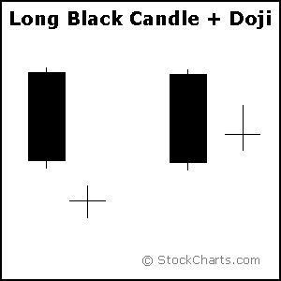

- Long Legged Doji: Long-legged doji have long upper and lower shadows that are almost equal in length. These doji reflect a great amount of indecision in the market. Long-legged doji indicate that prices traded well above and below the session's opening level, but closed virtually even with the open. After a whole lot of yelling and screaming, the end result showed little change from the initial open.
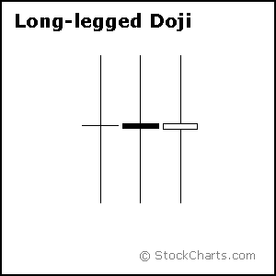

- Dragon Fly and Gravestone Doji:
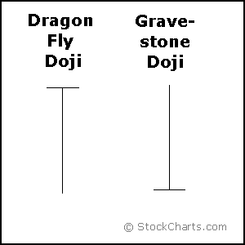
- Dragon Fly Doji: Dragon fly doji form when the open, high and close are equal and the low creates a long lower shadow. The resulting candlestick looks like a "T" with a long lower shadow and no upper shadow. Dragon fly doji indicate that sellers dominated trading and drove prices lower during the session. By the end of the session, buyers resurfaced and pushed prices back to the opening level and the session high. The reversal implications of a dragon fly doji depend on previous price action and future confirmation. After a long downtrend, or a long black candlestick, or at support, a dragon fly doji could signal a potential bullish reversal or bottom. After a long uptrend, long white candlestick or at resistance, the long lower shadow could foreshadow a potential bearish reversal or top. Bearish or bullish confirmation is required for both situations.
- Gravestone Doji: Gravestone doji form when the open, low and close are equal and the high creates a long upper shadow. The resulting candlestick looks like an “inverted -T" with a long upper shadow and no lower shadow. Gravestone doji indicate that buyers dominated trading and drove prices higher during the session. However, by the end of the session, sellers resurfaced and pushed prices back to the opening level and end the session at low. As with the dragon fly doji and other candlesticks, the reversal implications of gravestone doji depend on previous price action and future confirmation. Even though the long upper shadow indicates a failed rally, the intraday high provides evidence of some buying pressure. After a long downtrend, long black candlestick, or at support, focus turns to the evidence of buying pressure and a potential bullish reversal. After a long uptrend, long white candlestick or at resistance, focus turns to the failed rally and a potential bearish reversal. Bearish or bullish confirmation is required for both situations.
General Guidelines for Candle sticks: Bulls vs. Bears:
A candlestick depicts the battle between Bulls and Bears over a given period of time. An analogy to this battle can be made between two football teams, which we can also call the Bulls and the other is Bears. The bottom (intra-session low) of the candlestick represents a touchdown for the Bears and the top (intra-session high) a touchdown for the Bulls. The closer the close is to the high, the closer the Bulls are to a touchdown. The closer the close is to the low, the closer the Bears are to a touchdown. While there are many variations, I have narrowed the field to 6 types of games (or candlesticks):
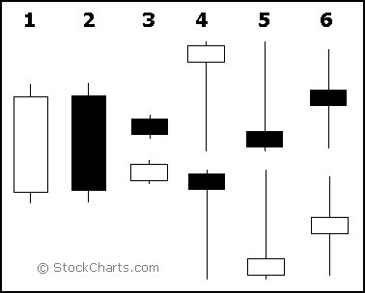
- Long white candlesticks indicate that the Bulls controlled the ball (trading) for most of the game.
- Long black candlesticks indicate that the Bears controlled the ball (trading) for most of the game.
- Small candlesticks indicate that neither team could move the ball and prices finished about where they started.
- A long lower shadow indicates that the Bears controlled the ball for part of the game, but lost control by the end and the Bulls made an impressive comeback.
- A long upper shadow indicates that the Bulls controlled the ball for part of the game, but lost control by the end and the Bears made an impressive comeback.
- A long upper and lower shadow indicates that the both the Bears and the Bulls had their moments during the game, but neither could put the other away, resulting in a standoff.
What Candlesticks do not tell you?
Candlesticks do not reflect the sequence of events between the open and close, only the relationship between the open and the close. The high and the low are obvious and indisputable, but candlesticks (and bar charts) cannot tell us which came first. Two of many possibilities are depicted in the figure below.
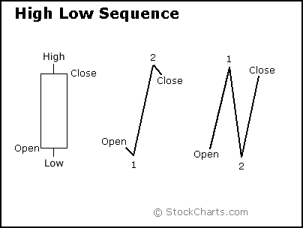
With a long white candlestick, the assumption is that prices advanced most of the session. However, based on the high/low sequence, the session could have been more volatile. The example above depicts two possible high/low sequences that would form the same candlestick. The first sequence shows two small moves and one large move: a small decline off the open to form the low, a sharp advance to form the high, and a small decline to form the close. The second sequence shows three rather sharp moves: a sharp advance off the open to form the high, a sharp decline to form the low, and a sharp advance to form the close. The first sequence portrays strong, sustained buying pressure, and would be considered more bullish. The second sequence reflects more volatility and some selling pressure. These are just two examples, and there are hundreds of potential combinations that could result in the same candlestick. Candlesticks still offer valuable information on the relative positions of the open, high, low and close. However, the trading activity that forms a particular candlestick can vary.

Importance of the prior trend
In his book, Candlestick Charting Explained, Greg Morris notes that for a pattern to qualify as a reversal pattern there should be a prior trend to reverse. Bullish reversals require a preceding downtrend and bearish reversals require a prior uptrend. The direction of the trend can be determined using trend lines, moving averages, peak/trough analysis or other aspects of technical analysis. A downtrend might exist as long as the security was trading below its down trend line, below its previous reaction high or below a specific moving average. The length and duration will depend on individual preferences. However, because candlesticks are short-term in nature, it is usually best to consider the last 1-4 weeks of price action.

Candlestick positioning:
- Star Position: A candlestick that gaps away from the previous candlestick is said to be in star position. The first candlestick usually has a large real body, but not always, and the second candlestick in star position has a small real body. Depending on the previous candlestick, the star position candlestick gaps up or down and appears isolated from previous price action. The two candlesticks can be any combination of white and black. Doji, hammers, shooting stars and spinning tops have small real bodies, and can form in the star position.
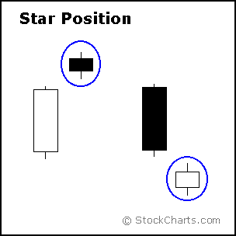
- Harami Position: The word harami means pregnant in Japanese. A candlestick that forms within the real body of the previous candlestick is in Harami position. Harami means pregnant in Japanese and the second candlestick is nestled inside the first. The first candlestick usually has a large real body and the second a smaller real body than the first. The shadows (high/low) of the second candlestick do not have to be contained within the first, though it's preferable if they are. Doji and spinning tops have small real bodies, and can form in the harami position as well.
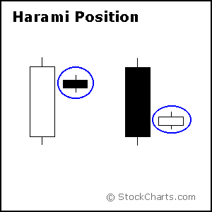
- Harami: A two day pattern that has a small body day completely contained within the range of the previous body, and is the opposite color.
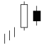
- Stars Vs Raindrops: Doji lines are patterns with the same open and close price. There are four special types of Doji lines. A Star appears when a small body gaps ABOVE the previous day's long body. Stars are part of more complicated candlestick patterns, especially the reversal patterns. A Rain Drop appears when a small body gaps BELOW the previous day's long body. Rain Drops are part of the more complicated patterns, especially the reversal patterns.
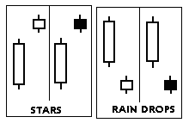

- Harami Cross: The word harami means pregnant in Japanese.In Harami pattern, if the small candle is a doji, the pattern is referred as Harami Cross. It is an important reversal sign, especially after a long body in a downtrend. The first one in the following is a Bullish Harami Cross while the second one is the Bearish Harami Cross
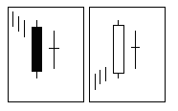
Recognition Criteria:
- The second day's open and close are the same (Doji).
- The Doji is in the range of the previous long day.
- The long day appears within a trending market. (Confirmation is suggested.)
- Long Shadow Reversals: There are two pairs of single candlestick reversal patterns as given below.

- (1) Hammer and Hanging Man: The first pair, Hammer and Hanging Man, consists of identical candlesticks with small bodies and long lower shadows. Only preceding price action and further confirmation determine the bullish or bearish nature of these candlesticks.
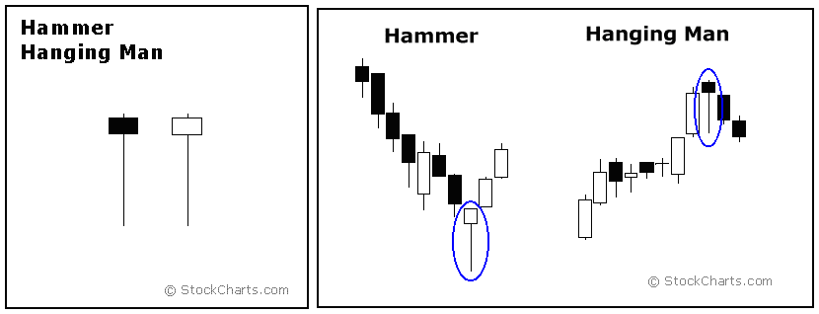

- Hammer: The Hammer is a bullish reversal pattern that forms after a decline. In addition to a potential trend reversal, hammers can mark bottoms or support levels. The low of the long lower shadow implies that sellers drove prices lower during the session. However, the strong finish indicates that buyers regained their footing to end the session on a strong note. While this may seem enough to act on, hammers require further bullish confirmation. The low of the hammer shows that plenty of sellers remain. Further buying pressure, and preferably on expanding volume, is needed before acting. Such confirmation could come from a gap up or long white candlestick. Hammers are similar to selling climaxes, and heavy volume can serve to reinforce the validity of the reversal. The body of the hammer shall be small (how small? Just compare with other candles on the chart. It is enough if it is small as compared to other candles on an average day.), with the lower wick/tail is more than double the size of the body.

- Hanging Man: The Hanging Man is a bearish reversal pattern that forms after an advance and it can also mark a top or resistance level. Forming after an advance, a Hanging Man signals that selling pressure is starting to increase. The low of the long lower shadow confirms that sellers pushed prices lower during the session. Even though the bulls regained their footing and drove prices higher by the finish, the appearance of selling pressure raises the yellow flag. As with the Hammer, a Hanging Man requires bearish confirmation before action. Such confirmation can come as a gap down or long black candlestick on heavy volume.

- (2) Inverted Hammer and shooting star: The second pair, Shooting Star and Inverted Hammer, also contains identical candlesticks, except, in this case, they have small bodies and long upper shadows. Only preceding price action and further confirmation determine the bullish or bearish nature of these candlesticks.
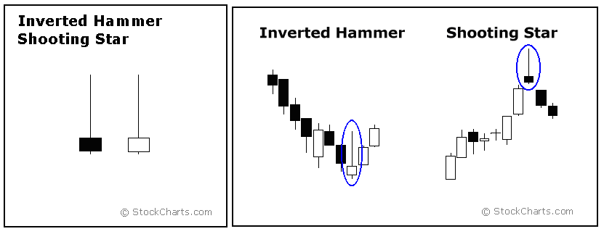
- The Hammer and Inverted Hammer form after a decline and are bullish reversal patterns, while the Shooting Star and Hanging Man form after an advance and are bearish reversal patterns. The Hammer and Hanging Man look exactly alike, but have different implications based on the preceding price action. Have small real bodies (black or white), long lower shadows and short or non-existent upper shadows. As with most single and double candlestick formations, the Hammer and Hanging Man require confirmation before action.
- The Inverted Hammer and Shooting Star look exactly alike, but have different implications based on previous price action. Both candlesticks have small real bodies (black or white), long upper shadows and small or nonexistent lower shadows. These candlesticks mark potential trend reversals, but require confirmation before action.
- The Shooting Star: The Shooting Star is a bearish reversal pattern that forms after an advance and in the star position, hence its name. A Shooting Star can mark a potential trend reversal or mark a resistance level. The candlestick forms when prices gap higher on the open, advance during the session and close well off their highs. The resulting candlestick has a long upper shadow and small black or white body. After a large advance, (the upper shadow), the bears push prices down. To indicate a substantial reversal, the upper shadow should relatively long and at least 2 times the length of the body. Bearish confirmation is required after the Shooting Star and it can come in the form of a gap down or long black candlestick on heavy volume.
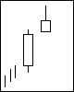
Recognition Criteria:
- A very long upper shadow (more than twice the real body).
- The small real body at the lower end of the price range.
- The real body gaps away from the prior real body. (Confirmation is suggested.)
- The Inverted Hammer: The Inverted Hammer is a bullish reversal pattern, forms after a decline and represents a potential trend reversal or marks support levels. After a decline, the long upper shadow indicates buying pressure during the session. However, the bulls were not able to sustain this buying pressure and prices closed well off of their highs to create the long upper shadow. Because of this failure, bullish confirmation is required before action. An Inverted Hammer followed by a gap up or long white candlestick with heavy volume could act as bullish confirmation.

- Blending Candlesticks: Candlestick patterns are made up of one or more candlesticks and these can be blended together to form one candlestick. This blended candlestick captures the essence of the pattern and can be formed using the following:
- The open of first candlestick
- The close of the last candlestick
- The high and low of the pattern
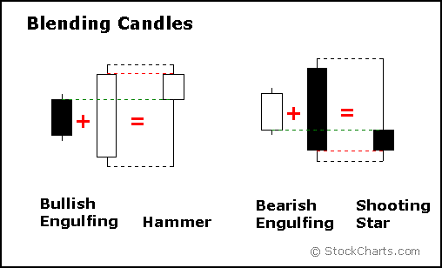
- By using the open of the first candlestick, close of the second candlestick, and high/low of the pattern, a Bullish Engulfing Pattern or Piercing Pattern blends into a Hammer. The long lower shadow of the Hammer signals a potential bullish reversal. As with the Hammer, both the Bullish Engulfing Pattern and the Piercing Pattern require bullish confirmation.
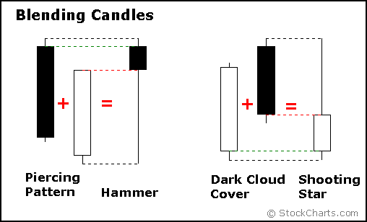
- Blending the candlesticks of a Bearish Engulfing Pattern or Dark Cloud Cover Pattern creates a Shooting Star. The long, upper shadow of the Shooting Star indicates a potential bearish reversal. As with the Shooting Star, Bearish Engulfing, and Dark Cloud Cover Patterns require bearish confirmation.
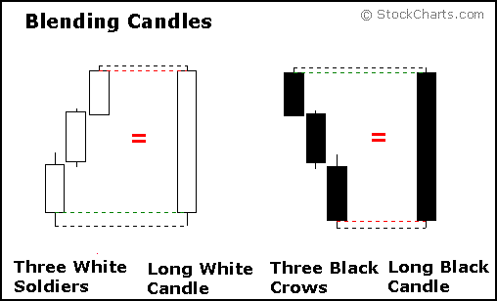
- More than two candlesticks can be blended using the same guidelines: open from the first, close from the last and high/low of the pattern. Blending Three White Soldiers creates a long white candlestick and blending Three Black Crows creates a long black candlestick.

- Candlesticks and Support: Single candlesticks and candlestick patterns can be used to confirm or mark support levels. Such a support level could be new after an extended decline or confirm a previous support level within a trading range. In a trading range, candlesticks can help choose entry points for buying near support and selling near resistance.
- The list below contains some, but not all, of the candlesticks and candlestick patterns that can be used to together with support levels. Bullish reversal candlesticks and patterns, that are marked {R} suggest that early selling pressure was overcome and buying pressure emerged for a strong finish. Such bullish price action indicates strong demand and that support may be found.
- Bullish Engulfing {R}
- Bullish Harami {R}
- Hammer, Inverted Hammer {R}
- Morning Star or Bullish Abandoned Baby {R}
- Piercing Pattern {R}
- Three White Soldiers {R}
- Long White candlestick or White Marubozu
- Doji (Normal, Long Legged, Dragonfly) {N}
- Spinning Top{N}
- The inverted hammer, long white candlestick and Marubozu show increased buying pressure rather than an actual price reversal. With its long upper shadow, an inverted hammer signifies intra-session buying interest that faded by the finish. Even though the security finished well below its high, the ability of buyers to push prices higher during the session is bullish. The long white candlestick and white Marubozu signify sustained buying pressure in which prices advanced sharply from open to close. Signs of increased buying pressure bode well for support.

- The doji and spinning top denote indecision and are generally considered neutral. These non-reversal patterns indicate a decrease in selling pressure, but not necessarily a revival of buying pressure. After a decline, the appearance of a doji or spinning top denotes a sudden letup in selling pressure. A stand-off has developed between buyers and sellers, and a support level may form.
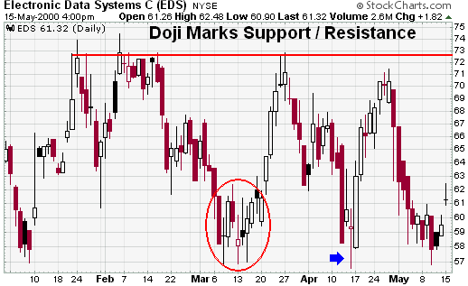
- Electronic Data Systems (EDS) (Above chart, example): traded in a range bound by 58 and 75 for about 4 months at the beginning of 2000. Support at 58 was first established in early January and resistance at 75 in late January. The stock declined to its previous support level in early March, formed a long legged doji and later a spinning top (red circle). Notice that the doji formed immediately after a long black Marubozu (long black candlestick without upper or lower shadows) and at the bottom of the move. This doji marked a sudden decrease in relative selling pressure and support held. Support was tested again in April and this test was also marked by a long legged doji (blue arrow).
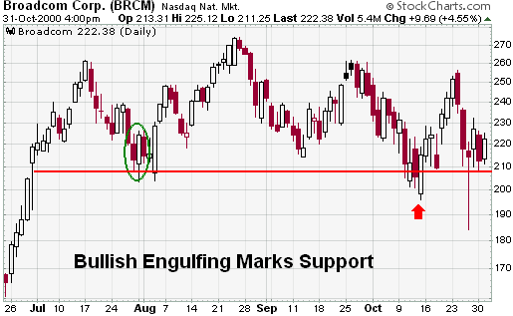
- (Example chart, above) Broadcom (BRCM) formed a bullish engulfing pattern to mark a new support level just below 210 (green oval) in late July 2000. A few days later a long white candlestick formed and engulfed the previous 4 candlesticks. The combination of the bullish engulfing and long white candlestick served to reinforce the validity of support around 208. The stock has since tested support around 208 once in early September and twice in October. A piercing pattern (red arrow) formed in early October and a large hammer in late October.
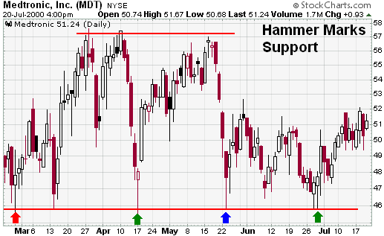
- Medtronic (MDT) established support around 46 in late February with a spinning top (red arrow) and early March with a harami. The stock declined sharply in April and formed a hammer to confirm support at 46 (green arrow). After a reaction rally to resistance around 57, the stock again declined sharply and again found support around 46 (blue arrow). The black candlestick with the long lower shadow marked support, but the body was too big to qualify as a hammer.

Candlestick and Resistance

Single candlesticks and candlestick patterns can be used to confirm or mark resistance levels. Such a resistance level could be new after an extended advance, or an existing resistance level confirmed within a trading range. In a trading range, candlesticks can help identify entry points to sell near resistance or buy near support. The list below contains some, but not all, of the candlesticks and candlestick patterns that can be used to identify or confirm resistance levels. The bearish reversal patterns are marked (R).
- Bearish Engulfing (R)
- Bearish Harami (R)
- Dark Cloud Cover (R)
- Evening Star or Bearish Abandoned Baby (R)
- Hanging Man (R)
- Three Black Crows (R)
- Shooting Star (R)
- Long Black Candlestick or Black Marubozu
- Spinning Top
- Doji (Normal, Long Legged, Gravestone)
- Bearish reversal candlesticks and patterns suggest that buying pressure was suddenly overturned and selling pressure prevailed. Such a quick reversal of fortune indicates overhead supply and a resistance level may form.
- The hanging man, long black candlestick and black Marubozu signify increased selling pressure rather than an actual reversal. After an advance, the hanging man's long lower shadow indicates intra-session selling pressure that was overcome by the end of the session. Even though the security finished above its low, the ability of sellers to drive prices lower raises a yellow flag. The long black candlestick and black Marubozu signify sustained selling pressure that moved prices significantly lower from beginning to end. Such intense selling pressure signals weakness among buyers and a resistance level may be established.
- The doji and spinning top show indecision and are generally considered neutral. These non-reversal patterns indicate decreased buying pressure, but no noticeable increase in selling pressure. For an advance to continue, new buyers must be willing to pay higher prices. As noted by the spinning top and doji, a standoff shows lack of conviction among buyers and a possible resistance level.
Candlesticks with Bullish reversal pattern
There are dozens of bullish reversal candlestick patterns. I have elected to narrow the field by selecting the most popular for detailed explanations. Below are some of the key bullish reversal patterns with the number of candlesticks required in parentheses.
- Bullish Engulfing (2 candles)
- Piercing Pattern (2 candles)
- Bullish Harami (2 candles)
- Hammer (1 Candle)
- Inverted Hammer (1 Candle)
- Morning Star (3 candles)
- Bullish Abandoned Baby (3 candles)
Before moving on to individual patterns, certain guidelines should be established:
- Most patterns require bullish confirmation.
- Bullish reversal patterns should form within a downtrend.
- Other aspects of technical analysis should be used as well.
- Bullish Confirmation: Patterns can form with one or more candlesticks; most require bullish confirmation. The actual reversal indicates that buyers overcame prior selling pressure, but it remains unclear whether new buyers will bid prices higher. Bullish confirmation means further upside follows through and can come as a gap up, long white candlestick or high volume advance. Because candlestick patterns are short-term and usually effective for only 1 or 2 weeks, bullish confirmation should come within 1 to 3 days after the pattern. Without confirmation, these patterns would be considered neutral and merely indicate a potential support level at best.

- Existing Down-Trend: To be considered a bullish reversal, there should be an existing downtrend to reverse. A bullish engulfing at new highs can hardly be considered a bullish reversal pattern. Such formations would indicate continued buying pressure and could be considered a continuation pattern. In the Ciena example below, the pattern in the red oval looks like a bullish engulfing, but formed near resistance after about a 30 point advance. The pattern does show strength, but is more likely a continuation at this point than a reversal pattern.
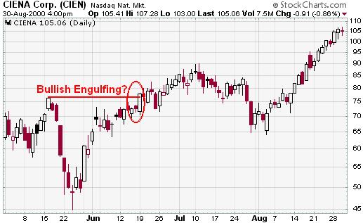
- The existence of a downtrend can be determined by using moving averages, peak/trough analysis or trend lines. A security could be deemed in a downtrend based on one of the following:
- The security is trading below its 20-day exponential moving average (EMA).
- Each reaction peak and trough is lower than the previous.
- The security is trading below its trend line.
- These are just examples of possible guidelines to determine a downtrend. Some traders may prefer shorter downtrends and consider securities below the 10-day EMA. Defining criteria will depend on your trading style and personal preferences.

- Other Technical Analysis: Candlesticks provide an excellent means to identify short-term reversals, but should not be used alone. Other aspects of technical analysis can and should be incorporated to increase reversal robustness. Below are three ideas on how traditional technical analysis might be combined with candlestick analysis.

Support: Look for bullish reversals at support levels to increase robustness. Support levels can be identified with moving averages, previous reaction lows, trend lines or Fibonacci retracement.
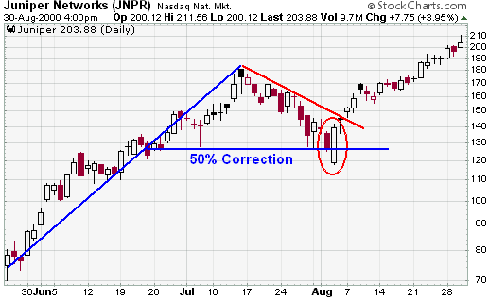

Momentum: Use oscillators to confirm improving momentum with bullish reversals. Positive divergences in MACD, PPO, Stochastic, RSI, Stoch-RSI or Williams’s %R would indicate improving momentum and increase the robustness behind a bullish reversal pattern.

Money Flows: Money Flows: Use volume-based indicators to access buying and selling pressure. On Balance Volume (OBV), Chaikin Money Flow (CMF) and the Accumulation/Distribution Line can be used in conjunction with candlesticks. Strength in any of these would increase the robustness of a reversal. For those that want to take it one step further, all three aspects could be combined for the ultimate signal. Look for bullish candlestick reversal in securities trading near support with positive divergences and signs of buying pressure.

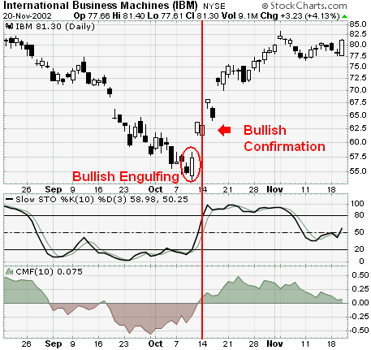
Example: A number of signals came together for IBM in early October. After a steep decline since August, the stock formed a bullish engulfing pattern (red oval) and this was confirmed three days later with a strong advance. The 10-day Slow Stochastic Oscillator formed a positive divergence and moved above its trigger line just before the stock advanced. Although not in the green yet, CMF showed constant improvement and moved into positive territory a week later.
- Bullish Engulfing: The bullish engulfing pattern consists of two candlesticks, the first black and the second white. The size of the black candlestick is not that important, but it should not be a doji which would be relatively easy to engulf. The second should be a long white candlestick – the bigger it is, the more bullish. The white body must totally engulf the body of the first black candlestick. Ideally, though not necessarily, the white body would engulf the shadows as well. Although shadows are permitted, they are usually small or nonexistent on both candlesticks.
After a decline, the second white candlestick begins to form when selling pressure causes the security to open below the previous close. Buyers step in after the open and push prices above the previous open for a strong finish and potential short-term reversal. The larger the white candlestick - the greater the engulfing, the more bullish the reversal. Further strength is required to provide bullish confirmation of this reversal pattern.
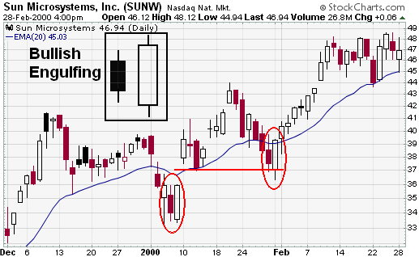
Example: In Jan-00, Sun Microsystems (SUNW) formed a pair of bullish engulfing patterns that foreshadowed two significant advances. The first formed in early January after a sharp decline that took the stock well below its 20-day exponential moving average (EMA). An immediate gap up confirmed the pattern as bullish and the stock raced ahead to the mid-forties. After correcting to support, the second bullish engulfing pattern formed in late January. The stock declined below its 20-day EMA and found support from its earlier gap up. This also marked a 2/3 correction of the prior advance. A bullish engulfing pattern formed and was confirmed the next day with a strong follow-up advance.
Engulfing Pattern: A reversal pattern that can be bearish or bullish, depending upon whether it appears at the end of an uptrend (bearish engulfing pattern) or a downtrend (bullish engulfing pattern). The first day is characterized by a small body, followed by a day whose body completely engulfs the previous day's body.
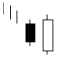
- Piercing Pattern: the piercing pattern is made up of two candlesticks, the first black and the second white. Both candlesticks should have fairly large bodies and the shadows are usually, but not necessarily, small or nonexistent. The white candlestick must open below the previous close and close above the midpoint of the black candlestick's body. A close below the midpoint might qualify as a reversal, but would not be considered as bullish. Just as with the bullish engulfing pattern, selling pressure forces the security to open below the previous close, indicating that sellers still have the upper hand on the open. However, buyers step in after the open to push the security higher and it closes above the midpoint of the previous black candlestick's body. Further strength is required to provide bullish confirmation of this reversal pattern.
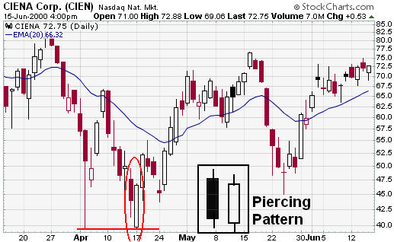
Example: In late March and early April 2000, Ciena (CIEN) declined from above 80 to around 40. The stock first touched 40 in early April with a long lower shadow. After a bounce, the stock tested support around 40 again in mid April and formed a piercing pattern. The piercing pattern was confirmed the very next day with a strong advance above 50. Even though there was a setback after confirmation, the stock remained above support and advanced above 70. Also notice the morning doji star in late May.
Piercing Line: It is a bullish two day reversal pattern which is composed of a long black body followed by a white body. It tells that the market opens lower on the opening and closes above the midpoint of the prior body.
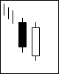

Recognition Criteria:
- A long black body followed by a white body.
- The white body pierces the midpoint of the prior white body.
- Occurs in a downtrend. (Confirmation is suggested.)

- Bullish Harami: The bullish harami is made up of two candlesticks. The first has a large body and the second a small body that is totally encompassed by the first. There are four possible combinations: white/white, white/black, black/white and black/black. Whether they are bullish reversal or bearish reversal patterns, all harami look the same. Their bullish or bearish nature depends on the preceding trend. Harami are considered potential bullish reversals after a decline and potential bearish reversals after an advance. No matter what the color of the first candlestick, the smaller the body of the second candlestick is, the more likely the reversal. If the small candlestick is a doji, the chances of a reversal increase.
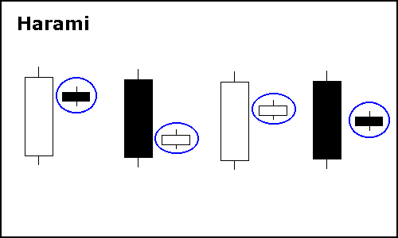
In his book Beyond Candlesticks, Steve Nilsson asserts that any combination of colors can form a harami, but that the most bullish are those that form with a white/black or white/white combination. White/white and white/black bullish harami are likely to occur less often than black/black or black/white. Because the first candlestick has a large body, it implies that the bullish reversal pattern would be stronger if this body were white. The long white candlestick shows a sudden and sustained resurgence of buying pressure. The small candlestick afterwards indicates consolidation. After a decline, a black/black or black/white combination can still be regarded as a bullish harami. The first long black candlestick signals that significant selling pressure remains and could indicate capitulation. The small candlestick immediately following forms with a gap up on the open, indicating a sudden increase in buying pressure and potential reversal.
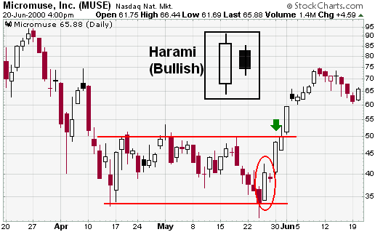
Example: Micro muse (MUSE) declined to the mid sixties in Apr-00 and began to trade in a range bound by 33 and 50 over the next few weeks. After a 6-day decline back to support in late May, a bullish harami (red oval) formed. The first day formed a long white candlestick, and the second a small black candlestick that could be classified as a doji. The next day's advance provided bullish confirmation and the stock subsequently rose to around 75.
- Hammer: The hammer is made up of one candlestick, white or black, with a small body, long lower shadow and small or nonexistent upper shadow. The hammer is a bullish reversal pattern and becomes significant after a decline of prices. In other words a hammer that forms below EMA (21) could be seen as bullish reversal. The size of the lower shadow should be a least twice the length of the body and the high/low range should be relatively large. Large is a relative term and the high/low range should be large relative to range over the last 10-20 days. After a decline, the hammer's intraday low indicates that selling pressure remains. However, the strong close shows that buyers are starting to become active again. Further strength is required to provide bullish confirmation of this reversal pattern.
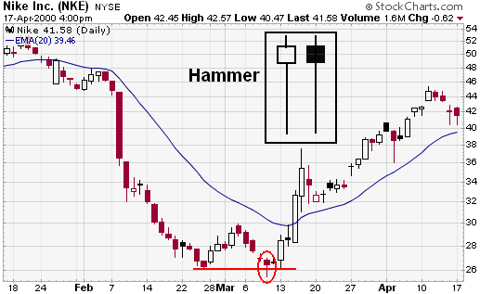

Example: Nike (NKE) declined from the low fifties to the mid thirties before starting to find support in late February. After a small reaction rally, the stock declined back to support in mid March and formed a hammer. Bullish confirmation came two days later with a sharp advance.
Morning Star/Morning Doji Star (3 Candles): The morning star consists of three candlesticks: It becomes significant after decline in prices, preferably when below a moving average such as EMA-21.
- A long black candlestick.
- A small white or black candlestick that gaps below the close of the previous candlestick. This candlestick can also be a doji, in which case the pattern would be a morning doji star.
- A long white candlestick.
The black candlestick confirms that the decline remains in force and selling dominates. When the second candlestick gaps down, it provides further evidence of selling pressure. However, the decline ceases or slows significantly after the gap and a small candlestick forms. The small candlestick indicates indecision and a possible reversal of trend. If the small candlestick is a doji, the chances of a reversal increase. The third long white candlestick provides bullish confirmation of the reversal.
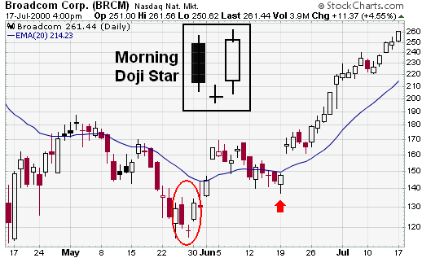
Example: After declining from above 180 to below 120, Broadcom (BRCM) formed a morning doji star and subsequently advanced above 160 in the next three days. These are strong reversal patterns and do not require further bullish confirmation, beyond the long white candlestick on the third day. After the advance above 160, a two-week pullback followed and the stock formed a piecing pattern (red arrow) that was confirmed with a large gap up.
Morning Star: A three day bullish reversal pattern consisting of three candlesticks – First, a long-bodied black candle extending the current downtrend, Second, a short middle candle that gapped down on the open, and third, a long-bodied white candle that gapped up on the open and closed above the midpoint of the body of the first day. The third candle is the confirmation of the reversal. It is named because it appears in the morning before the sun rises.

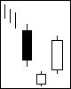
Recognition Criteria:
- The first day is a long black day.
- The second day is a star gaps away from the first day.
- The third day is a long white body that gaps up from the prior star. (Confirmation is suggested.)
Doji Star: A Doji Star is a trend reversal pattern which is composed of a long black body followed by a doji (a pattern with the same opening and closing price).

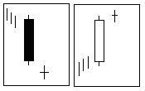

Recognition Criteria:
- Long black day followed by a doji.
- The doji gaps down from the prior black body. (Confirmation is suggested.)
Morning Doji Star: A three day bullish reversal pattern that is very similar to the Morning Star. The first day is in a downtrend with a long black body. The next day opens lower with a Doji that has a small trading range. The last day closes above the midpoint of the first day. Like the regular Morning Star, the third day will support the reversal of the trend. It is more significant than the regular Morning Star pattern.

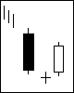
Recognition Criteria:
- The first day is a black day which indicates the trend of the market.
- The second day must be a Doji day.
- The third day is a white day and supports the reversal of the trend. (Confirmation is suggested.)

- Bullish Abandoned Baby: The bullish abandoned baby resembles the morning doji star and also consists of three candlesticks: It becomes significant after decline in prices, preferably when below a moving average such as EMA-21.
- A long black candlestick.
- A doji that gaps below the low of the previous candlestick.
- A long white candlestick that gaps above the high of the doji.

Abandoned Baby: A rare reversal pattern characterized by a gap followed by a Doji, which is then followed by another gap in the opposite direction. The shadows on the Doji must completely gap below or above the shadows of the first and third day.

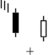
The main difference between the morning doji star and the bullish abandoned baby are the gaps on either side of the doji. The first gap down signals that selling pressure remains strong. However, selling pressure eases and the security closes at or near the open, creating a doji. Following the doji, the gap up and long white candlestick indicate strong buying pressure and the reversal is complete. Further bullish confirmation is not required.
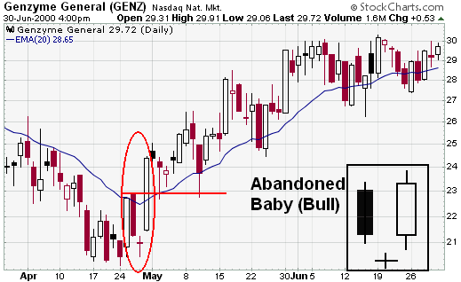
Example: In April, Genzyme (GENZ) declined below its 20-day EMA and began to find support in the low thirties. The stock began forming a base as early as 17-Apr, but a discernible reversal pattern failed to emerge until the end of May. The bullish abandoned baby formed with a long black candlestick, doji and long white candlestick. The gaps on either side of the doji reinforced the bullish reversal.
Candle Stick patterns with bearish reversal
Below are some of the key bearish reversal patterns, with the number of candlesticks required in parentheses.
- Bearish Abandoned Baby (3 Candles)
- Bearish Engulfing (2 Candles)
- Bearish Harami (2 Candles)
- Dark Cloud Cover (2 Candles)
- Evening Star (3 Candles)
- Shooting Star (1 Candle)
It is important to remember the following guidelines relating to bearish reversal patterns:
- Most patterns require further bearish confirmation.
- Bearish reversal patterns should form within an uptrend.
- Other aspects of technical analysis should be used as well.
Bearish Confirmation: Bearish reversal patterns can form with one or more candlesticks; most require bearish confirmation. The actual reversal indicates that selling pressure overwhelmed buying pressure for one or more days, but it remains unclear whether or not sustained selling or lack of buyers will continue to push prices lower. Bearish confirmation means further downside follow through, such as a gap down, long black candlestick or high volume decline. Because candlestick patterns are short-term and usually effective for 1-2 weeks, bearish confirmation should come within 1-3 days. Without confirmation, many of these patterns would be considered neutral and merely indicate a potential resistance level at best.
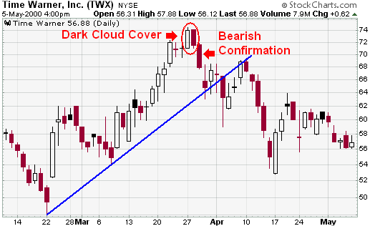
Example: Time Warner (TWX) advanced from the upper fifties to the low seventies in less than two months. The long white candlestick that took the stock above 70 in late March was followed by a long-legged doji in the harami position. A second long-legged doji immediately followed and indicated that the uptrend was beginning to tire. The dark cloud cover (red oval) increased these suspicions and bearish confirmation was provided by the long black candlestick (red arrow).
Existing Up-Trend: To be considered a bearish reversal, there should be an existing uptrend to reverse. It does not have to be a major uptrend, but should be up for the short term or at least over the last few days. A dark cloud cover after a sharp decline or near new lows is unlikely to be a valid bearish reversal pattern. Bearish reversal patterns within a downtrend would simply confirm existing selling pressure and could be considered continuation patterns. There are many methods available to determine the trend. An uptrend can be established using moving averages peak/trough analysis or trend lines. A security could be deemed in an uptrend based on one or more of the following:
- The security is trading above its 20-day exponential moving average (EMA).
- Each reaction peak and trough is higher than the previous.
- The security is trading above a trend line.
These are just three possible methods. Some traders may prefer shorter up-trends and qualify securities that are trading above their 10-day EMA. Defining criteria will depend on your trading style, time horizon and personal preferences.
Other Technical Analysis: Candlesticks provide an excellent means to identify short-term reversals, but should not be used alone. Other aspects of technical analysis can and should be incorporated to increase the robustness of bearish reversal patterns.

Resistance: Look for bearish reversals at Resistance levels to increase robustness. Resistance levels can be identified with moving averages, previous reaction lows, trend lines or Fibonacci retracement.
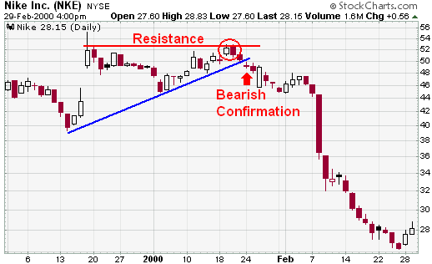
In Jan-00, Nike (NKE) gapped up over 5 points and closed above 50. A candlestick with a long upper shadow formed and the stock subsequently traded down to 45. This established a resistance level around 53. After an advance back to resistance at 53, the stock formed a bearish engulfing pattern (red oval). Bearish confirmation came when the stock declined the next day, gapped down below 50 and broke its short-term trend line two days later.
Momentum: Use oscillators to confirm weakening momentum with bearish reversals. Negative divergences in MACD, PPO, Stochastic, RSI, Stoch-RSI or Williams’s %R indicate weakening momentum and can increase the robustness of a bearish reversal pattern. In addition, bearish moving average crossovers in the PPO and MACD can provide confirmation, as well as trigger line crossovers for the Slow Stochastic Oscillator.
Money Flows: Use volume-based indicators to assess selling pressure and confirm reversals. On Balance Volume (OBV), Chaikin Money Flow and the Accumulation/Distribution Line can be used to spot negative divergences or simply excessive selling pressure. Signs of increased selling pressure can improve the robustness of a bearish reversal pattern.
For those that want to take it one step further, all three aspects could be combined for the ultimate signal. Look for a bearish candlestick reversal in securities trading near resistance with weakening momentum and signs of increased selling pressure. Such signals would be relatively rare, but could offer above-average profit potential.
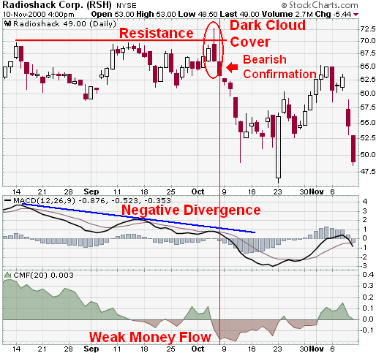
Example: A number of signals came together for RadioShack (RSH) in early Oct-00. The stock traded up to resistance at 70 for the third time in two months and formed a dark cloud cover pattern (red oval). In addition, the long black candlestick had a long upper shadow to indicate an intraday reversal. Bearish confirmation came the next day with a sharp decline. The negative divergence in the PPO and extremely weak money flows also provided further bearish confirmation.

Bearish Engulfing: The bearish engulfing pattern consists of two candlesticks; the first is white and the second black. The size of the white candlestick is not that important, but should not be a doji, which would be relatively easy to engulf. The second should be a long black candlestick. The bigger it is, the more bearish the reversal. The black body must totally engulf the body of the first, white, candlestick. Ideally, the black body should engulf the shadows as well, but this is not a requirement. Shadows are permitted, but they are usually small or nonexistent on both candlesticks.
After an advance, the second black candlestick begins to form when residual buying pressure causes the security to open above the previous close. However, sellers step in after this opening gap up and begin to drive prices down. By the end of the session, selling becomes so intense that prices move below the previous open. The resulting candlestick engulfs the previous day's body and creates a potential short-term reversal. Further weakness is required for bearish confirmation of this reversal pattern.
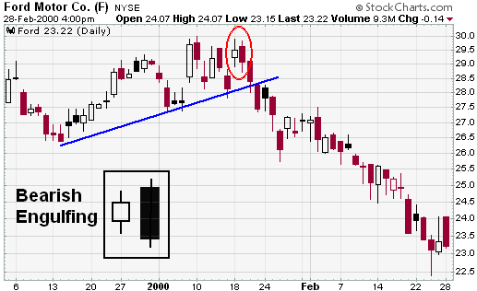
Example: After meeting resistance around 30 in mid-January, Ford (F) formed a bearish engulfing (red oval). The pattern was immediately confirmed with a decline and subsequent support break.

Dark Cloud Cover: The dark cloud cover pattern is made up of two candlesticks; the first is white and the second black. Both candlesticks should have fairly large bodies and the shadows are usually small or nonexistent, though not necessarily. The black candlestick must open above the previous close and close below the midpoint of the white candlestick's body. A close above the midpoint might qualify as a reversal, but would not be considered as bearish. Just as with the bearish engulfing pattern, residual buying pressure forces prices higher on the open, creating an opening gap above the white candlestick's body. However, sellers step in after the strong open and push prices lower. The intensity of the selling drives prices below the midpoint of the white candlestick's body. Further weakness is required for bearish confirmation of this reversal pattern.
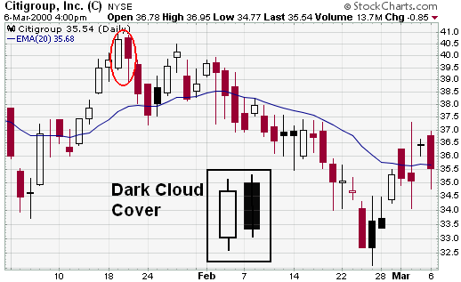
Example: After a sharp advance from 37 1/2 to 40.5 in about 2 weeks, Citigroup (C) formed a dark cloud cover pattern (red oval). This pattern was confirmed with two long black candlesticks and marked an abrupt reversal around 40.5.
Dark Cloud Cover: A bearish reversal pattern that continues the uptrend with a long white body. The next day opens at a new high then closes below the midpoint of the body of the first day. It is the opposite of the Piercing Line. It tells that the market opens above the prior day's high, and closes below the midpoint of the prior white body.
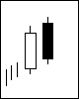

Recognition Criteria:
- A white body followed by a black body.
- The black body passes the midpoint of the prior white body.
- Occurs in an uptrend. (Confirmation is suggested.)

Shooting Star: The shooting star is made up of one candlestick (white or black) with a small body, long upper shadow and small or nonexistent lower shadow. The size of the upper shadow should be a least twice the length of the body and the high/low range should be relatively large. Large is a relative term and the high/low range should be large relative to the range over the last 10-20 days. For a candlestick to be in star position, it must gap way from the previous candlestick. In Candlestick Charting Explained, Greg Morris indicates that a shooting star should gap up from the preceding candlestick. However, in Beyond Candlesticks, Steve Nelson provides a shooting star example that forms below the previous close. There should be room to maneuver, especially when dealing with stocks and indices, which often open near the previous close. A gap up would definitely enhance the robustness of a shooting star, but the essence of the reversal should not be lost without the gap.
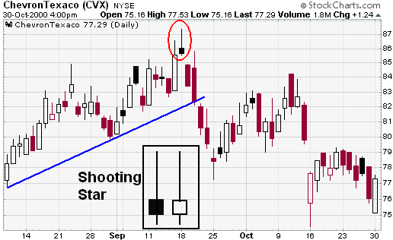
Example: After an advance that was punctuated by a long white candlestick, Chevron (CHV) formed a shooting star candlestick above 90 (red oval). The bearish reversal pattern was confirmed with a gap down the following day

Bearish Harami: The bearish harami is made up of two candlesticks. The first has a large body and the second a small body that is totally encompassed by the first. There are four possible combinations: white/white, white/black, black/white and black/black. Whether a bullish reversal or bearish reversal pattern, all harami look the same. Their bullish or bearish nature depends on the preceding trend. Harami are considered potential bearish reversals after an advance and potential bullish reversals after a decline. No matter what the color of the first candlestick, the smaller the body of the second candlestick is, the more likely the reversal. If the small candlestick is a doji, the chances of a reversal increase.
In his book, Beyond Candlesticks, Steve Nison asserts that any combination of colors can form a harami, but the most bearish are those that form with a black/white or black/black combination. Because the first candlestick has a large body, it implies that the bearish reversal pattern would be stronger if this body were black. This would indicate a sudden and sustained increase in selling pressure. The small candlestick afterwards indicates consolidation before continuation. After an advance, black/white or black/black bearish harami are not as common as white/black or white/white variations.
A white/black or white/white combination can still be regarded as a bearish harami and signal a potential reversal. The first long white candlestick forms in the direction of the trend. It signals that significant buying pressure remains, but could also indicate excessive bullishness. Immediately following, the small candlestick forms with a gap down on the open, indicating a sudden shift towards the sellers and a potential reversal.
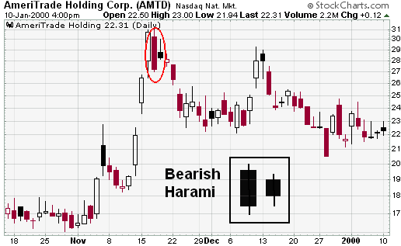
After a gap up and rapid advance to 30, Ameritrade (AMTD) formed a bearish harami (red oval). This harami consists of a long black candlestick and a small black candlestick. The decline two days later confirmed the bearish harami and the stock fell to the low twenties.
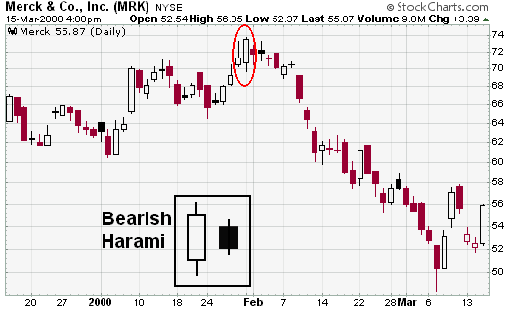
Merck (MRK) formed a bearish harami with a long white candlestick and long black candlestick (red oval). The long white candlestick confirmed the direction of the current trend. However, the stock gapped down the next day and traded in a narrow range. The decline three days later confirmed the pattern as bearish.

Evening Star/Evening Doji Star: The evening star consists of three candlesticks:
- A long white candlestick, which indicates the buying pressure or continuation of the existing buying pressure.
- A small white or black candlestick that gaps above the close (body) of the previous candlestick. This candle stick may be a spinning top or any other small candle stick, small as compared to the previous candle. This candlestick can also be a doji, in which case the pattern would be an evening doji star in which case the chances of reversal increase. This indicates the remaining buying pressure may be exhausting and indecision is mounting.
- A long black candlestick. This confirms the bearishness and confirms the reversal of the previous up trend.
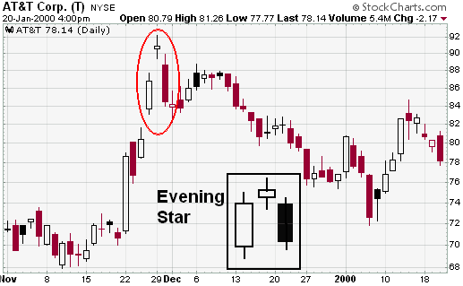
After advancing from 68 to 91 in about two weeks, AT&T (T) formed an evening star (red oval). The middle candlestick is a spinning top, which indicates indecision and possible reversal. The gap above 91 was reversed immediately with a long black candlestick. Even though the stock stabilized in the next few days, it never exceeded the top of the long black candlestick and subsequently fell below 75.
Evening Star: A bearish reversal pattern that continues an uptrend with a long white body day followed by a gapped up small body day, then a down close with the close below the midpoint of the first day.
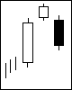
Recognition Criteria:
- The first day is a long white day.
- The second day gap higher from the first day.
- The third day is a long black day and close below the midpoint of the first white day. Confirmation is suggested.)

Evening Doji Star; It is a three day bearish reversal pattern similar to the Evening Star. The uptrend continues with a large white body. The next day opens higher, trades in a small range, then closes at its open (Doji). The next day closes below the midpoint of the body of the first day, which confirms the reversal of the trend. It is more significant than the regular Evening Star pattern.
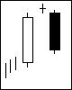
Recognition Criteria:
- The first day is a white day which indicates the trend of the market.
- The second day is a Doji day.
- The third day is black day which supports the reversal of the trend. (Confirmation is suggested.)
Abandoned Baby: The Abandoned Baby pattern is similar to the family of Morning Star and Evening Star patterns. It is almost the same as Morning Doji and Evening Doji Star. The difference is the shadows on the Doji must gap below the shadows of the first and third days for the Abandoned Baby bottom. Abandoned baby patterns are of two types. The first one is Bullish Abandoned Baby while the second one is Bearish Abandoned Baby
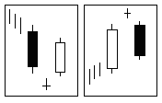

Recognition Criteria:
- The first day shall indicates the prior trend.
- The second day is a Doji which gaps above or below the previous day's range.
- The third day is the opposite color of the first day and gaps in the opposite direction.
- There is no shadows overlapping between the Doji and other two days. Confirmation is suggested.)

Bearish Abandoned Baby: The bearish abandoned baby resembles the evening doji star and also consists of three candlesticks:
- A long white candlestick.
- A doji that gaps above the high of the previous candlestick.
- A long black candlestick that gaps below the low of the doji.
The main difference between the evening doji star and the bearish abandoned baby are the gaps on either side of the doji. The first gap up signals a continuation of the uptrend and confirms strong buying pressure. However, buying pressure subsides after the gap up and the security closes at or near the open, creating a doji. Following the doji, the gap down and long black candlestick indicate strong and sustained selling pressure to complete the reversal. Further bearish confirmation is not required.
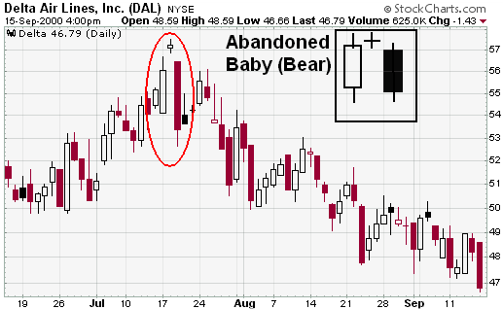
Delta (DAL) formed an abandoned baby to mark a sharp reversal that carried the stock from 57 1/2 to 47 1/2. Although the open and close are not exactly equal, the small white candlestick in the middle captures the essence of a doji. Indecision is reflected with the small body and equal upper and lower shadows. In addition, the middle candlestick is separated by gaps on either side, which add emphasis to the reversal.

