NIFTY ELLIOTT WAVE COMMENTARY:
Hi all,
This is more or less the working of the past data, it is more of post mortem, but it would be helpful for any person who wants statistics as well, further I have uploaded pics and tables for reference.
The wave analysis has been done based on Closing Price.

I shall concentrate here only the present bull-run that started from 25th April 2003. The progress of nifty to 8th January 2008 is presented in the following table:

Table 1
Count | Date | Open | High | Low | Close | Points | % | Session | Calender Days
0 | 25-Apr-2003 | 929.45 | 931.35 | 921.10 | 924.30 | -
1 | 14-Jan-2004 | 1,987.40 | 1,995.20 | 1,970.10 | 1,982.15 | 1,057.85 | 114.45% | 186 | 264
2 | 17-May-2004 | 1,582.50 | 1,583.80 | 1,292.20 | 1,388.75 | 593.40 | 29.94% | 83 | 124
3 | 10-May-2006 | 3,720.75 | 3,758.05 | 3,717.25 | 3,754.25 | 2,365.50 | 170.33% | 498 | 723
4 | 14-Jun-2006 | 2,665.05 | 2,767.75 | 2,595.65 | 2,632.80 | 1,121.45 | 29.87% | 25 | 35
5 | 08-Jan-2008 | 6,282.45 | 6,357.10 | 6,221.60 | 6,287.85 | 3,655.05 | 138.83% | 394 | 573

Now let me first lay down the basic Elliott rules:

- Wave 2 never moves beyond wave 1
- Wave 3 is never the shortest wave
- Wave 4 never enters the price territory of wave 1

Now, these are basic rules, so let me put the above table to the above test.
Here, we see that on points basis, the nifty wave 3 of 3754.25 points is although smaller than wave 5 but still larger than wave 1, making it not the shortest. However, for longer period, we need to compare based on percentage terms and we observe that wave 3 was 170.33% which is more than wave 1 and wave 4, whose movement was 114.45% and 138.83% respectively.
Even on the count of sessions and calendar days, the movement of wave 3 is more than that of wave 1 and 2.

Now the waves 2 and 4 are the corrective waves in the major wave uptrend denoted by 1, 3 and 5. Now, as per the rule of alteration, the wave 2 is a side ways correction while wave 4 is a sharp correction. This works in either or way, meaning, in case wave 2 is sharp correction, then wave 4 would be sideways. Here, wave 2 was sideways followed by wave 4 as sharp correction.

The above table and following graph which gives the wave count over semi-log scale.

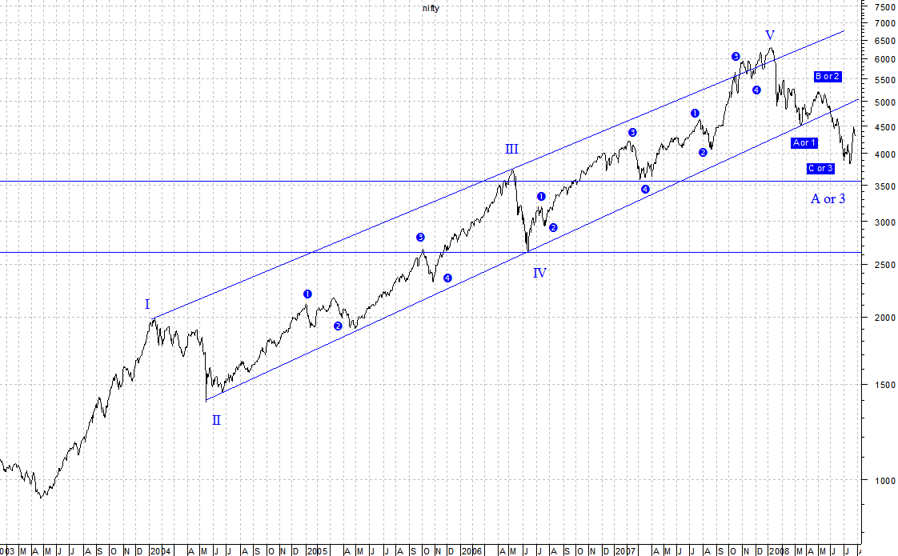

Now, I will try and concentrate on individual wave counts, the following table shall give the detailed counts for the waves in wave 1:

Table 2
Count | Date | Open | High | Low | Close | Points | % | Calender Days | Session
0 | 25-Apr-2003 | 929.45 | 931.35 | 921.10 | 924.30 |  |  | 0
1 | 14-Jul-2003 | 1,161.20 | 1,173.95 | 1,161.20 | 1,171.50 | 247.20 | 26.74% | 80 | 56
2 | 22-Jul-2003 | 1,115.35 | 1,118.25 | 1,089.30 | 1,109.20 | 62.30 | 5.32% | 8 | 6
i | 08-Sep-2003 | 1,398.40 | 1,420.25 | 1,398.35 | 1,417.35 | 308.15 | 27.78% | 48 | 33
ii | 22-Sep-2003 | 1,319.25 | 1,333.55 | 1,300.25 | 1,302.90 | 114.45 | 8.07% | 14 | 10
iii | 17-Oct-2003 | 1,565.20 | 1,574.10 | 1,552.15 | 1,569.45 | 266.55 | 20.46% | 25 | 18
iv | 23-Oct-2003 | 1,494.75 | 1,503.00 | 1,466.25 | 1,470.45 | 99.00 | 6.31% | 6 | 4
v | 04-Nov-2003 | 1,601.30 | 1,626.40 | 1,601.30 | 1,618.70 | 148.25 | 10.08% | 12 | 9
3 | 04-Nov-2003 | 1,601.30 | 1,626.40 | 1,601.30 | 1,618.70 | 509.50 | 45.93% | 105 | 74
4 | 20-Nov-2003 | 1,542.85 | 1,558.15 | 1,517.90 | 1,522.30 | 96.40 | 5.96% | 16 | 13
5 | 14-Jan-2004 | 1,987.40 | 1,995.20 | 1,970.10 | 1,982.15 | 459.85 | 30.21% | 55 | 37
1 | 14-Jan-2004 | 1,987.40 | 1,995.20 | 1,970.10 | 1,982.15 | 1,057.85 | 114.45% | 264 | 186

The above data is as represented in Exhibit 2 below:
Now the font color red represent major move, black colored with yellow fill indicates count one degree lower and similarly, even here we see uncanny adherence to the wave rules.
Exhibit 2
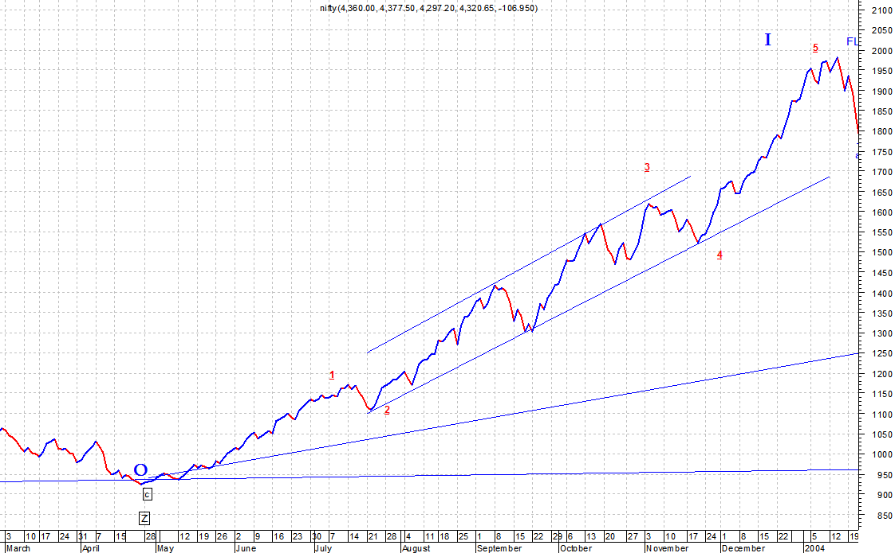

Now in case of wave 2, there is Flat correction with wave. The bifurcation of internal is presented below.
Table 3
Date | Open | High | Low | Close | Count | Points | %
22-Jan-2004 | 1,824.70 | 1,854.55 | 1,756.25 | 1,770.50 | a
27-Jan-2004 | 1,847.90 | 1,911.30 | 1,844.65 | 1,904.70 | b
03-Feb-2004 | 1,809.30 | 1,815.95 | 1,755.65 | 1,769.00 | c-A | 201.10 | 10.21%
17-Feb-2004 | 1,913.55 | 1,926.15 | 1,905.50 | 1,920.10 | a
26-Feb-2004 | 1,787.45 | 1,818.60 | 1,760.55 | 1,765.80 | b
08-Mar-2004 | 1,868.15 | 1,891.95 | 1,867.95 | 1,885.25 | c-B | 116.25 | 6.57%
22-Mar-2004 | 1,726.30 | 1,726.35 | 1,678.40 | 1,685.00 | a
22-Apr-2004 | 1,873.55 | 1,894.60 | 1,871.00 | 1,889.55 | b
17-May-2004 | 1,582.50 | 1,583.80 | 1,292.20 | 1,388.75 | c-C | 496.50 | 26.34%
17-May-2004 | 1,582.50 | 1,583.80 | 1,292.20 | 1,388.75 | 2 | 593.40 | 29.94%

Exhibit 3
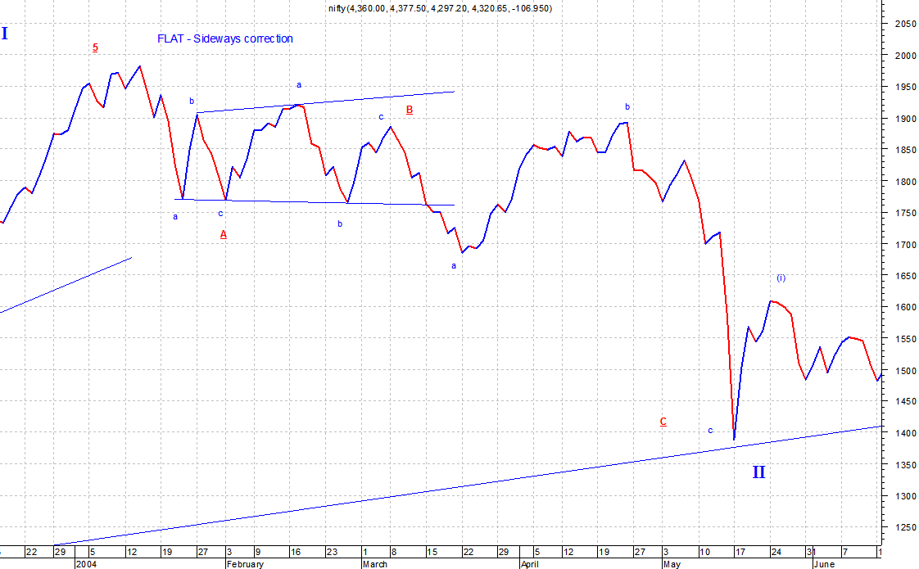

Now there exists a fibo relation in wave A and wave C here:
Wave A x 2.618 = wave C
10.21 % x 2.618 = 26.72 and wave C is 26.34, which is approximately the same.
The wave 2 is sideways correction, and corrects 56.118% to wave 1, which lies between 50% and 61.8% fibo correction, which although is not near 61.8% but does extend beyond sub wave (iv) which is 1522 and the wave 2 ends at 1388.75.

Wave 3 internal:
Table 4
Date | Open | High | Low | Close | Count | Points | % | Calender Days | Session
17-May-2004 | 1,582.50 | 1,583.80 | 1,292.20 | 1,388.75 | 2 |  |  | 0
24-May-2004 | 1,563.65 | 1,613.60 | 1,563.05 | 1,608.85 | i | 220.10 | 15.85% | 7 | 5
23-Jun-2004 | 1,474.80 | 1,481.45 | 1,442.55 | 1,446.10 | ii | 162.75 | 10.12% | 30 | 22
08-Oct-2004 | 1,815.65 | 1,825.15 | 1,808.75 | 1,820.20 | iii | 374.10 | 25.87% | 107 | 77
25-Oct-2004 | 1,780.00 | 1,783.55 | 1,753.50 | 1,757.25 | iv | 62.95 | 3.46% | 17 | 10
03-Jan-2005 | 2,080.00 | 2,118.60 | 2,080.00 | 2,115.00 | v | 357.75 | 20.36% | 70 | 48
03-Jan-2005 | 2,080.00 | 2,118.60 | 2,080.00 | 2,115.00 | 1 | 726.25 | 52.30% | 231 | 162
24-Jan-2005 | 1,925.30 | 1,932.75 | 1,902.90 | 1,909.00 | a |  |  | 21
08-Mar-2005 | 2,160.65 | 2,173.85 | 2,154.00 | 2,168.95 | b |  |  | 43
29-Apr-2005 | 1,943.20 | 1,943.20 | 1,896.30 | 1,902.50 | c |  |  | 52
29-Apr-2005 | 1,943.20 | 1,943.20 | 1,896.30 | 1,902.50 | 2 | 212.50 | 10.05% | 116 | 80
04-Oct-2005 | 2,630.00 | 2,667.05 | 2,629.60 | 2,663.35 | 3 | 760.85 | 39.99% | 158 | 110
28-Oct-2005 | 2,352.65 | 2,355.15 | 2,307.45 | 2,316.05 | 4 | 347.30 | 13.04% | 24 | 17
10-May-2006 | 3,720.75 | 3,758.05 | 3,717.25 | 3,754.25 | 5 | 1,438.20 | 62.10% | 194 | 129
10-May-2006 | 3,720.75 | 3,758.05 | 3,717.25 | 3,754.25 | 3 | 2,365.50 | 170.33% | 723 | 498

Exhibit 4
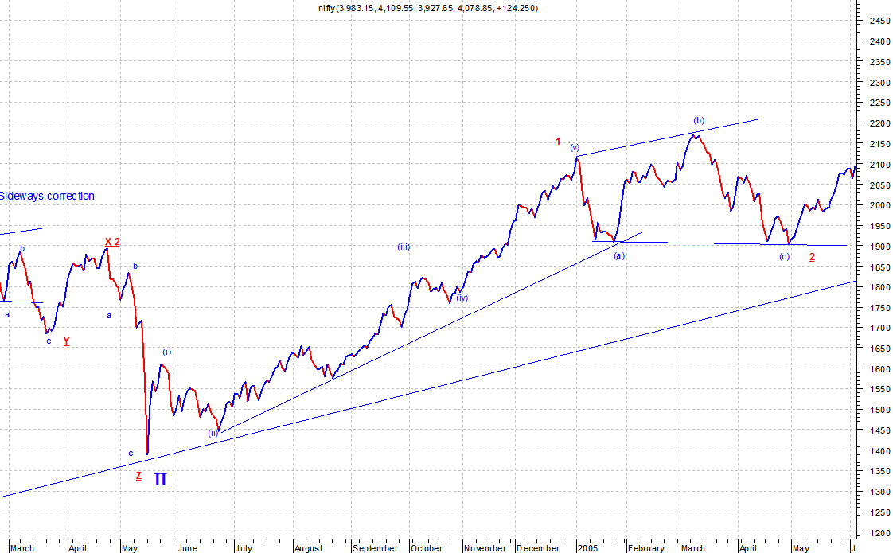

Exhibit 5
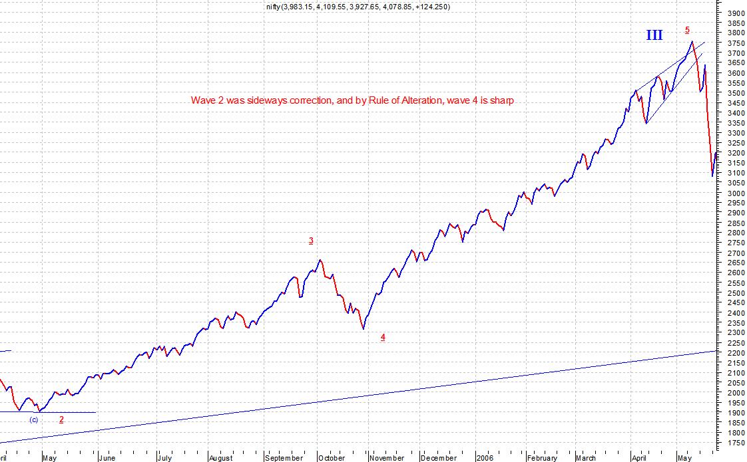

Here the markets rose 2365.50 points approx 170.33% rise (highest of the three impulse waves)

Now lengths of wave lengths from 0-4 and 4-5 are in following relation
Start to wave 4 = 1388.75 – 2316.05 = 927.30 0.392 approx 0.382
Wave 4 to wave 5 = 3754.25 – 2316.05 = 1438.20 0.6079 approx 0.618
Total = 2365.50 1.00
That would explain the relation in the elongated 5th wave of wave 3. In case there is such extension, then wave 4 (corrective) wave has to be sharp and using rule of alteration, where wave 2 was side ways correction, wave 4 had to be sharp correction.
The details of wave 4 are as discussed below:

Wave 4 internals:
Table 5
Date | Open | High | Low | Close | Count | Points | % | Calender Days | Session
10-May-2006 | 3,720.75 | 3,758.05 | 3,717.25 | 3,754.25 | 3 |  |  | 0
22-May-2006 | 3,254.30 | 3,313.90 | 2,896.40 | 3,081.35 | a | 672.90 | 17.92% | 12
29-May-2006 | 3,207.25 | 3,255.25 | 3,193.15 | 3,214.90 | b | 133.55 | 4.33% | 7
14-Jun-2006 | 2,665.05 | 2,767.75 | 2,595.65 | 2,632.80 | c | 582.10 | 18.11% | 16
14-Jun-2006 | 2,665.05 | 2,767.75 | 2,595.65 | 2,632.80 | 4 | 1,121.45 | 29.87% | 35 | 25

Exhibit 6
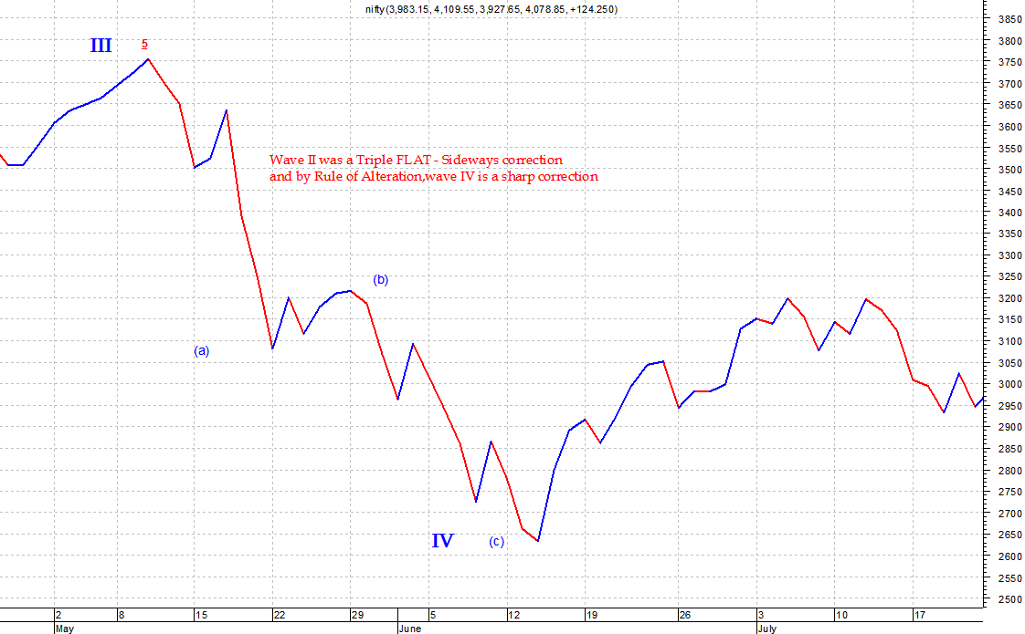

As we can see wave 4 was sharp correction and it corrected, from 3754.25 to 2632.80 making it 1121.45 points fall around 29.84% fall, in 25 session and entering into fibo retracement between 38.2% to 50% and entering into territory of 4th wave of previous territory. The length of wave 3 was 2365.50 points while that of wave 4 was 1121.45 points amounting to 47.4085% correction.

Wave 5 an extension:
Table 6
Date | Open | High | Low | Close | Count | Points | % | Calender Days | Session
14-Jun-2006 | 2,665.05 | 2,767.75 | 2,595.65 | 2,632.80 | 4 |  |  | 0
12-Jul-2006 | 3,124.95 | 3,201.35 | 3,078.25 | 3,195.90 | 1 | 563.10 | 21.39% | 28 | 21
19-Jul-2006 | 2,995.85 | 3,045.35 | 2,919.95 | 2,932.75 | 2 | 263.15 | 8.23% | 7 | 5
04-Sep-2006 | 3,435.55 | 3,483.10 | 3,435.55 | 3,476.85 | i | 544.10 | 18.55% | 47 | 32
11-Sep-2006 | 3,470.35 | 3,486.65 | 3,351.30 | 3,366.15 | ii | 110.70 | 3.18% | 7 | 5
06-Dec-2006 | 4,016.00 | 4,036.20 | 3,982.50 | 4,015.95 | iii | 649.80 | 19.30% | 86 | 60
12-Dec-2006 | 3,849.10 | 3,861.25 | 3,661.60 | 3,716.90 | iv | 299.05 | 7.45% | 6 | 4
07-Feb-2007 | 4,198.20 | 4,232.30 | 4,192.85 | 4,224.25 | v | 507.35 | 13.65% | 57 | 37
07-Feb-2007 | 4,198.20 | 4,232.30 | 4,192.85 | 4,224.25 | 3 | 1,291.50 | 44.04% | 203 | 138
16-Mar-2007 | 3,639.35 | 3,683.60 | 3,573.85 | 3,608.55 | 4 | 615.70 | 14.58% | 37 | 26
26-Jun-2007 | 4,259.40 | 4,296.15 | 4,250.10 | 4,285.70 | i | 677.15 | 18.77% | 102 | 68
21-Aug-2007 | 4,209.55 | 4,238.10 | 4,058.55 | 4,074.90 | ii | 210.80 | 4.92% | 56 | 39
02-Nov-2007 | 5,854.85 | 5,944.75 | 5,714.25 | 5,932.40 | iii | 1,857.50 | 45.58% | 73 | 52
12-Nov-2007 | 5,660.60 | 5,660.60 | 5,477.50 | 5,617.10 | iv | 315.30 | 5.31% | 10 | 6
08-Jan-2008 | 6,282.45 | 6,357.10 | 6,221.60 | 6,287.85 | v | 670.75 | 11.94% | 57 | 39
08-Jan-2008 | 6,282.45 | 6,357.10 | 6,221.60 | 6,287.85 | 5 | 2,679.30 | 74.25% | 298 | 204
08-Jan-2008 | 6,282.45 | 6,357.10 | 6,221.60 | 6,287.85 | 5 | 3,655.05 | 138.83% | 573 | 394

Exhibit 7
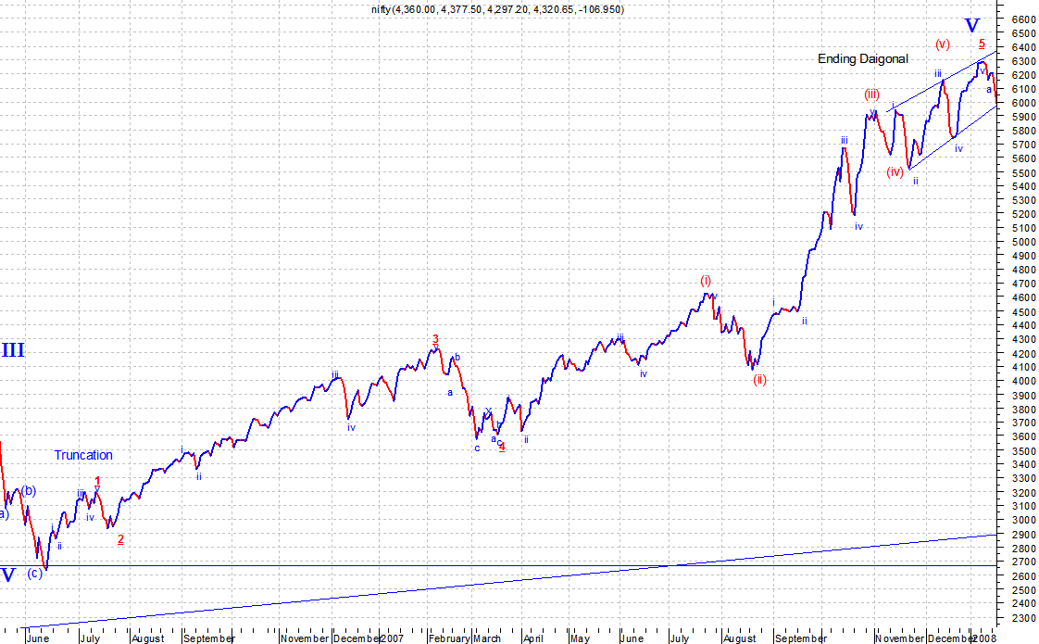

I reckon, wave 5 had an extension and has the points and counts as described above. Further since the wave 5 had an extension and was marked by an ending diagonal, the fall from 6287 which is quite evident then cause when we have extension and ending diagonal, the fall tends to be as much as the start of the ending diagonal. But the fall pretty much out did the start and went way lower.

Now I shall come to the correction that has taken place and its internal:
Table 7
Date | Open | High | Low | Close | Count | Points | %
08-Jan-2008 | 6,282.45 | 6,357.10 | 6,221.60 | 6,287.85 | 5
22-Jan-2008 | 5,203.35 | 5,203.35 | 4,448.50 | 4,899.30 | i | 1,388.55 | 22.08%
05-Feb-2008 | 5,463.75 | 5,500.60 | 5,412.95 | 5,483.90 | ii | 584.60 | 11.93%
12-Feb-2008 | 4,877.85 | 4,949.60 | 4,820.45 | 4,838.25 | iii | 645.65 | 11.77%
28-Feb-2008 | 5,266.35 | 5,302.85 | 5,227.15 | 5,285.10 | iv | 446.85 | 9.24%
17-Mar-2008 | 4,745.45 | 4,745.45 | 4,482.10 | 4,503.10 | v | 782.00 | 14.80%
17-Mar-2008 | 4,745.45 | 4,745.45 | 4,482.10 | 4,503.10 | A/1 | 1,784.75 | 28.38%
28-Mar-2008 | 4,830.00 | 4,970.80 | 4,796.35 | 4,942.00 | a | 438.90 | 9.75%
04-Apr-2008 | 4,766.70 | 4,791.70 | 4,632.70 | 4,647.00 | b | 295.00 | 5.97%
02-May-2008 | 5,265.30 | 5,298.85 | 5,197.60 | 5,228.20 | c | 581.20 | 12.51%
02-May-2008 | 5,265.30 | 5,298.85 | 5,197.60 | 5,228.20 | B/2 | 725.10 | 16.10%
13-May-2008 | 5,008.60 | 5,066.00 | 4,943.75 | 4,957.80 | i | 270.40 | 5.17%
16-May-2008 | 5,115.65 | 5,167.40 | 5,106.40 | 5,157.70 | ii | 199.90 | 4.03%
10-Jun-2008 | 4,522.00 | 4,522.55 | 4,369.80 | 4,449.80 | iii | 707.90 | 13.73%
17-Jun-2008 | 4,572.50 | 4,664.05 | 4,561.75 | 4,653.00 | iv | 203.20 | 4.57%
15-Jul-2008 | 3,970.65 | 3,970.65 | 3,837.00 | 3,837.00 | v | 816.00 | 17.54%
15-Jul-2008 | 3,970.65 | 3,970.65 | 3,837.00 | 3,837.00 | C/3 | 1,391.20 | 26.61%
15-Jul-2008 | 3,970.65 | 3,970.65 | 3,837.00 | 3,837.00 | A | 2,450.85 | 38.98%

Exhibit 8
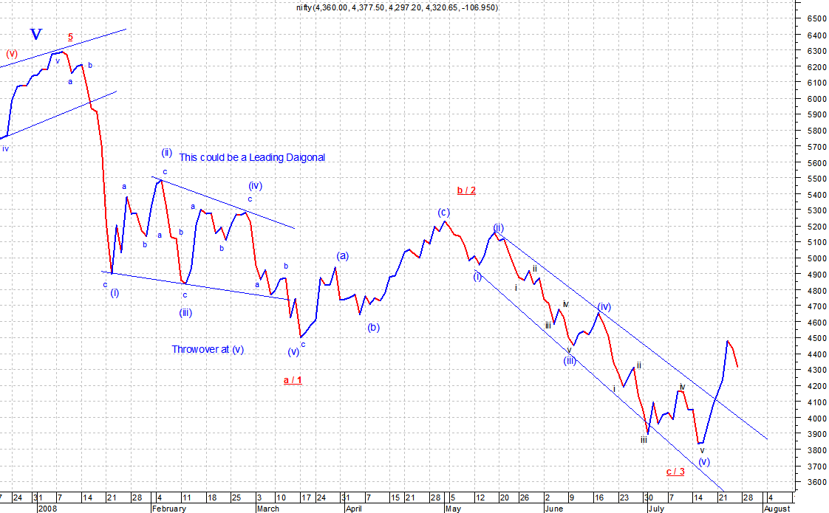

Now based on what I have commented earlier, the wave starting from that point was fairly sharp and we moved down, I reckon the wave formation in wave A or 1 was a leadin diagonal having a throwover at sub wave 5, where it ended. Now wave B or wave 2 retraced around 38.2% (fibo). Now since wave A was complex and B less complex, wave C was simple fall, using rule of alteration. In case of flat correction the wave A and C tend to equality, which is more or less evident in the percent count. Now we also need to focus on the internals of wave C, where I am attaching an hourly chart for reconciliation, which would aptly justify the low of 3790.

Exhibit 9:
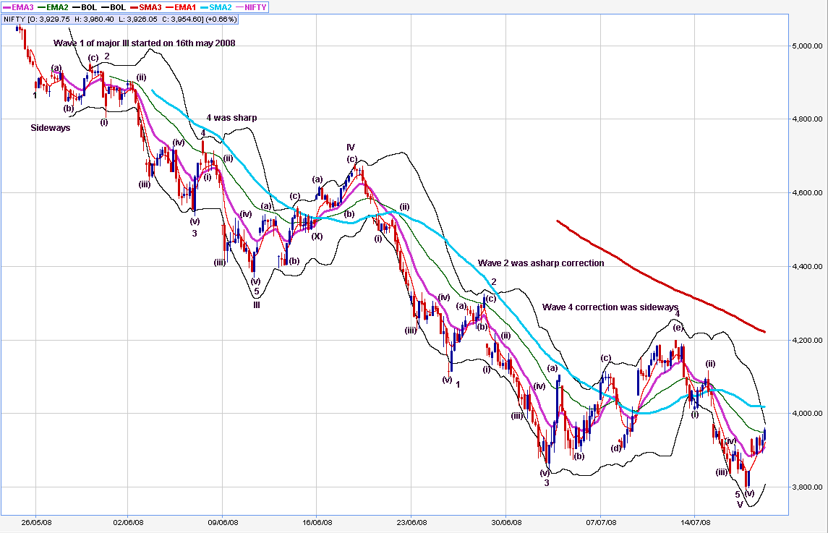

The chart is bit small, but I have attached the full size chart for the as well. I am mentioned the wave count on the charts as well, just to save myself from writing everything (sorry)

But now if we come to end, here we see that wave 4 was a triangle and in case we have a triangle, then the wave 5 should travel around the length of broadest area in the triangle, and the move of wave 5 would be swift.
Broadest length in the triagle is 4105 – 3849 = 256 points, which when reduced from 4051, we get tgt of 3795, and the low was 3790.

Now moving on to current issue, the Nifty has moved up quite fast in a monowave manner and touched a closing high of 4476 on 23 july 2008. From where have slid down, the problem lies here that in case i say that this is wave 4, then it has entered into territory of wave 1 [or (a) in case it’s a three wave correction], and as such violates rule of wave 4 not entering into wave 1, in that case should retrace and move up, and get into wave B, marking completion of wave A (which reached into territory of wave iv of preceding degree), so depending on the movement of ensuing day, i would try to understand the current phenomena.

Regards,
Vivek A Marne

