Intraday with swing Method

Hello frnds,

I share my intraday with swing method here for icharts user(FRIENDS) . hope its usefull to intraday nd position
Call.

First GO TO LIVE CHART PREMIUM.bcoz jchart(premium) does not support this system…

Add upper indicator sma(high,8) and sma (low,8)…

Timeframe for swing 30mini nd for intraday 15mini…I personally use 30mini chart for my swing trade…

Now, if nifty candle close above sma(high,8) with white candle then long …nd sell side if nifty candle close below sma(low,8) with red candle it short…

Below I attached nifty chart (30mini) which generate buy signal on may 30 @ 5474.. nd then market made high 5594..(1st june)

2nd june market gap down but first candle not with red color so I carry the long ….i exit 5554 on frist red candle …nd short .but my sl hit I exit at 5568(14 point loss).again long ..this time also I hit nd exit at 5549(20 point loss).

3rd I long at 5593 but sl hit at 5552.(42 point loss).nd short at 5552..nd 6th june nifty made low 5475…I exit 5505(47 point gain) nd long 5505 and nifty made high 5576 on 7th june..but I still carry

on 8th june market gap down nd I cover my long at(5542).nd short same price(5542) and

9th june nifty made 5495 low….and same day nifty giving buy at 5532 I cover my short at 5532(10point gain)
and long at 5532.but

10th june my sl hit at 5499 I book my loss nd short (32 poin loss) now I short at 5499 nd same day nifty made low 5450..nd nifty still ni selling mode

hope it help to intra nd position call…..

Avinash ☺
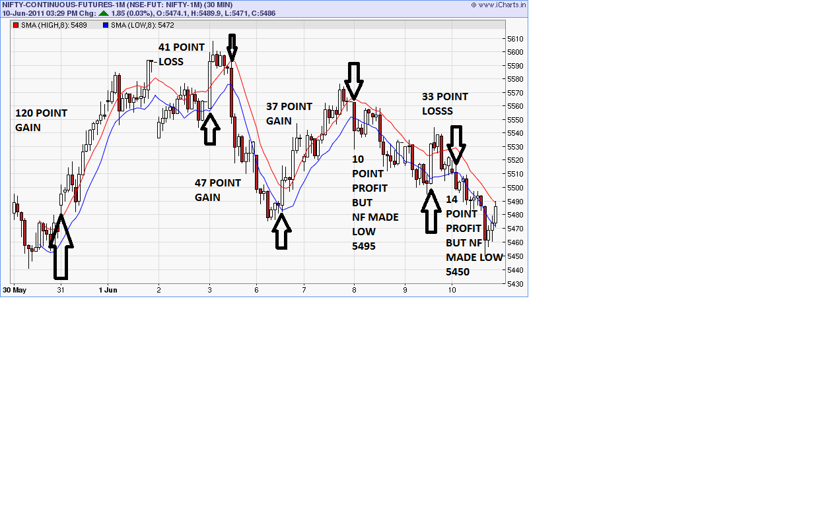
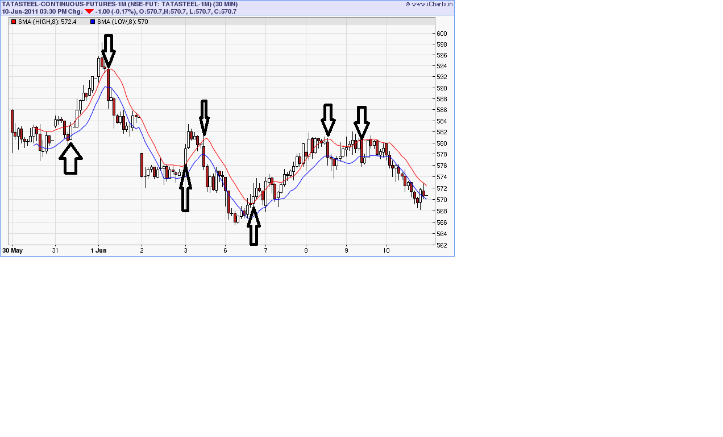

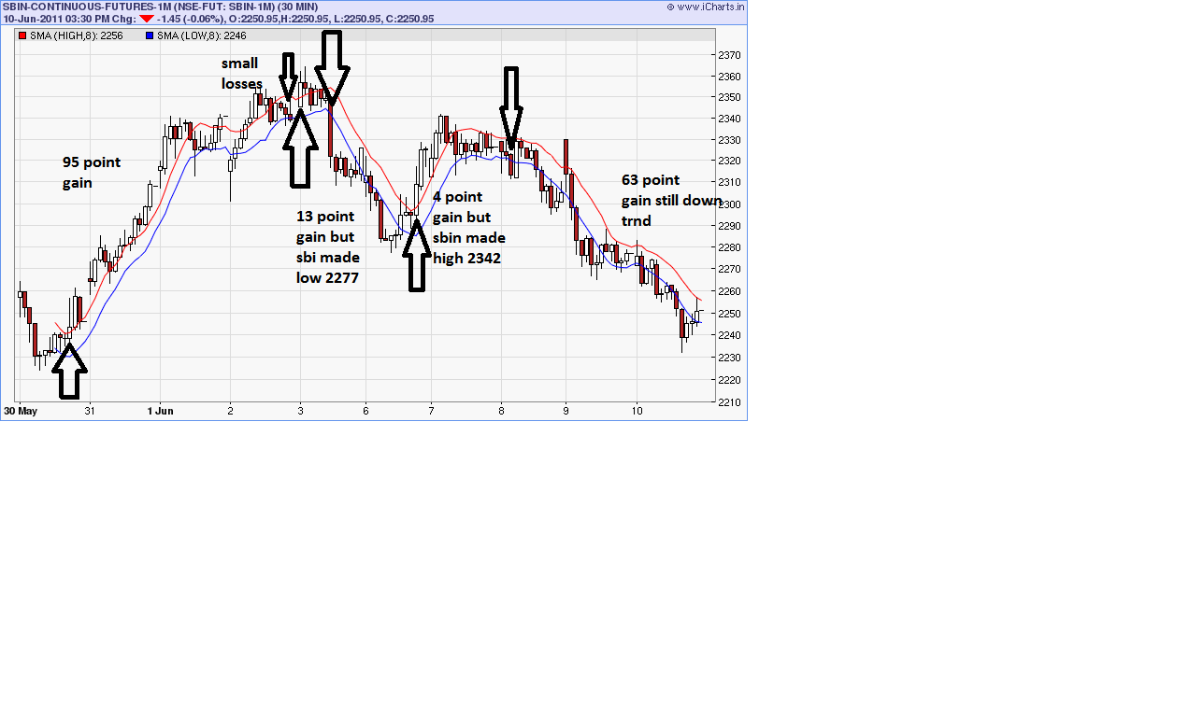

happy trading ..all the best frnds

Avinash ☺

