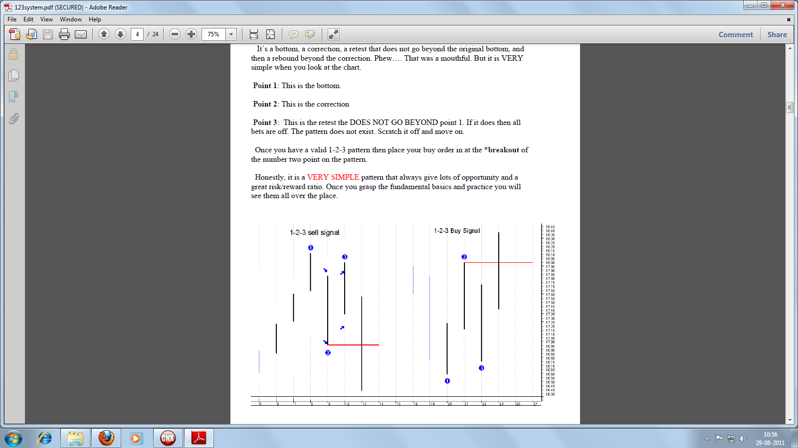

1-2-3 system explained above.
Next page you can see the 1-2-3 on Nifty Daily charts....

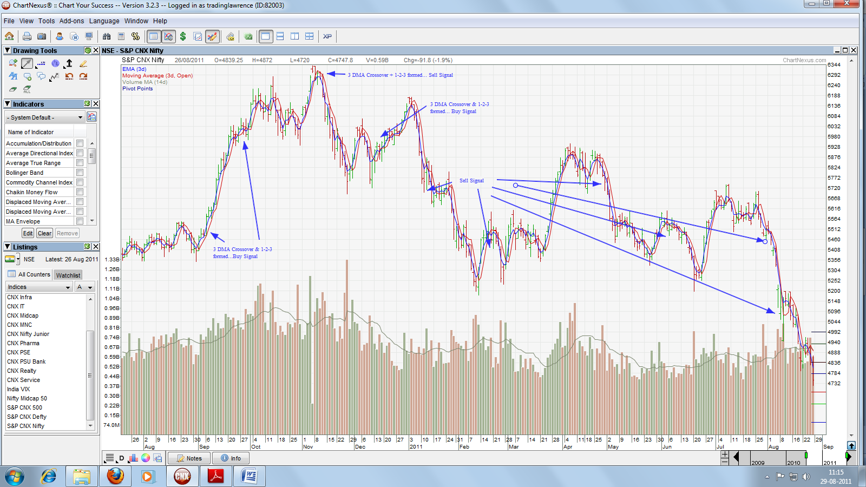

Also you can see that the MA crossovers are happening at the exact top and bottom of the swing. Sometimes the crossovers happen even one or two days in advance warning us about the potential top/bottom.

Author/Market Analyst: Lawrence Sequeira

