TECHNICAL ANALYSIS :-

INTRODUCTION: > in finance, tech analysis (TA) is a security disciple to forecasting the direction of prices thru the study of past market data., mainly price and volume.
- While fundamental analysos (FA) evaluate earnings, dividends, new products, research and like TA employ many techniques, one of which is use of CHARTS.
- Using CHARTS , tech analysts seek to identify price patterns and trends in financial mrkts and attempt to exploit those patterns.
- Technicians use various methods and tools, the study of price charts is but one.
- Technicians using charts search for archetypal price chart patterns, such as the well-known h&s or double top/bottom reversal patterns. Study indicators, ma, and look of support, resistance,channels, and more obscure formations such as FLAGS, PENNANTS, BALANCE DAYS, AND C&H patterns.
- Technical analysts also widely use mrkt indicators of many shorts, sum of which are mathematical transformation of price, often inclusing up and down volume, a/d data and other inputs.
- These indicators are used to help access whether an asset is trending, and if it is, its probability of its direction and of continuation.
- Technicians also look for relationships between price/volume indices, and mrkt indicators … including RSI and MACD.
- There are many techniques in TA ., for ex. Candle stick charting, dow/elliot wave theory.
- Many trades combine elements from more than one techniques. Sum TA use subjective judgment to decide which pattern(s) a particular instrument reflects as a given time. And what the interpretation of that pattern shud be.
- Others employ a strickly mechanical or systematic approach to pattern identification and interpretation..
- TA is frequently contrasted with FA, the study of economic factors that influence the way investors price financial mrkt.
- TA holds that prices already reflect all such trends before investors are aware of them.
- Sum traders usa TA/FA exclusively, while others use both types to make trading decisions which conceivably is the most rational approach.
- TA employs models and trading rules based on price and volume transformation, such as the RSI/MA/REGRESSIONS/INTER-MRKT AND INTRA-MRKT PRICE CORRELATIONS/CYCLES thru recognition of chart patterns.
- TA is widely used among traders of all types

PRINCIPLES:-
- Technicians say that a mrkt’s price reflects all relevant information, so their analysis looks at the history of a security’s trading patterns rather than external drivers such as economic, fundamental and news events, PRICE action also tends to repeat itself because investors collectively tend toward patterned behavior, focus on identifiable trends and conditions.
- TA believe that prices trend directionally i.e .. UP, DOWN, SIDEWAY or sum combination.
- Recent example is RELIANCE that had an trend down from april 2011 to august 2011. 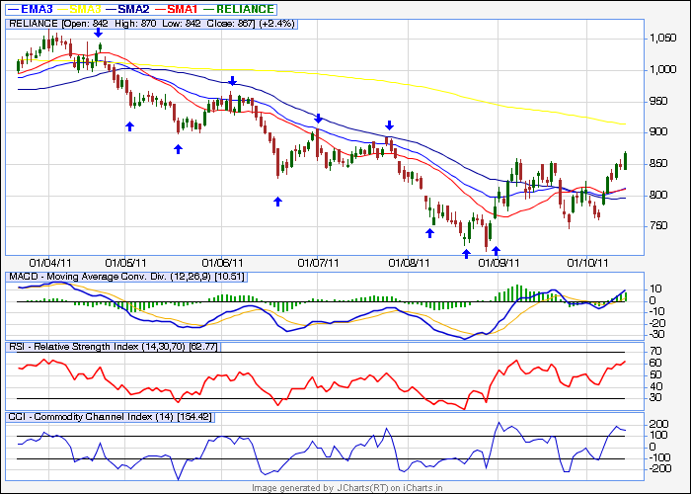TA recognizing this trend wood look for opportunities to sell this security.
- RELIANCE consistently moves downward in price. Each time the stock rose sellers entered the mrkt and sold it., hence the “zig-zag” movement in the price ., the series of lower highs and lower lows is a sure sign of a stock in a down trend.
- Each time RELIANCE moved lower, it fell below its previous relative low price, like wise it moved higher , it could not reach the level of its previous high price.
- Note that the sequence of LL AND LH did not begin until march 2011 than stock makes a low price that doesn’t piece the relative low set earlier.

>TA believe that investors collectively repeats the behavior of the investors that preceded them. It’s investors sentiments .. that : if this stock looks fundamentlly good fo buy at dips. To a TA , the emotions in the mrkt may be irrational, but they exist. Bcos investor behavior repeats itself so often.TA believes that recognizable and predictable price patterns will develop on a CHART.

LINE CHART :-

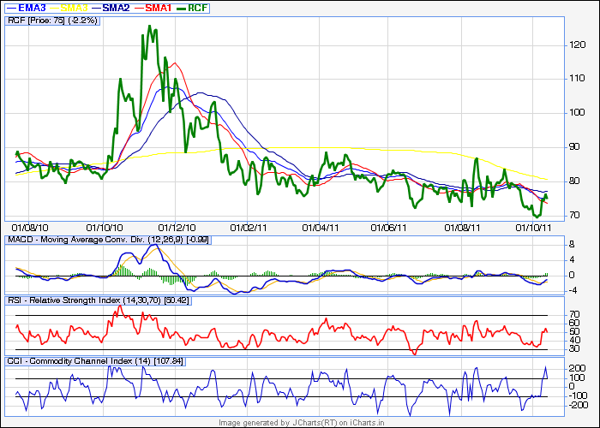

- A line chart is a type of chart , which displays information as a series of data points conneted by straight line segments.
- It is a basic type of chart common in many fields. It is an extention of a scatter grapg, and is created by connecting a series of points that represent individual measurements.
- A line chart is often used to visualize a trend in data over intervals of time – a time series., thus the line is often drawn chronologically.

CANDLESTICK CHART:-
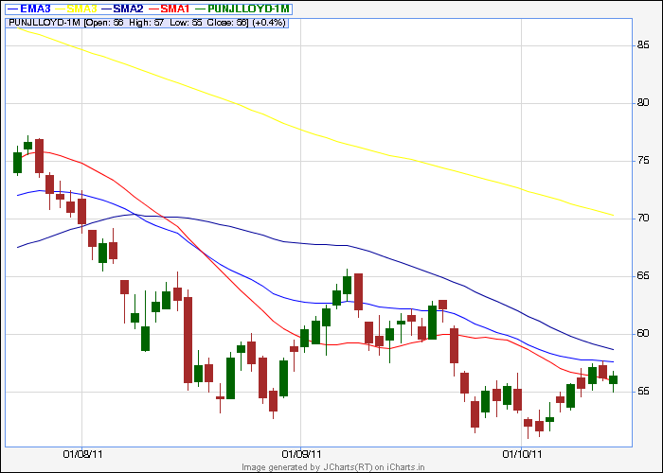

- A candlestick chart is a style of bar-chart used primarily to describe price movements of a security, derivative, or currency over time.
- It is a combination of a line-chart and a bar-chart, in that each bar represents the range of price movement over a given time interval. It is most often used in TA of equity and currency price patterns. They appear superficially similar to error bars , but are un related.
- Candlesticks are usually composed of the body (green or red) , and an upper and a lower shadow (wick)
- The area between the open and close is called the real body, price excursions above and below the real body are called shadows.
- The wick illustrates the highest and lowest traded prices of a security during the time interval represented.
- The body illustrates the opening and closing trades.
- If the security closed higher than it opened, the body is green with the opening price at bottom of the body and closing price at the top. If it closed lower than it opened, body is red , with the opening price at top and closing price at bottom.
- A candlestick need not have either a body or a wick.
- Candlestick charts also convey more information than other forms of charts, such as bar charts.
- Just as with bar charts, they display the absolute values of the open,high,low,closing price for a given period., but they also show how those prices are relative to the prior periods’ prices , so one can tell by looking at one bar than the pior one.
- They are also visually easier to look at, and can be coloured for even better definition.
- Rather than using the open high low close for a given time period (5mts 30mts 1 hour 1day 1 month) candlesticks ca also be constructed using the open high low close of a specified volume range ( 1k 100k 1000k).
- Candlestick charts are a visual aid for decision making in stock forex commodity and option trading.
- For example, when the bar is green and high relative to other time period, it means buyers are very bullish, the opposite is true for a red bar.
-----------------------------------------------------------------------------------------------------

MACD :-

Moving Average Convergence/Divergence is a TA indicator created by GERALD APPEL in the late 1970s.
- it is used to spot changes in the strength, direction, momentum, and duration of a trend in a stock’s price.
- The MACD is a computation of the difference between two exponential moving averages (EMAs) of closing prices.
- The difference is charted over time , alongside a moving average of the difference.the divergence between the two is shown as a histogram or bar graph.
- EMAs highlight recent changes in a stock’s price.
- By comparing EMAs of different periods, the MACD line illustrate changes in the trend of a stock.
- Then by comparing that difference to an average, an analyst can chart subtle shifts in the stock’s trend.
- As a metric of price trends, the MACD is less useful for stocks that are not trending or are trading eratically.

Pls see below chart:

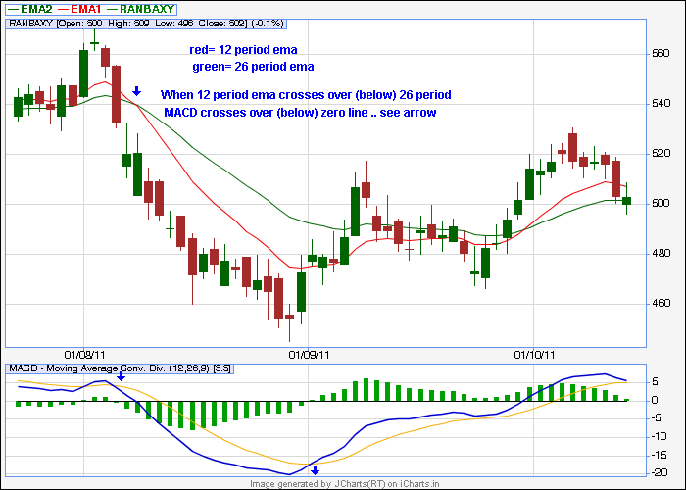

BASIC COMPONENTS :-

- The above chart shows a stock with a MACD indicator underneath it.
- The indicator shows a blue line, a yellow line, and a histogram or bar chart which calculates the difference between the two lines.
- Values are calculated from the price of the stock in the main part of the chart .
- For ex. It means – MACD line blue difference between the 12 and 26 days EMAs.- yellow line signals 9 day ema of the blue line. – histogram bar graph …difference between the blue and yellow lines.
- Mathematically -MACD=EMA(fast,12)EMA(SLOW,26) – signal = EMA (period,9) of MACD, -histogram= macd-signal
- The period for the MAs on which an MACD is based can vary, but the most commonly used parameters involve a faster EMA of 12 days, a slower EMA of 26 days,and the signal line as a 9 day EMA of the difference between the two.
- It is written in the form. MACD(FASTER,SLOWER,SIGNAL) OR IN THIS CASE (12,26,9).
- Signal line crossovers are the primary cues provided by the MACD.
- The standard interpretation is to buy when the MACD line crosses up thru the signal line, or sell when it crosses down thru the signal line.
- The upwards move is called a bullish crossover and the downwards move a bearish crossover.
- Respectively , they indicate that the trend in the stock is about to accelerate in the direction of the crossover.
SIGNAL LINE CROSSOVER:-
- The histogram shows when a crossing occurs, since the histogram is the difference between the MACD line and the signal line, when they cross there is no difference between them.
- The histogram can also help in visualizing when the two lines ae approaching a crossover.
- Though it may show a difference , the changinf size of a difference can indicate the acceleration of a trend.
- A narrowing histogram suggests a crossover may be approaching, and a widening histogram suggests that an ongoing trend is likely to get even stronger.
- While it is theoretically possible for a trend to increase indefinitely, under normal circumstances , even stocks moving drastically will eventually slow down,lest they go up to infinity or down to nothing.

ZERO CROSSOVER:-

- A crossing of the MACD line thru zero happens when there is no difference between the fast and slow EMAs
- A move from positive to negative is bearish and from negative to positive, bullish.
- Zero crossover provides evidence of a change in the direction of a trend but less confirmation of its momentum than a signal line crossover .

DIVERGENCE :-

- The third cue, divergence, refers to a discrepancy between MACD line and the graph of the stock price. Positive divergence between the MACD and price arises when price makes hits a new low, but the MACD doesn’t.
- This is interpreted as bullish, suggesting the downtrend may be nearly over.
- Negative divergence is when the stock price hits a new high but the MACD doesn.t., this is interpreted as bearish , suggesting that recent price rise will not continue.
- Divergence may also occur between the stock price and the histogram., if new high price levels are not confirmed by new high histogram levels, it is considered bearish, and if vice versa than bullish.
- Longer and sharper divergences- distict peaks or troughs – are regarded as more significant than small, shallow patterns.

Timing:-
- The MACD is only as useful as the context in which it is applied., an analyst might apply the MACD to a weekly scale before looking at a daily scale. In order to avoid making short term trades against the direction of a intermediate trend.
- Analyst will also vary the parameters of the MACD to track trends of varying duration.
- One short term set=up , is (5,35,5)

FALSE SIGNALS :-
- Like any indicator, the MACD can generate false signals. A false positive , for ex. Would be a bullish crossover followed by a sudden decline in a stock., a false negative is vise vera may result in stock price accelerate suddenly upwards.
- A prudent strategy would be to apply a filter to signal line crossover to ensure that they will hold., an ex. Of a price filter would be to buy if the MACD line breaks above the signal line and then remains above for three days.
- As with any filtering strategy . this reduces both the probability of false signals as well as the frequency of missed profit.
- Analysts use a variety of approaches to filter out false signals and confirm true ones.
- As a lagging indicator, the MACD is often paired with a leading indicator RSI the relative strength index.
- Historical comparisons to similar stocks as well as a careful investigation of past price movement provide added information about how a stock tends to move.

LIMITATIONS:-
- The MACD has often been criticized for failing to respond in very low or alternately very high volatility mrkt conditions.
- Since the MACD measures the divergence between averages, it can only give meaningful feedback as trends change. Thus the MACD is less useful if the market is not trending – trading sideways or erratically – making sudden, dramatic, and/or countervailing moves.
- In a sideway mrkt. The divergence between averages will not have a trend to illuminate. In an erratic mrkt , the changes will happen too quickly to be picked up by MAs or will cancel each other out, diminishing the MACDs usefulness.
- A particular caveat to the criticism is that whether a mrkt is trending or volatile is always, relative to a particular timeframe and the MACD can be adjusted to shorter or longer spans.
- Though some analysts trade on technical indicators alone, the abundance of experts recommend a complete work-up of a company’s business sectors, financial strength, past earnings, new product, management, and institutional buying.
- For more traditional investors, an indicator like the MACD may be used only to support a previously determined stock choice, or to select and ideal entry-point into a fundamentally sound stock.

RSI = RELATIVE STRENGTH INDEX:-

- The RSI is a technical indicator used in the tech analysis of financial mrkts ., it is intended to chart the current and historical strength or weakness of a stock or mrkt based on the closing prices of a recent trading period. The indicator shouldn’t be confused with relative strength .
- The RSI is classified as a momentum oscillator, measuring the velocity and magnitude of directional price movements.
- Momentum is the rate of the rise or fall in price. The RSI computes momentum as the ratio of higher closes to lower closes.
- The RSI is most typically used on a 14 day timeframe, measured on a scale from 0 to 100, with high and low levels marked at 70 and 30 respectively., shorter or longer timeframes are used for alternately shorter or longer outlooks.
- More extreme high and low levels 80 and 20 or 90 and 10 – occurs less frequently but indicates stronger momentum.

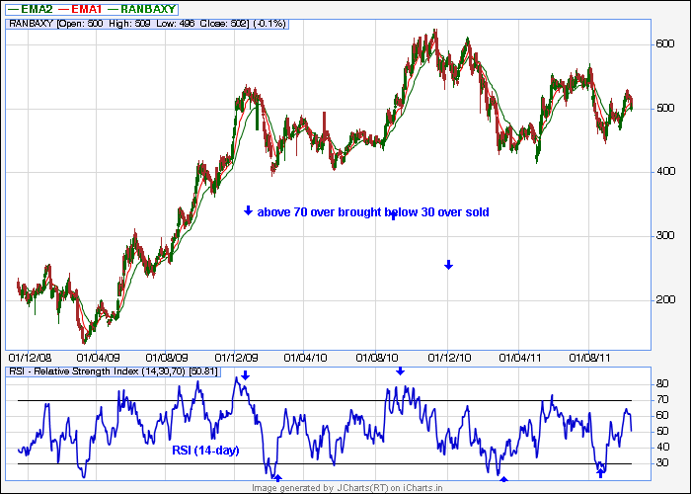

BASIC CONFIGURATION :-
- The RSI indicator has an upper line, typically at 70, and lower line at 30, and a dashed mid-line at 50. wider recommended a smoothing period of 14 .

PRINCIPLES :-
- wider posited that when price moves up very rapidly, at some point it is considered overbought. Likewise fall to certain level considered oversold. In either case, wilderdeemed a reaction or reversal imminent.
- The level of RSI isa measure of the stock’s recent trading strength, the slope of the RSI is directly proportional to the velocity of a change in the trend.
- The distance traveled by the RSI is proportional to the magnitude of the move. Wilder believed that tops and bottoms are indicated when RSI goes above 70 and drops below 30 ., traditionally in between 30 and 70 level is considered neutral, with the 50 level a sign of no trend .

DIVERGENCE:-
- Wilder further believed that divergence between RSI and PRICE action is a very strong indication that market turning point is imminent
- Bearish divergence occurs when price makes a new high but the RSI makes a lower high, thus failing to confirm. Bullish divergence occurs when price makes a new low but RSI makes a higher low.

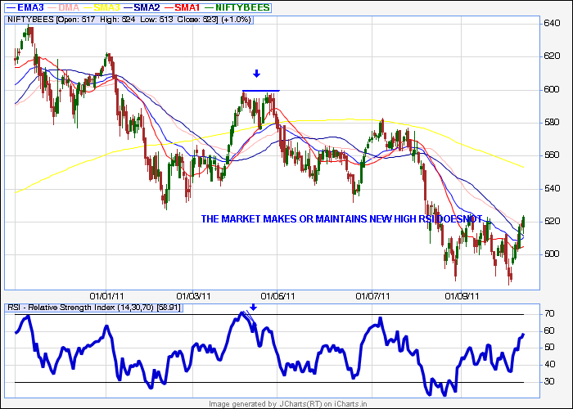

OVERBOUGHT AND OVERSOLD CONDITIONS :-

- Wilder thought that “ failure swings” above 70 and below 30 on RSI are strong indications of mrkt reversals., assume that the RSI hits 76 , pullbacks to 72, wilder consider this a “ failure swing” above 70. he also wrote that chart formations and areas of support and resistance could sometimes be more easily seen on the RSI chart as opposed to the price chart.
- The center line for the relative strength index is 50, which is often seen as both the support and resistance line for the indicator. If the RSI is below, it generally means that the stock’s losses are greater than the gains and when it is above 50 its vice vera ..gains are greater than the losses.

UPTRENDS AND DOWNTRENDS :-

- in addition to wilder’s original theories of RSI interpretation, Andew Cardwell has developed several new interpretations of RSI to help determine and confirm trend
- 1st, Cardwell noticed that uptrends generally traded between rsi 40 and 80, while downtrends usally traded between RSI 60 and 20. Cardwell observed when securities change from up to downtrend and vice versa, the RSI will undergo a “range shift”., he also noted that bearish divergence: 1, only occurs in uptrends. And 2, mostly only leads to a brief correction instead of a reversal in trend
- Therefore bearish divergence is a sign confirming an uptrend. Similarly bullish divergence is a sign confirming a downtrend.

Reversals:
- Cardwell discovered the existence of positive and negative reversals in the RSI. REVERSALS are the opposite of divergence., A positive reversal occurs when an uptrend price correction. While RSI results in a lower low compared to the prior correction. A negative reversal happens when a downtrend rally results in a lower high compared to the last downtrend rally. But RSI makes a higher high compared to the prior rally.
- Despite stronger momentum as seen by the higher high or lower low in RSI , PRICE could not make a higher high or lower low. This is evidence the main trend is about to resume. He also noted that positive reversals only happen in up trends while negative reversals only occur in downtrends, and therefore their existence confirms the trend.

TO BE CONTINUED … AS AND WHEN GET TIME PART 2 : NEXT TOPIC STOCHASTIC OSCILLATOR/MOMENTUM/ COMMODITY CHANNEL INDEX CCI / ATR AVERAGE TRUE RANGE /BREAKOUTS / SUPPORT AND RESISTANCE CHART PATTERNS/ TRENDLINES/PRICE CHANNEL /WEDGE PATTERNS /TRINGLES/BOLLINGER BANDS/PARABOLIC SARS till than bye ….

