TECHNICAL ANALYSIS part:2

Stochastic oscillator :-
- in technical analysis of securities trading, the stochastics oscillator (so) is a momentum indicator that uses support and resistance levels.
- The term stochastic refers to the location of a current price in relation to its price range over a period of time.
- This method attempts to redict price turning points by comparing the closing price of a security to its price range,
- The calculation finds the range between an asset’s high and low price during a given period of time.
- The current securities price is then expressed as a percentage of this range wih 0% indicating the bottom of the range and 100% indicating the upper limits of the range over the time period covered.
- The idea behind this indicator is that prices tend to close near the extremes of the recent range before turning points.
The stochastic oscillator is calculated:
Where >
. price is last closing price
. lown(price) is the lowest price over the last N periods
. HIGH(price) is the highest price over the last N periods
. EMA 3 (%D) is a 3 period exponential moving averages of %K
EMA3(%D-SLOW) is a 3 period ema of %D

Interpretation:-
- the signal to act is when you have a divergence-convergence, in an extreme area, with a crossover on the right hand side, of a cycle bottom.
- As plain crossover can occur frequently, one typically waits for crossovers occurring together with an extreme pullback, after a peak or trough in the %D line.
- If price volatility is high, an ema of the %D indicator may be taken, which tends to smooth out rapid fluctuations in price.
- Stochastics attempts to predict turning points by comparing the closing price of a security to its price range,
- Prices tend to close near the extremes of the recent range just before turning points.
- In the case of an uptrend, prices tend to make higher highs, and the settlement price usually tends to be in the upper end of that time period’s trading range.
- When the momentum starts to slow, the settlement prices will start to retreat from the upper boundaries of the range, causing the stochastic indicator to turn down at or before the final price high.
- An alert or set-up is present when the %D line is in an extreme area and diverging from the price action.
- The actual signal takes place when the faster % line crosses the %D line.
- Divergence-convergence is an indication that the momentum in the market is waning and a reversal may be in the making.

> the chart below illustrate an example of where a divergence in stochastics reversal in the price’s direction.

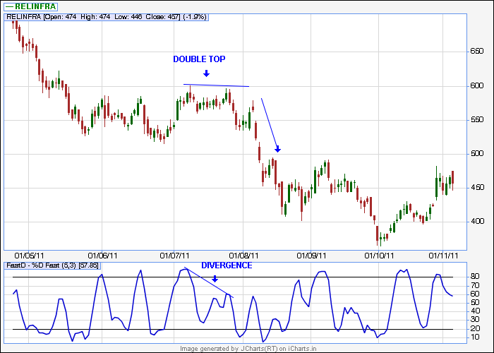

Stochastics pop:-
- this is where prices pop through and keep on going- that is break out.
- Rules to follow:
. increase long position-when price crosses the upper band from below., vise versa for short position.
- liquidate position – when stochastic %D crosses %K in direction reversed to open trade.

MOMENTUM :-

- “momentum” in general refers to prices continuing to trend.
- The momentum and ROC indicators shows trend by remaining positive while an uptrend is sustained, or negative while a downtrend is sustained.
- A crossing up through zero may be used as a signal to buy, or a crossing down through zero as a signal to sell.
- How high (or how low when negative) the indicators get shows how strong the trend is.
- The way momentum shows an absolute change means it shows for instance a Rs 10 rise over 20 days, whereas ROC might show that as 0.50 for a 25% rise over the same period.
- One can choose between looking at a move in ruppe terms, relative point terms, or proportional terms.
- The zero crossing are the same in each, of course , but the highs or lows showing strength are on the respective different bases.
- Momentum is the change in an N-day simple moving average SMA between yesterday and today, with a scale factor N
- Momentum = SMAtoda – SMAyesterday
N
> this is the slope or steepness of the sma line, like a derivative.
> This relationship is not much discussed generally, but it’s of interest in understanding the signals from the indicator.
> when momentum crosses up thru zero it corresponds to a trough in the SMA and when it crosses down thru zero it’s a peak.
> how high (or low) momentum gets represents how steeply the SMA is rising (or falling)

COMMODITY CHANNEL INDEX (CCI) :-

- The CCI is an oscillator originally introduced by Donald Lambert in an article published in the October 1980 issue of commodities magazine
- Since its introduction , the indicator has grown in popularity and is now a very common tool for trades in identifying cyclic trends not only in commodities , but also equities and currencies.
- The CCI can be adjusted to the timeframe of the market traded on by changing the averaging period.

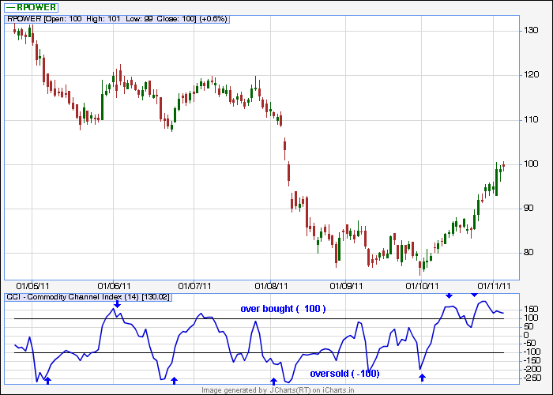

INTERPRETATION
- Traders and investors use the CCI to help identify price reversels, price extremes and trend strength.
- As with most indicators, the CCI should be used in conjunction with other aspects of technical analysis. CCI fits into the momentum category of oscillators.
- In addition to momentum, volume indicators and the price chart may also influence a technical assessment.
- It is often used to detecting divergences from price trends as an OB/OS indicator, and to draw patterns on it and trade according to those patterns.
- In this respect, it is similar to Bollinger bands, but is presented as an indicator rather than as OB/OS levels.
- The CCI typically oscillates above and below a zero line. Normal oscillations will occur within the range of +100 and -100.
- Reading above +100 imply an overbought condition, while reading below -100 imply an oversold condition.
- As with other OB/OS indicators, this means that there is a large probability that the price will correct to more representative levels.
- The CCI , when used in conjunction with other oscillators, can be a valuable tool to identify potential peaks and valleys in the asset’s price, and thus provide investors with reasonable evidence to estimate changes in the direction of price movement of the asset.
- Trading guidelines for the CCI focused on movements above +100 and below -100 to generate buy and sell signals.
- About 70 to 80 percent of the CCI values are between +100 and -100 , a buy or sell signal will be in force only 20 to 30 percent of the time.
- When CCI moves above +100, a stock/index is considered to be entering into a strong uptrend and a buy signal is given., position should be closed when the CCI moves back below +100. and vise versa when CCI moves below -100. hence CCI is valuable for identifying reversels.
- CCI can be used to identify OB/OS levels. A stock would be deemed oversold when the CCI dips below -100 and overbought when it exceeds +100 .
- From overbought levels, a buy signal might be given when the CCI moves back above -100. and vise versa when CCI moves back below +100.
- As with most oscillators, divergences can also be applied to increase the robustness of signal., a positive divergence below -100 would increase the robustness of a signal based on a move back above -100 and vise versa applies for negative divergence abv +100 when it moves back below +100.
- Trend line breaks can be used to generate signals. Trend lines can be drawn connecting peaks and troughs., from oversold levels, an advance above -100 and trend line breakout could be considered bullish., from overbought levels, a decline below +100 and a trendline break could be considered bearish.

SUPPORT AND RESISTANCE :-

> Support and resistance is a concept in technical analysis that the movement of the price of a stock will tend to stop and reverse at certain predetermined price levels.

> a support level is a price level where the price tends to find support as it is
going down. This means the price is more likely to BOUNCE off this level
rather than break thru it. However, once the price has passed this level. by
an amount exceeding some noise. It is likely to continue dropping until it
finds another support level.
- a resistance level is the opposite of a support level.
- Reactive vs Proactive support and resistance :-
- Mos traders will be aware of many differant types of the of support and resistance methods used by traders.
- Proactive support and resistance methods are “predictive” they often outline areas where price has not actually been . they are formed based upon current price action that thru analysis has been shown to be predictive of future price action., Proactive support and resistance methods include elliot wave, Fibonacci, calculated pivots, trendlines and moving averages… etc.
- Reactive support and resistance are the opposite they are formed directly as a result of price action or volume behaviour., they include volume profile, price swing lows and highs, initial balance, open gaps and OHLC.
- Both proactive and reactive support and resistance methods have merit and form a staple part of any support and resistance based trading strategy .
- Support and resistance levels can be identified by trend lines, sum traders believe in using pivot point calculations.
- More often a support and resistance level is “tested” touched and bounced off by price, the more significance given to that specific level.
- If price breaks past a support level, that support level often becomes a new resistance level, the opposite is true as well, if price breaks a resistance level, it will often find support at that level in the future.
- Various methods of determining support and resistance levels exist. A price histogram is useful in showing at what price a market has spent more relative time.
- Psychological levels near round numbers often serve as support and resistance ., recently volatility has been used to calculate potential support ans resistance.

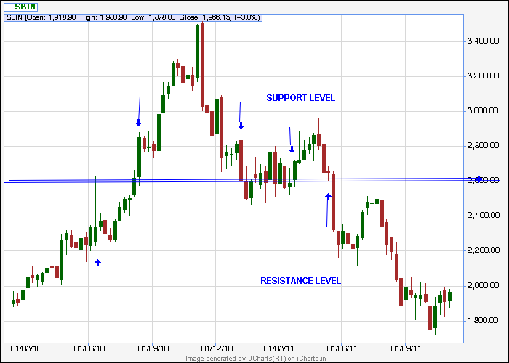

> IF a stock price is moving between support and resistance levels, then
a basic investment strategy commonly used by traders, is to buy a stock at support and sell at resistance and cover the short at support.

- when judging entry and exit investment timing using support
- or resistance levels it is important to choose a chart based on a price interval period that aligns with your trading strategy time frame. Short term traders tend to use charts based on interval periods , such as 5 minutes i.e. the price of the security is plotted on the chart every 5 minutes) with longer term traders using price charts based on hourly daily weekly or monthly interval periods.

BREAKOUT :-

A breakout is when prices pass thru and stay thru an area of support or resistance. On the technical analysis chart a breakout occurs when price of a stock or commodity exits an area pattern.

AVERAGE TRUE RANGE (ATR) :-

>ATR is a technical analysis volatility indicator originally developed by J. WELLES WIDER. JR. for commodities.
> the indicator does not provide an indication of price trend. , simply the degree of price volatility. The ATR is an N-day ema of the true range values., wider recommended a 14-period smoothing.

>the range of a day’s trading is simply high-low. The true range extends it to yesterday’s closing price if it was outside of today’s range.
The true range is the largest of the : most recent period’s high less the most recent period’s low., absolute value of the most recent period’s high less the previous close. And absolute value of the most recent period’s low less the previos close.

The idea of ranges is that they show the commitment or enthusiasm of traders. Large or increasing ranges suggest traders prepared to continue to bid up or sell down a stock thru the course of a day. Decreasing ranges suggests waning interest .

BOLLINGER BANDS:-

> Bollinger bands are a technical analysis tool invented by john Bollinger
in the 1980s.
- having evolved from the concept of trading bands , Bollinger bands can be used to measure the highness or lowness of the price relative to previous trades.
- Bollinger bands consist of : - a middle band being an N-period sma., an upper band at K times an N-period standard deviation above the middle band (MA + Ko)., a lower band at K times an N-period standard deviation below the middle band (MA-Ko).
- Typical value for N and K are 20 and 2, respectively.
- The default choice for the average is a SMA., but other types of averages can be employed as needed.
- EMA are a common second choice , usually the same period is used for both the middle band and the calculation of standard deviation.
- The purpose of Bollinger band is to provide a relative definition of high and low. By definition prices are high at the upper band and low at the lower band.
- This definition can aid in rigorous pattern recognition and is useful in comparing price action to the action of indicators to arrive at systematic trading decisions.
- The use of BB varies widely among traders. Sum traders buy when price touches the lower BB and exit when price touches the moving average in the center of the bands. Other traders buy when price breaks above the upper BB or sell when price falls below the lower Bollinger.
- INTERPRETATION:-
- The use of BB is not confined to stock traders; options traders, most notably implied volatility traders, often sell options when BB are historically far apart or buy options when the BB are historically close together, in both instances, expecting volatility to revert back towards the average historical volatility level for the stock.
- When bands lie close together a period of low volatility in stock price is indicated. When they are far apart a period of high volatility in price is indicated.
- When bands have only a slight slope and lie approximately parallel for an extended time the price of a stock will be found to oscillate up and down between the bands as though in a channel.
- Traders are often inclined to use BB with other indicators to see if there is confirmation. The use of an oscillator like BB will often be coupled with a non-oscillator indicator like chart patterns or a trend line.
- If this indicators confirm the recommendation of the BB , the trader will have greater evidence that what the bands forecast is correct.

PARABOLIC SAR :-

> it may be used as a trailing stop loss based on prices tending to stay within
a parabolic curve during a strong trend .
> the concept draws on the idea that time is the enemy (similar to option theory’s concept of time decay) and unless a security can continue to generate more profits over time, it shud be liquidated.

The indicator generally works well in trending markets , but provides “whipsaws” during non-trending sideways phases.
As such wilder recommended establishing the strength and direction of the trend first thru the use of things such as the average directional index. And then using the parabolic sar to trade that trend.
In a chart a parabola below the price is generally bullish, while a parabola above is generally bearish.
--------------------------------------------------------------------------------------------

Author’s note: before using and indicators , moving averages, oscillators in real trades please watch live charts for some time and when confident do use it.
Wishing you all happy and confident earnings
Love and regards
Nitin Sinojia

